**Template and explanation**

**Submission internships**

MSc Technical Medicine, year 2

Version 1.8 - 29-03-2019

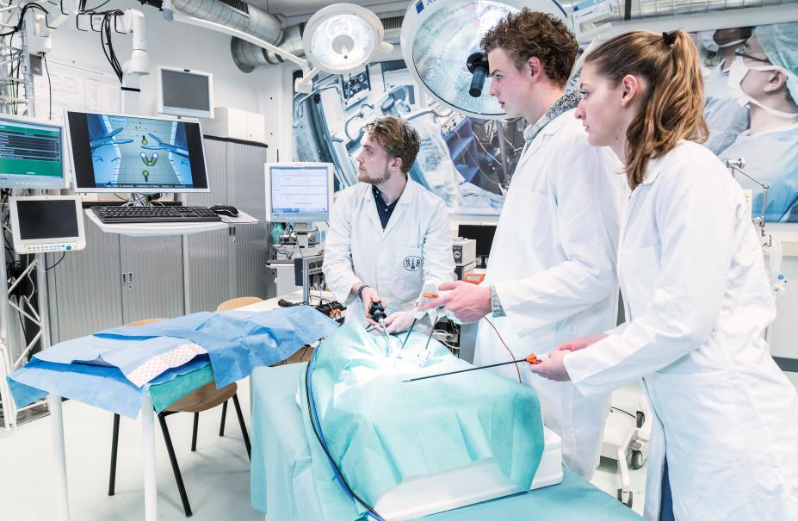



**Internship MSc Technical Medicine - year 2**

***Delivery of an internship? Use the form on the last page***

***For other questions, read the F.A.Q. on page 4***

The second year of the three-year Master's degree in Technical Medicine consists of four ten-week clinical internships. These internships are an excellent opportunity for you to get acquainted with the unique approach and contribution that a future technical medicine professional offers you and health care in general. The third year is a graduation year, in which a complete project or research is carried out. Graduation assignments will only be accepted from applicants who also offer second-year internships.

These internships are meant to guide the students, as well as interns, in health care practice and develop their competence in patient contact. In these internships, they will work on finding a technical-medical solution for a medical problem from your practice and they get the opportunity to become familiar with the medical processes in your department.

**What kind of internship description can you submit?**

A technical medical internship means that the student has the opportunity to gain clinical experience. The internship assignment must therefore have an explicit clinical connection. In addition, both the supervision and the workplace must stimulate patient contact. The assignment description offers space for a technical approach to the medical problem definition. The student can use his or her tech med mindset and ingenuity to come up with new solutions.

**The process?**

No later than six weeks before the start of the internship, the matching procedure will be completed and you will receive a message or a letter whether a student is linked to your internship. The students have 10 weeks of full-time internship, in which every Friday is a study day. During the internship, the student spends half of the time on gaining clinical experience (anamnesis, physical examination, diagnosis and treatment process, etc.) and the other half with the internship assignment.

At the end of the internship, the student is assessed on the clinical performance, the completed result with respect to the assignment and the development of the student over the internships.

**What do we ask you?**

* An internship description via enclosed form (last two pages)
* Clinical guidance and stimulation of patient contact
* Assessment of the internship product and clinical functioning
* Monitoring the technical-medical topic for usefulness and applicability
* Identify research lines with technical-medical opportunities
* Form a supervision team with both a medical and a technical supervisor

**What does it bring you?**

* A substantial contribution to an innovative solution to a medical problem
* Acquaintance with the future value that a technical medicine professional can provide
* Possibility of a one-year full-time technical-medical graduation project
* New perspectives and networks for innovative research

We look forward to your internship description and will gladly help you to optimize the result. On behalf of the Master-TM team: thank you very much!

***Dr. Mariëlle Walraven***

*Internship coordinator Technical Medicine*

**Technical University of Delft**

Department of BioMechanical Engineering

Faculty Mechanical, Maritime and Materials Engineering (3mE)

Mekelweg 2, 2628 CD Delft, Netherlands

T. +31 (0) 15 2781638 [stage-TM@tudelft.nl](mailto:stage-TM@tudelft.nl)

**Structuur Stage**

Structure

The internship is 10 weeks. Per week, the student will have four days available for the internship, and one day for education. This education day concerns technical-medical topics (MTK team), reflection and coaching (Social Team) or a day to work on reports. In addition, during an internship the next internship and different contact moments have to be planned. An internship starts in one period of 13 weeks, leaving three weeks between two internships. The following figure shows the global structure of the internship.



Figure 1. Internship structure. In the figure, 10 internship weeks are shown, with in each week one education day (Friday). One education day per 2 weeks is pre-filled, for the other one the student can work on the internship proposal, the Personal Development Plan (POP), the final report and the reflection. A longitudinal development line runs through the 10 weeks supervised by the social team. Between week 3 and 9 there will be as many clinical feedback moments as possible, with an absolute minimum of 10 per internship.

Assessment

In order to successfully complete the internship, the student must obtain a sufficient internship assessment and have provided a sufficient personal development report. The first is assessed by the supervisors and the second is done by the social team (of the TM-institution).

During the internship a number of (informal) feedback and (formal) assessment moments take place. In week 2 the internship proposal will be checked, in week 6 the student will receive one fictitious interim evaluation according to the final assessment form and in week 10 the final assessment follows. In between, a clinical observation and feedback moment will take place at least once a week. The results from these feedback moments are used by the student for the personal development report that is assessed by the social team and is therefore of great importance. The table summarizes the evaluation system.

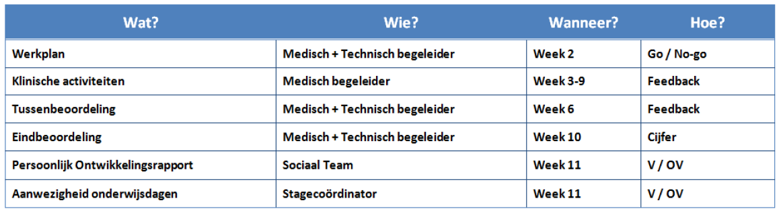

**F.A.Q.**

Is my proposal suitable?

The internship coordinator assesses submitted internship descriptions to ensure that internships are suitable for the development and assessment of the qualities of the TM students.

Should it be decided that your submitted form does not fit completely within TM-year 2, we will contact you to adjust this together so that all parties agree with the assignment. If your assignment concerns human subjects, then your project will only be approved if an (M) ETC approval has already been obtained.

During the internship we expect from the students that they (with you and us as coaches and you as a content expert) design their assignment themselves with sufficient depth and quality.

Who is the TM-intern?

The technical physicians work within a medical treatment team for an optimal diagnosis and treatment of the patient using advanced technological tools. They facilitate the introduction and strengthen the application of technological innovations in healthcare. They help to make a difference in the healthcare of the future by their technological expertise and the new perspectives and possibilities for diagnosis and treatment. The second-year Master's student TM has at the start of the clinical placement:

* Learned to develop technical solutions for medical problems
* Prepared himself for the role as health care professional
* Studied the anatomy and (patho) physiology of all organ systems for three years
* Three years of consultation skills
* Familiarized himself with Matlab programming skills
* Developed the skill to review technical-medical issues and developments in a broad context

What is the structure of the 2nd year?

As mentioned earlier, the second Master year consists of four ten-week internships, one per quarter (13 weeks). The starting day will be agreed between you and the student in mutual consultation. The possible starting moments per quarter are: beginning of September, beginning of December, beginning of March, and beginning of June.

Ten weeks prior to the start dates you will receive an invitation from us to submit assignments or, if your previous application is not yet fulfilled, the question or your previous assignment description is still up-to-date. Eight weeks prior, the assignments are finalized and they are presented to the students. Six weeks prior, the placement is final and students are asked to contact you to make appointments.

What is the difference between the four internships?

Only the assignments. The internships have an identical structure and an identical assessment structure; they are therefore interchangeable. This fits well with the various inflow moments interns can have at the Master TM. A distinction can be made in terms of independence that is required of a student. On the form this can be indicated at 'independence level'. We try to take this into account during placement.

What track should I choose for my project?

**Imaging & Intervention:** Combines the techniques and applications of imaging and interventions. The domain extends from molecular imaging techniques to tissue printing, and from advanced preoperative planning techniques to image guided interventions. It focuses on the use of images for diagnostics, making treatment decisions, guiding treatment, monitoring of treatment effects and prognosis.

**Sensing & Stimulation:** Accurate monitoring of the status of the patient and timely and precise adjustments when needed. Sensing mainly focuses on diagnostics, making treatment decisions, monitoring of effects and the preparation of a prognosis. Stimulation mainly focuses on all technologies that be used to restore the homeostasis.

## Title of the internship: …………………………………………………………………………………………………

## Internship suitable for track:

Sensing and Stimulation  Imaging and Intervention  both

Level: Novice  Advanced  Independent

## Information about the research group and/or clinical department (max 200 words)

## Information about the specific TM-question (max 400 words)

## Precise research question and the desired result (max 100 words)

## Clinical experiences within the internship:

|  |  |  |  |  |  |  |  |
| --- | --- | --- | --- | --- | --- | --- | --- |
| Surgical acts |  | Injections |  | Defibrillation |  | Anamnesis |  |
| Elective cardio version |  | Endoscopies |  | Radiation |  | Physical examination |  |
| Catheterizations |  | Punctions |  | Other, such as: ... |  | additional examination |  |

## Explanation about clinical activities:

## Facilities

Required facilities: Available:

Required facilities: Available:

Required facilities: Available:

Required facilities: Available:

Does this research project require (M)ETC approval? Yes  No

If yes, is (M)ETC approval already obtained? Yes  No

## Information internship provider

**Name and title medical supervisor:**

Position:

Institute and address:

Faculty and department:

Email address:

Phone number:

**Name and title technical supervisor:**

Position:

Institute and address:

Faculty and department:

Email address:

Phone number:

**Name and title other supervisor (optional):**

Position:

Institute and address:

Faculty and department:

Email address:

Phone number:

The internship provider has taken knowledge of this template and explanation about the criteria for internships.

Name: Date: