Analysis of eye fat deformation in 3D with optical flow technique
10-286
Thijs de Graaf, Wb1048422 and Ronald Root, Wb1050265
Abstract
The eye is suspended the orbit and is supported by the eye fat behind the eye. Six eye muscles rotate the eye in all directions of gaze. The fat behind the eye bears the eye and surrounds the eye muscles and the optic nerve. Together with the material properties of the fat¹⁾, its deformation must be known for the development of the Finite Element Analysis model of orbital mechanics²⁾. The deformation of orbital fat was investigated with MRI and an optical flow technique. Three regions of interest were specificly analyzed in 3D. These were: First the region between muscle and the eyeball, secondly the region around the optic nerve behind the eyeball, and thirdly the apex region (the end of the cone shaped bony orbit). Vectorfields were generated in order to discribe the deformation of the eye fat in these regions. The first region, could not be resolved in sufficient detail. In the second region, the motion of the fat was primarily transverse. Apparent was that the fat followed approximately half of the movement of the backside of the eye. In the third region the fat deformed primarily in the same direction as the muscle moved. Apparent was that the fat followed aproximately half of the muscle movement.
Authors keywords: Eye movement, Eye-fat, Optical flow.

Introduction
The eye is suspended in the orbit and the eye fat behind the eye supports the eye. The conical orbit is filled with eye fat. Six eye muscles, of which four are 10 mm wide ribbons attached to the eye, rotate the eye in all possible directions of gaze. The visual information is transmitted to the brain by the optic nerve, which lies in between the eye muscles. The fat behind the eye bears the eye, and surrounds the eye muscles and the optic nerve. Little is known about the deformation of the eye fat during eye rotation, and about the attachment of the fat to the eyeball, nerve and muscles. Together with the material properties of the fat¹⁾, deformation and attachment of the fat must be known for the development of the Finite Element Analysis model of orbital mechanics²⁾.
The deformation of eye fat was investigated. Three regions of specific interest were analyzed in 3D. These regions were, region I, between eye muscle and eyeball, region II, around the optic nerve close behind the eyeball, and region III, the apex region (the end of the cone shaped bony orbit). The regions that were investigated are indicated in figure 1.
For region I the research question is: How does the eye fat deform between muscle and eyeball during eye rotation. The muscle rolls up onto the eyeball and the fat in between is squeezed out sideways or backwards. The hypothesis is: The fat moves primarily backwards.
For region II the research question is: How does the eye fat move around the optic nerve. Known is that the fat close behind the eye follows about half of eye rotation³⁾. Because the nerve is attached to the eye, the hypothesis is: As the nerve moves through the orbit, the fat moves partially with and partially around the nerve.
For region III the research question is: How does the eye fat deform in the apex region. The hypothesis is: The deformation of fat is primarily transverse.

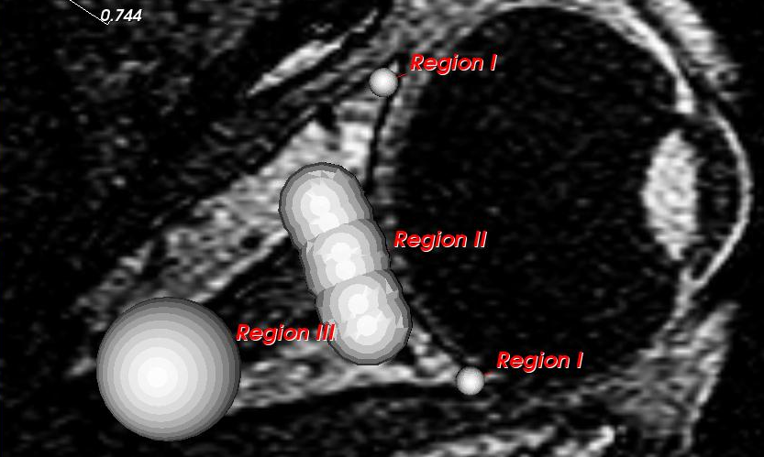
Fig. 1: Three regions of interest.

Methods
To analyze the deformation of the eye fat, three-dimensional datasets were obtained from the eyes. Seven horizontal gaze directions were scanned with a 1.5T Magnetic Resonance Image scanner. MRI data consist of slices of grayscale pictures, with which the inside of a human body can be analyzed.
Due to small head movement between scanning sessions, the datasets did not align. The datasets were aligned with in all datasets identifiable points. The points were placed in bony structures.
Volumes containing the orbit and the eye were cropped to save calculating time.
The data was analyzed with demons optical flow technique⁴⁾. This algorithm is applied to visualize eye fat deformation. The algorithm generates a vectorfield between two gaze directions. This vectorfield represents the deformation in 3D.
To analyze a vectorfield in a specific region a virtual spherical volume is placed in that region in the dataset. Every point on the spherical volume is translated with its accompanying vector. This results in a new volume.
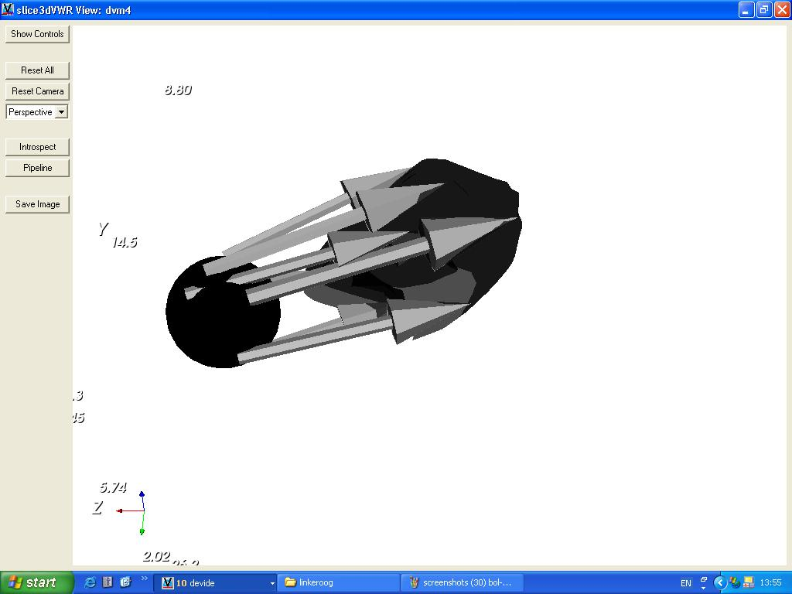
Fig. 2: Deforming a spherical volume.

Spheres were placed in the region between the muscle and the eyeball. Other spheres were placed in the region around the optic nerve, behind the eyeball, and spheres were placed in the apex region. All image processing was done with DeVIDE⁵⁾.

Results
Vectorfields were generated for eye movement from the central eye position, to the left and right gazes. For analysis of the regions of specific interest, the left eye was used in the central eye position and in three gazes to the left. The angular positions of the eyes were 0° for the central position and 14°, 24° and 33° for the left gazes³⁾. Spherical volumes were translated three times resulting in three deformed volumes. The black volume is the original sphere, and the dark gray, light gray, and white volumes are the first, second, and third translations.
In region I, three virtual spheres were placed, between the muscle and the eyeball. The spheres were placed above each other on the right side of the eye, behind where the muscle attaches (Fig. 3). The volume was translated with three vectorfields. The eye rotated into left gaze and the volume moved forward along with the eye. However, the region could not be analyzed in sufficient detail, because the resolution of the MRI data was too low.

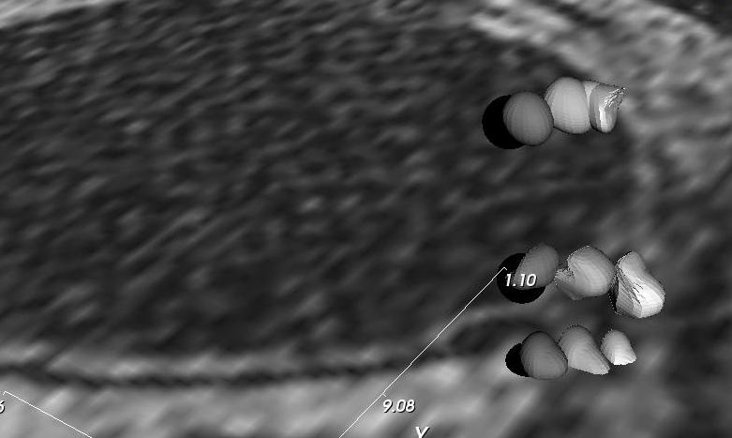
Muscle
Eye
Eyefat
Fig. 3: Results region I.

In region II, six virtual spheres were placed around the optic nerve close behind the eyeball, and one was placed within the optic nerve. The motion of the volumes was primarily transverse and in the same direction as eye rotation. Apparent was that the fat followed approximately half of the nerve head movement. Resolution was too low to describe deformation around the optic nerve in detail.

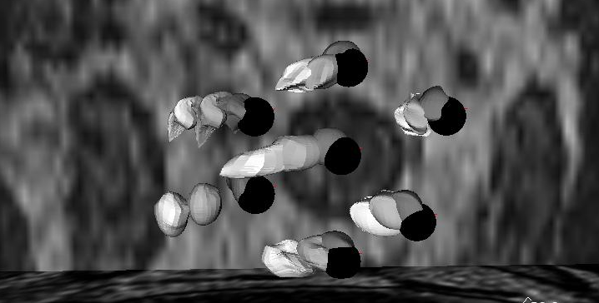
Optic Nerve
Eyefat
Muscle
Fig. 4: Results region II.

In region III, virtual spheres were placed in the apex. Motion of the fat in this region was transverse, but also in the direction of muscle movement. Apparent was that fat in this region follows about half the movement of the muscles. Attachment between fat and muscles is loose, similar as attachment of fat to the eye.
Optic Nerve
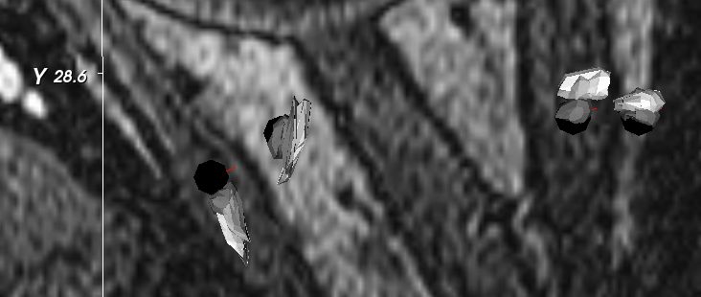
Eyefat
Muscle
Fig. 5: Results region III.

Conclusion
Region I could not be resolved in sufficient detail, so the hypothesis could not be tested. In region II, motion of the fat was transverse and fat moved approximately half of the nerve head movement. The hypothesis was partially rejected. In region III, motion was transverse as well as in the same direction as the muscles. Apparent was that fat in this region follows approximately half of the muscle movement. The hypothesis was rejected. The latter finding was interesting, because expected was that the muscles would fully slide through the fat. In that case minimal energy would be needed for displacement of fat. Concluding, the attachment of fat to the eye and to the muscles was present but loose.
References
- I. Schoenmaker et al, (2004), Visual Research.
- S. Schutte et al, (2003), ARVO.
- T. Masterbroek et al, (2004), Visual Research
- J.P. Thirion, (1998), Medical Image Analysis.
- C.P. Botha, (2004), The Delft Visualisation and Image processing Development Environment.

