Nr  11-310 | Sectie opdrachtgever  TM |  | Naam opdrachtgever  Prof. Daniel Rixen |  |  | Datum  Sept 2004
Titel | Vibration reduction of an ophthalmologic test bench
Trefwoorden | Vibration, experimental model analysis, modeling, re-design
Inleiding  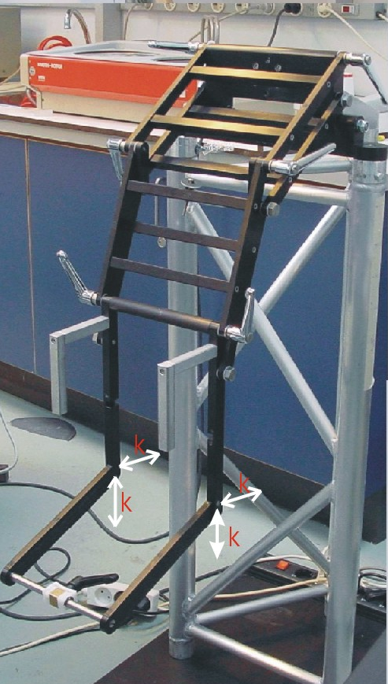 | In the group of Neuroscience at the Erasmus Medical Center (Rotterdam), a unique experimental test facility has been created to investigate equilibrium troubles in patient. It consists of a flight simulator platform on which a measurement frame is attached in order to hold the head of the patient and to measure the motion of his eyes during the motion of the platform.  Unfortunately the test frame designed for this experiment by the Erasmus MC is made of a moveable arm that holds the measurement sensors and that can be lower on the head of the patient (see Figure). This specific design has shown to have at least one eigenfrequency under 50 Hz which causes vibrations unacceptable for the patient and for the accuracy of the measurements when the platform is shacked.  It is therefore necessary to modify the design in order to ensure that all natural frequencies are well above 50 Hz.
Vraagstelling | The basic question we want to answer in this investigation are:  Is it possible modify the design in such a way that it can still guarantee easy access for patients and researchers and such that its lowest eigenfrequency is at least 60 Hz ?
Uitwerking en eisen | The investigation should be conducted as follows:  - Discuss with the Neuroscience research group in Rotterdam in order to understand the problem.  - Perform an experimental modal analysis on the original frame in the lab of the group of Engineering Dynamics (See picture).  - Propose small modifications to the design and build those modifications on the original set-up. If necessary, a simple finite element analysis of the frame before and after modification should be performed (with Ansys or Matlab).  - Redo the modal analysis on the modified system to verify if the first eigenfrequency is above 60 Hz.  - If time permits, one can also retest the setup during operation once the frame is mounted on the flight simulator at the Erasmus MC.
Opmerkingen | Support will be provided by the Engineering Mechanics, groups. The candidates must have an interest in experimental testing and dynamical modeling.
Begeleiding | Naam | Sectie |  | Tel | E-mail
Begeleiding | Prof. dr. ir. D.J. Rixen | Eng. Mech. |  | 8 1523 | d.j.rixen@wbmt.tudelft.nl
Begeleiding | Ir. Nadine Conza | Eng. Mech. |  | 8 2701 | n.e.conza@wbmt.tudelft.nl
Begeleiding | dr. J. van der Steen | NeuroSciences, Erasmus |  |  | j.vandersteen@erasmusmc.nl
Toegewezen aan Paul Breur en Ryan Derks

