Sound Quality (on a Ford Bantam)
Code 10-315

Menno van Rossum (stnr.1047078 )
Summary
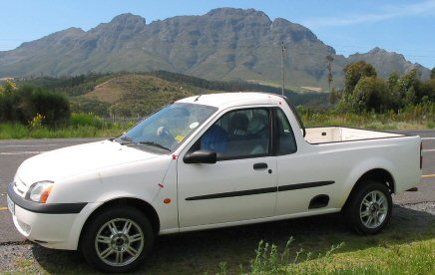
Traditionally noise engineering has taken place mostly on the functional components of sound, lowering the sound pressure level is an example, overlooking many important factors that influence people’s perception or experience of these sounds. How does one begin to design for example a vacuum cleaner to sound more robust, or determine why customers prefer the competitor’s car’s door slam over yours? In this research project performed in South Africa, first Sound Quality as a phenomenon was described, as well as the most important outcomes of the first stage of acoustical research on the Ford Bantam, a South African pickup truck. An annoying sound that bothers customers of the Bantam is likely to be produced by the car’s driveshafts and amplified by the cabin’s back panel.
Figure 1:
Ford Bantam

1. Introduction on Sound Quality
Sound Quality states that sound can be either of a better or worse nature. When saying that one sound can be of a greater quality than another it is implied that we are making a judgment about that sound. Sound quality works closely with subjective opinions (subjective is defined as having to do with one’s own mind). There are, however, sound characteristics about which all people are agreed on. Sound quality seeks to predict these experiences by taking into account all the factors that influence it. Masking, Loudness, Sharpness and Fluctuation Strength are examples of the most important sound quality metrics.
In the case of the Bantam a booming noise, occasionally obtained at a speed of about 35 km/h on a rough road, is investigated. Ford is getting an increasing amount of complaints of it’s customers so in order to be able to improve the car’s acoustical performance and secure salesnumbers in the future we needed to try and find an appropriate solution. Evidently the source of the noise is some sort of vibration resonating at a specific impulse. Checking the moving parts of the vehicule the drive shafts seemed the most likely source of the noise.

2. Hypothesis
The driveshafts are an important source of the unwanted “booming” noise.

3. Methods
In order to start finding practical solutions to the problem for Ford, first we needed to identify and characterise the booming noise inside the cabin. We wanted to see the vibrations and the sound itself, the way it’s being transported through the chassis of the car (transfer functions) and the way the cabin acoustically responds to the vibrations.
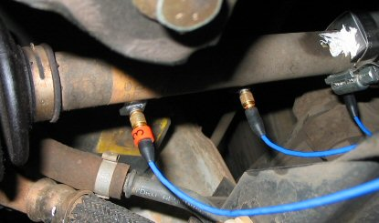
The transfer functions, which are the transfer paths between the input at the wheels and the accelerations of the panels, play the biggest role in transmitting vibrations from the wheels to the cabin’s panels, which convert the vibrations into noise. The transfer functions were calculated by putting the vehicle on stands in the laboratory and excite it using a shaker attached to a wheel hub with accelero-meters placed on the panels sur-rounding the cabin.
For acoustic analy-sis the vehicle’s cabin was modelled in order to identify the fundamental resonant modes and their associated frequencies. The resonant modes of the cabin interior will prove to play a significant role in amplifying the cabin noise caused by the vibrating panels, especially the backpanel.
Figure 2:
Accelerometers on
the driveshaft
To visualize the noise, “Run-up” tests were performed on one Bantam, which was accelerated from rest to over 80 km/h by driving down an inclined, straight, roughly tarred road with the engine idling in neutral. During the test, a binaural recording head was put on the passenger’s seat.
An important question concerns the frequencies that are the most noticeable and annoying for a driver of the Bantam. Once the noise signal was A-weighted {1}, the effect of the low frequency noise was heavily diminished and significant contributions were seen in the 75-300 Hz range.

{1} A-weighing is a technique that approximates the frequency response of the human ear, a “perceived loudness”.

4. Results
The resulting transfer functions between the noise input and the microphone readings showed a large acoustic mode at about 100 Hz: the fundamental acoustic mode.
Figure 3:
fundamental
acoustic mode
Excitation tests on the panel directly behind the seats at the front of the load box, referred to as the “back panel” revealed a significant mode at about 90 Hz. Being so close to the mode of the cabin, the two are a “succesful” acoustic combination. Figure 4 shows the transfer function between the excitation input and the movement of the panel.
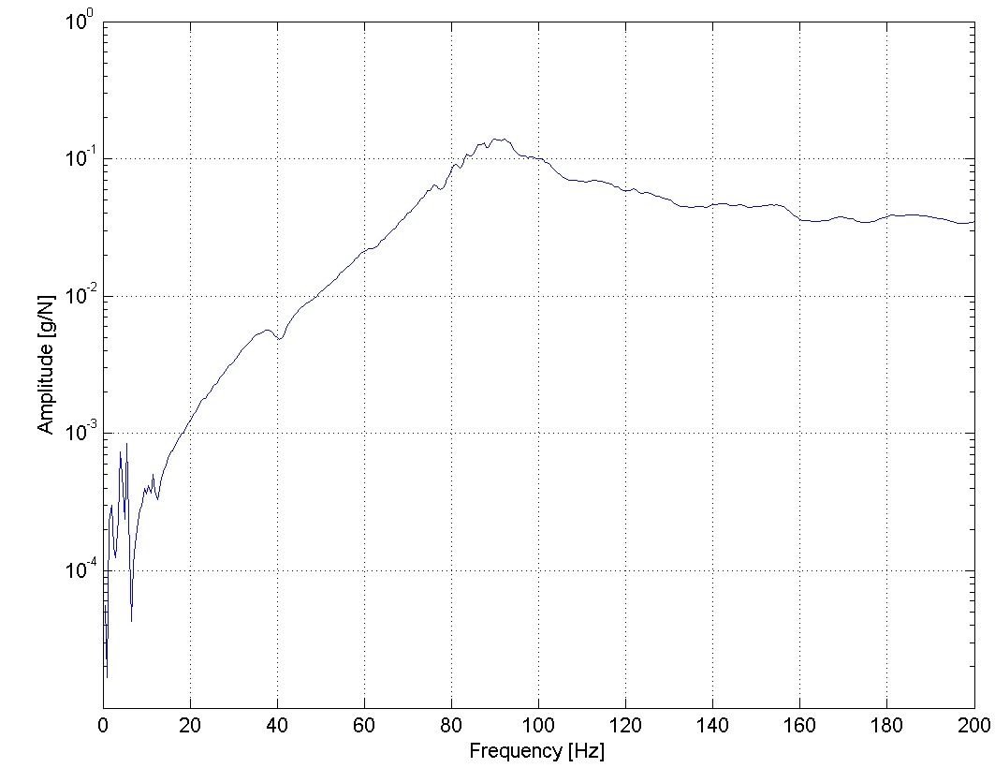
Figure 4 Transfer function for the "back panel"
In order to find a way to remove the irregular booming sound, exploring excitation tests were performed on several parts of the wheels, hubs and driveshafts to find an excitation which would lead to the amplification of the back panel. The driveshafts had proven to be of major importance to the vibrations of the panels during shaking/excitation experiments on the stands. We decided a road test was to be performed with both the left and right driveshaft assemblies in the front removed.
A big reduction in the interior cabin noise was achieved. Figure 5 shows a far smoother Sound Pressure Level (SPL) than the original one, increasing almost linearly with speed, as is desired. The sudden increases at 20 and especially at 25 to 35 km/h are removed. A reduction of up to 7 dBA is seen between 30 and 35 km/h.
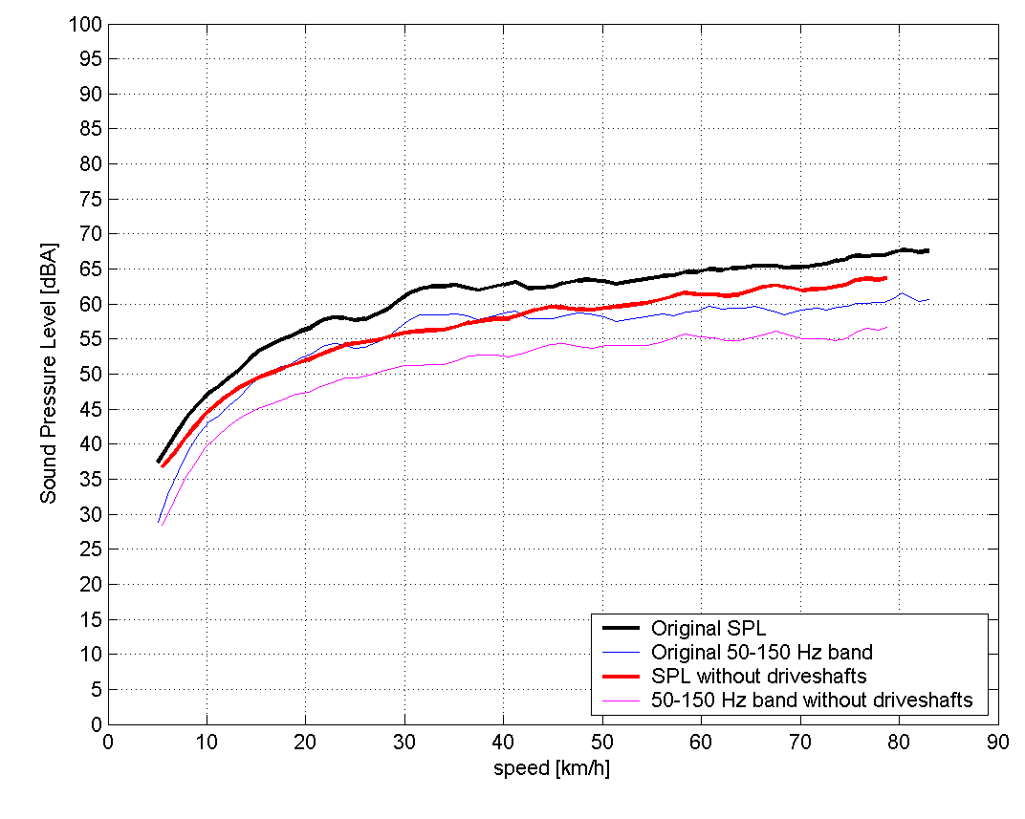
Figure 5 Sound Pressure Level with and without drive shafts

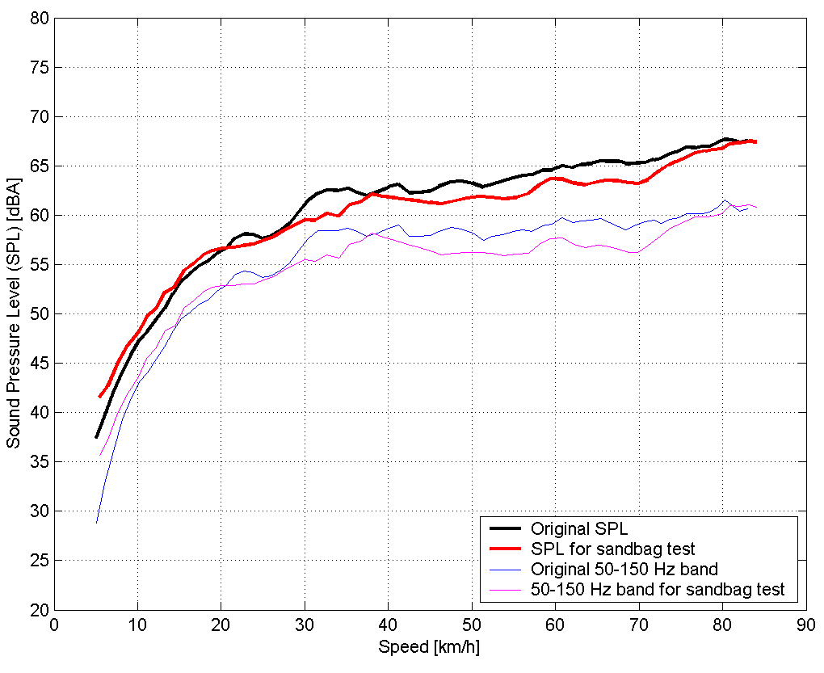
For a cheaper and more practical solution for Ford we tried to fight the symptoms and prevent the back panel of the car’s cabin from vibrating and converting it into noise in the cabin. A roadtest was therefore performed with 3 sand bags in the load box pushed firmly against the back panel. Figure 6 shows the resulting Sound Pressure Level at the passenger’s inner ear compared to the SPL without sand bags but with driveshafts. The sudden increase at 25 to 32 km/h is reduced. A reduction of about 4 dBA, which is perceptible, from 30 to 35 km/h was achieved.
Figure 6 Sound Pressure Level plot with and without sandbags against the back panel

It is clear that a part of the booming noise level can be fairly easily diminished by fixating the back panel of the car.

5. Conclusion & Discussion
Without the driveshafts, an overall “clearly distinguishable decrease” of noise, defined as 5 dBA or more, was established. The test showed that the drive shaft assemblies play a major role in creating and conducting the booming and overall noise in the cabin. However, there is not enough evidence to confirm or reject the hypothesis completely. There was only one Bantam available for a limited amount of tests. In the time of investigation the removal of the driveshafts was the first choice after the excitation tests. But the same type of driveshaft in the Ford Fiesta does not create the same problem. The manual line of fabrication in South Africa and the acoustical characteristics of the Bantam cabin are also an important issue to this problem. Other parts of the chassis or driveshaft assembly not yet investigated could also very well contribute to the noise.

6. Recommendations
More detailed and professional research is needed in order to truly adopt or reject the hypothesis. Investigation will need to be done concerning the actual assembly of the driveshafts in South Africa, the influence of (different) gears during Run-up tests, different Bantams alltogether and different tyres, suspension and driveshafts. A simulation of the problem in the lab, with excitation on a stripped chassis and driveshaft assembly will also give valuable data.

