Onderzoek opdracht
Werktuigbouwkunde / Maritieme Techniek
Toegewezen aan: Stefanie Lunshof, Diederick Nierstrasz, Albert Rijkens, Karel Wagner

Nr  07-068 SH | Sectie opdrachtgever  SH |  | Naam opdrachtgever  Ir. P. Naaijen |  |  | Datum  Aug 05
Titel | Brandstofbesparing dmv kite-voortstuwing
Trefwoorden | Kite, brandstofbesparing, hydromechanica, duurzame voortstuwing
Inleiding | Stijgende olieprijzen geven aanleiding tot nader onderzoek naar alternatieve voortstuwing. In dit kader wordt bij SH een afstudeeronderzoek naar windvoortstuwing voor commerciële schepen dmv kites (vliegers) gedaan. Dit onderzoek moet uiteindelijk leiden tot een voorspelling van de lange-termijn opbrengst van kite- hulpvoortstuwing.
Vraagstelling | Bij een gegeven snelheid zal een kite een bepaald percentage van de oorspronkelijk (zonder kite) benodigde stuwkracht kunnen leveren. Wat betekent deze procentuele bijdrage aan stuwkracht uiteindelijk concreet voor de brandstofbesparing ?
Uitwerking en eisen | Inventarisatie van relevante aspecten die bij kite- hulpvoortstuwing van invloed zijn op het brandstofverbruik.  Quantifiseren van de brandstofbesparing aan de hand van deze inventarisatie.
Opmerkingen

Begeleiding | Naam | Sectie |  | Tel | E-mail
Begeleiding | P. Naaijen | SH |  | 81570 | p.naaijen@3me.tudelft.nl  is in september enkele weken weg.
Begeleiding | V. Koster | SH |  | 06-54213054 | V.Koster@student.tudelft.nl

Master Thesis Project

Ship Hydromechanics

Traction Kite Propulsion

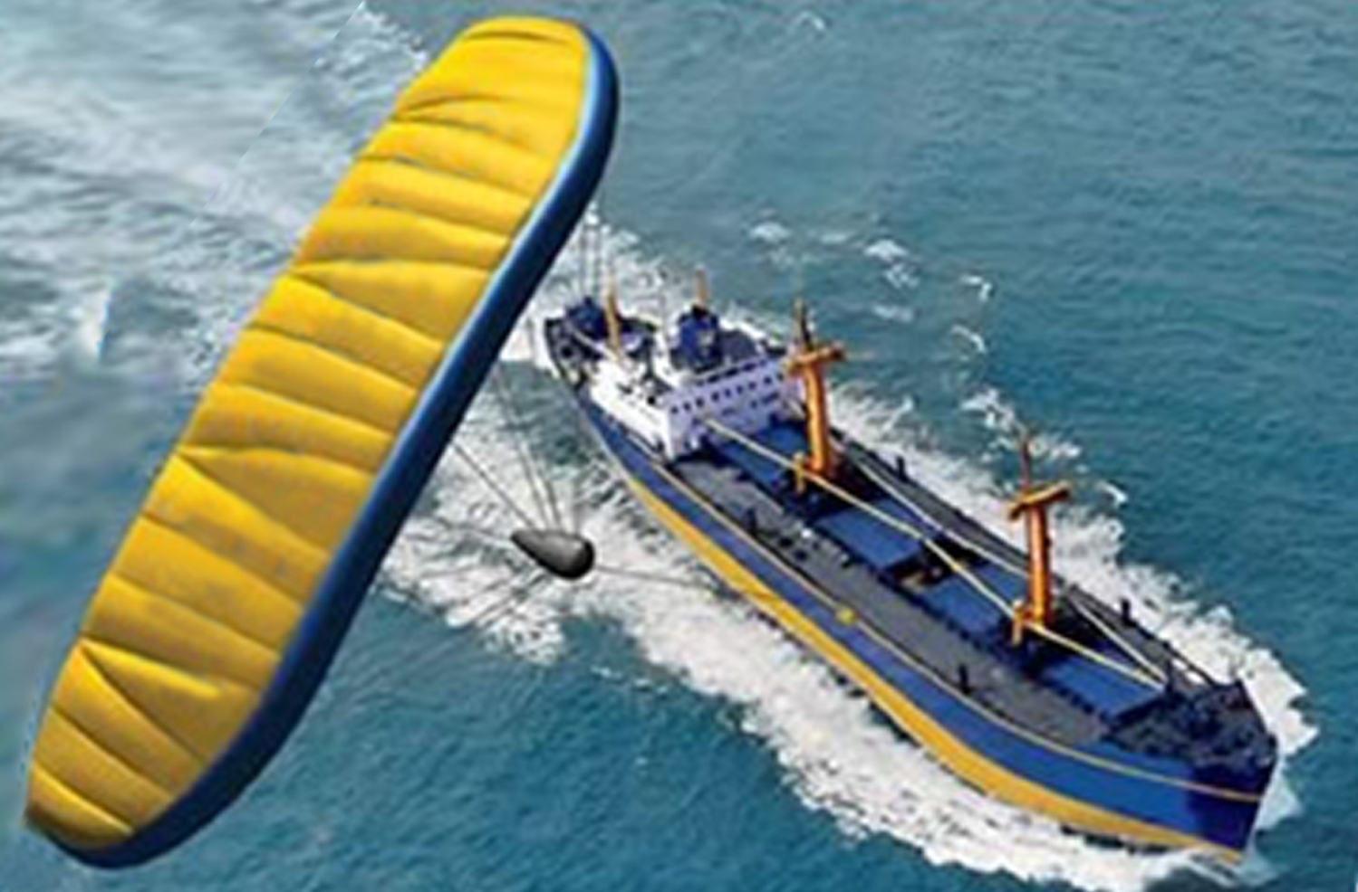

Introduction
These days, with historic oil price records being broken on a weekly basis, renewed interest in sustainable energy solutions results in interesting concepts. One of these concepts is the traction kite propulsion system for commercial ships which is being worked on by various parties in industry.
How much is the deliverance of such a system ? Is it worth the investment ? In order to answer these questions and to assess the possible long term benefits of wind propulsion by means of traction kites, a performance prediction has to be made. This means fuel savings at any desired forward speed under all weather conditions are to be predicted. This performance prediction will be used to do voyage simulations resulting in the long term benefits of the system.
This research project is already being worked on at the hydromechanics section by graduate student Vincent Koster. The result of this Bsc research assignment will be incorporated in the overall project.

Task description
The task of the Bsc students will be to quantify the relation between auxiliar towing force provided the kite and the amount of fuel saving.
Given the amount of towing force (as a percentage of the original required thrust without kite) and its direction, the amount of fuel saving has to be determined.
Therefore a case-ship will be examined for which a limited number of sub-cases will be studied. These sub-cases differ in the amount of towing force provided by the kite and the direction of the towing line with respect to the forward speed direction. See Error: Reference source not found to Error: Reference source not found for sketches of the different subcases.
A first idea for some cases to look at is given in Table 1. However, gained insight during the project may give reason to examine other combinations.

Case | Kite thrust in direction of forward speed [% of original towing force without kite] | Towing line angle γ [deg]
1 | 10 | 0
2 | 10 | 15
3 | 10 | 30
4 | 10 | 45
5 | 25 | 0
6 | 25 | 15
7 | 25 | 30
8 | 50 | 0
9 | 50 | 15
Table 1
For a case ship, students preferably look for a relatively slow ship, e.g. a crude carrier, and find all needed characteristics on the propulsion system / hull hydromechanics. (For a slow ship, relatively higher benefits from wind propulsion can be expected.)

Contact information

Peter Naaijen
Room 7-0-119
Tel. 81570
P.Naaijen@3me.tudelft.nl

Vincent Koster
Tel. 06-54213054
V.Koster@student.tudelft.nl

