Onderzoek opdracht
Werktuigbouwkunde / Maritieme Techniek
Toegewezen aan: (niet invullen)
Nr  12-400 | Sectie opdrachtgever  Engineering Dynamics |  | Naam opdrachtgever  Van Woerkom |  |  | Datum  Aug 05
Titel | Pulse-peeling pipe-perils
Trefwoorden | Dynamics, finite elements, launcher, modal analysis, propulsion, rupture, vibrations
Inleiding   | Some 100 years ago Jules Verne proposed the use of a canon for launching men to the Moon. Some 40 years ago Gerald Bull experimented with a canon with a superlong barrel to launch satellites around the Earth (project HARP). These were sort of scaled-up versions of canon more commonly used by the military.  One general concern with the design of a slender barrel is the risk of peeling of the pipe under the time-varying loading caused by the combustion pulse (see photo, below). As a result, both man and payload are at risk.
Vraagstelling
The basic questions we pose in this preliminary investigation are: how do the equations of structural dynamics look for a simple cylindrical pipe; how can the internal pressure field (due to combustion) be modelled as a prescribed input function; how large are the dynamic loads on the structure due to that pressure field and also due to contact between payload and spin-stabilizing grooves in the barrel; should the barrel be designed based on dynamic analysis or would quasi-static design be sufficient?
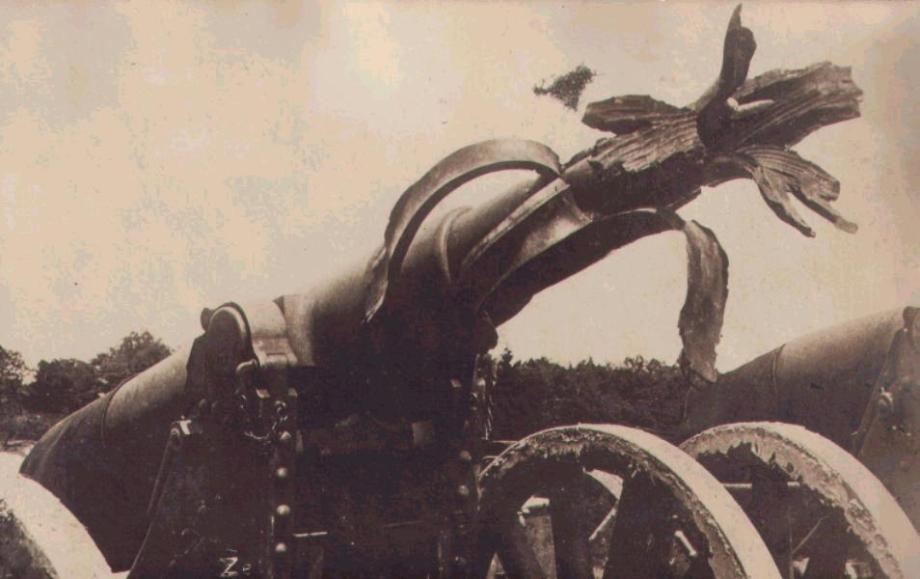
Ruptured canon barrel

Uitwerking en eisen | The investigation should be conducted along the following lines:  - formulate the dynamics of a thin cylindrical pipe subjected to radial and axial loads;  - model the pressure pulse produced by combustion at one end of the pipe;  - determine the transient structural loads generated by pressure pulse and groove interaction, through model analysis;  - compare these loads with loads obtained from quasi-static analysis;  - build a finite element model in Ansys;  - establish validity and practicality of the modal analysis through comparison with Ansys output;  - propose a test facility for hardware experiments.
Opmerkingen | Carrying out actual and adequate hardware experiments is beyond the scope of the present study – for technical, operational and financial reasons. However, the students should arrange to meet experienced firing range specialists for in-depth discussion of their findings and of their proposed test facility
Begeleiding | Naam | Sectie |  | Tel | E-mail
Begeleiding | Dr.ir. P. van Woerkom | Eng Dyn |  | 82792 | p.vanwoerkom@3me.tudelft.nl
Begeleiding | Ir. B. Heru Utomo | Eng Mech  TNO-PML |  | 86512 | b.d.heruutomo@3me.tudelft.nl  beate.heruutomo@tno.nl

