Friction behind the eye
12-384
Dampening and stiffness between sclera and Tenon’s capsule

Sietze Akkerman (1100939), Chris Bogaard (1151053), Frans-Willem Goudsmit (1101161), Joris Moerkerken (1132725)
Summary
The fat immediately behind the eye follows approximately 50% of the eye rotation. Presumably, a fluid-interface layer facilitates the required sliding. To incorporate this layer in our Delft Finite-element Model of Orbital Mechanics (DFEM), we measured the friction in passive rotation of the eye of a pig, shortly after its death. Time of oscillation decreased from 0.61 to 0.55 seconds and the amplitude decrease of the pendulum changed from linear (free movement) to polynomial (with eye attached). Subsequently we developed and validated a lumped model. We determined stiffness and dampening of the orbital fat and the fluid-interface layer. The dampening and stiffness coefficients were found to be respectively 92.8 μNm∙s/rad for the damper and 1.93 mNm/rad for the spring.

- Introduction
The suspension of the eye in the bony orbit is still an unknown issue. The eye is pulled back in the pear-shaped orbit by four straight eye muscles, while it is supported by and slides over orbital fat. The supporting roll of the orbital fat has been underestimated in previous lumped models. Such complex suspensions require a model with six degrees of freedom which can only be done by a finite element model (DFEM²). In previous measurements on pig-eyes the elastic shear modulus was found to be 500 Pa and viscous shear modulus 200 Pa¹. In a subsequent MRI-experiment the degree of deformation was found to be such that the fat follows approximately 50% of eye rotation.
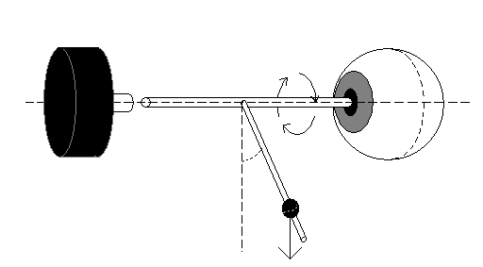
Mechanical characteristics of the sliding-layer are unknown. In previous measurements⁴ the quasi-static (a series of isometric) passive rotation of the eye with muscles attached and later detached were determined. Presumably, a fluid-interface layer facilitates the required sliding; this layer between sclera and Tenon’s capsule probably contains synovial fluid (Fig. 1a).
Incremental angle encoder
Eye
Figure 2) Pendulum axis with incremental angle encoder, attached to the eye.
θ(t)
m
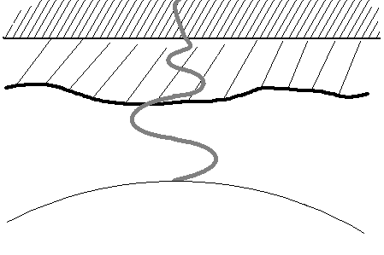
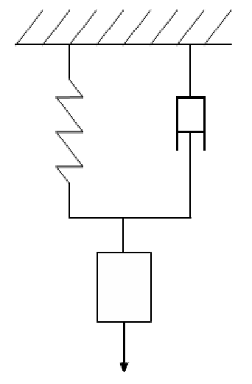
To incorporate this friction in our DFEM, we measured its mechanical characteristics. We also developed and validated a lumped model of the mechanical properties of this layer and deformation of the orbital fat. From the dampening and stiffness we could determine various types of friction. Our hypothesis is that the friction is low to facilitate large-amplitude and fast eye movements all day long. A non-Newtonian fluid-interface layer and shear thinning was surmised.
Figure 1a) Left: Schematic representation of the displacement behind the eye parallel to the rotational axis.
Figure 1b) Right: Kelvin-Voigt Model of this representation.
Fluid-interface layer
Orbital fat
Tenon’s Capsule
Sclera
Optic Nerve
I
M(t)
Eye
Bone
- Methods
The experiments were done on four eyes of two dead pigs; the heads were obtained from a meat processing facility. Twenty measurements were done, all 20 to 50 minutes post mortem. A pendulum axis (diameter 2 mm), mounted in two ball-bearings (2x5mm), equipped with a perilimbal suction ring (12 mm inside diameter and 14 mm outside with 30 holes in it, 0,5 mm diameter each) sucked on the conjunctiva (not the cornea itself) with a pressure of 0.5 bar. The shaft position of the pendulum was measured by an incremental angle encoder (internal friction: 3 Nmm). The shaft position of the pendulum decreased over time because of the internal friction of the device (incremental angle encoder and bearings), friction between muscles, sclera and Tenon’s capsule, the viscosity of the fluid-interface layer and the orbital fat and the deformation of the orbital fat. The measurement was repeated after detachment of the eye muscles from the eye and, as a control, free movement (detachment of the eye) to determine the internal friction of the device.

To look at the significance of drying of the eye and its surroundings, we also dropped a little amount of water on the eye and then measured the difference without water dropping.
We modeled the eye movements with simulation models (Simulink, Matlab) to describe the mechanical characteristics of the fluid-interface layer and the orbital fat (Fig. 1a & 1b). We tested different Maxwell elements and various linear and non-linear dampers as a model for the fluid layer. The models were evaluated with the measurements on eyes.
- Results
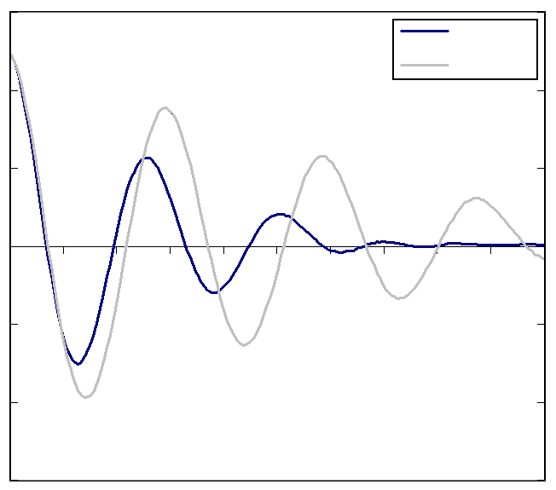
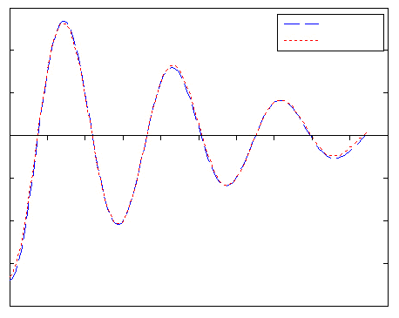
The internal Coulomb friction of the device (pendulum, -axis, ball bearings and incremental angle encoder) was found to be 99.4 μNm and viscous friction 33.3 μNm∙s/rad. The measurements showed that the time of oscillation with free movement was 0.61 seconds and the amplitude of the pendulum decreased linear. With the eye attached the time of oscillation was 0.55 seconds and decreased in the time to 0.50 seconds and the amplitude of the pendulum decreased polynomial. The difference between measurements with eye muscles attached and later detached was small. The measurements at the end of the pendulum did not always fade out at zero degrees, due to an amount of stick-slip in the encoder.
Figure 3) Graph with results of the experiments, both measurements with (n=8) and without (n=4) an eye.
Time (sec)
Angle (degrees)
15
0
-15
1,0
2,0
Free
Eye
Angle (degrees)
Time (sec)
Figure 4) Example of one fit between a measurement and a Kelvin-Voigt model.
15
0
-15
1,0
2,0
Model
Exp.
The values of the measurements (Fig. 3) were taken into our lumped model to determine the friction coefficients behind the eye. The experimental data were used to fit the parameters of the models, with a least squared fit optimization algorithm. After the parameter fit (Fig. 4), it was found that the Kelvin-Voigt element (Fig. 1b) best suited the measurements. In this model I is the inertia of the total system (the pendulum, the pendulum axis and the eye) and M(t) the moment on the eye. The dampening and stiffness coefficients were found to be respectively 92.8 μNm∙s/rad for the damper and 1.93 mNm/rad for the spring.
The influence of dropping water into the eye turned out to be significant. The amplitude decreased faster and time of oscillation was shorter when dropping a few drops of water in the eye in comparison to the other measurements. We compared the first and last measurements on one eye without dropping water (time elapsed: 20 minutes) and did not see a difference.
- Discussion and conclusions
We could confirm that friction is low, we cannot prove that the fluid-interface layer is non-Newtonian although it is likely to be the case. The fact that the time of oscillation decreased together with amplitude indicates an increasing coefficient of dampening at lower speed, similar to the decrease of viscosity found at higher speeds of deformation (shear thinning) in the orbital fat and fluid interface-layer.
Comparison of our result with values obtained from earlier analysis⁴ showed that for the stiffness coefficient their value was a factor 1.29 higher. Their experiment described a horizontal rotation; therefore it is likely that the translation of the optic nerve which deforms the fat causes this difference. The stiffness coefficient was also compared with another earlier analysis⁵. In this case their value was a factor 1.73 higher. The major part of this difference was likely caused by the attached muscles in the last analysis.
The lumped model seems suited for modeling the mechanical characteristics of the fluid-interface layer between Tenon and sclera.
Because little is known about the fluid behind the eye and the fat is anisotropic¹, it is difficult to say what part of the friction can be attributed to the fluid and what part of the deformation to the fat.
The amplitude and shortening of the time of oscillation after dropping water onto the eye is presumably because of washing away the fluid-interface layer. So dropping water has a side effect which effects the measurements. We saw no effect of drying however so eventually drying is not an issue in our measurements.

- References
1 Hoefnagel PPW, Schoemaker I: Viscoelastische metingen aan retrobulbair vet. Proc Bachelor Mech Engin Cong Delft, Juni 2003, WBTP 302, p344.
2 Schutte S, van den Bedem SPW, van Keulen F, van der Helm FCT, Simonsz HJ: A finite element analysis model of orbital biomechanics. Vision Res, accepted for publication.
3 Collins CC: The control of eye movements p311.
4 Mooijweer R, Faaij MAC: Passieve rotatiestijfheid van het oog.
5 Simonsz HJ, Crone RA, de Waal BJ, Schooneman M, Lorentz de Haas HAL: Measurement of the mechanical stiffness in cyclotorsion of the human eye. Vision Res, vol.24, no.9, p961-967, 1984.

