Communication and Cooperation in Multi-Agent Systems for Robot Soccer
12-395

Stefan Taal (1099442), Thomas Poiesz (1156144), Alex Verbart (1133659), Menno Ronde (1151495)

Abstract
In this paper we consider communication and cooperation in multi-agent systems. In particular we consider the domain of robot soccer, where there is not much cooperation present yet. We simulate the situation in which two robots of the same team try to defeat a single opponent by playing the ball to each other. Robot velocities and information transfer between robots are varied between the simulations. From the results of this research we conclude that communication of positions and tasks is required for team play in robot soccer. Furthermore, the influence of uncertainties in position determination on the success rate of fast and accurate team play depends highly on the robot velocity.

1. Introduction
A group of agents cooperating to solve a shared problem is called a multi-agent system (MAS). MASs frequently appear in the domains of, e.g., traffic and power network control. Besides that, a robot soccer tournament called RoboCup is organized as a platform for MASs research since 1997. In this domain the MAS is a robot soccer team consisting of autonomous robots that have the shared goal to defeat the opposing team. The RoboCup tournament is set up with the main goal to develop a team of fully autonomous humanoid robots that can defeat the human soccer world champion team in 2050 [1].
Although cooperation gives a strategic advantage, this rarely happens. Therefore this research focuses on improving the performance of teams by introducing team play. We consider the frequently occurring situation in which two robots of the same team try to defeat a single opponent by playing the ball to each other. We expect two factors to influence the success rate of fast and accurate team play.
The first factor deals with communication strategies. We consider four different strategies with increasing information transfer:

- No communication. This could be the case with a failing wireless network.
- Communicating positions and tasks. Only one robot tries to get the ball while the other robot does not move.
- Robot with ball tells a team mate that he can expect the ball. This team mate starts to move.
- Robot with ball tells team mate where he will shoot the ball. This team mate will go to the designated position.

The second factor deals with the uncertainties in position determination. These uncertainties depend highly on the velocity of the robots. For this reason team play will be investigated with varying velocities [2].

In this paper we test the following three hypotheses:

- With increasing information transfer in the communication strategies the number of successful passes will increase and the average time between successful passes will decrease.
- First, the number of successful passes will increase with increasing velocity. Then, it will decrease; there is an optimal velocity.
- The average time between successful passes will decrease inversely proportional with increasing velocity, since there is an inversely proportional relation between time and velocity.

2. Method
To test our hypotheses we use experiments based on simulation studies, since real robots are still not able to pass the ball to each other due to technical issues, e.g. a limited vision [3] [4] [5]. The simulations are done with Webots, a program developed to simulate robots [6]. We designed a framework for simulating soccer using Webots containing a supervisor and several controllers for the individual robots. The framework is available for further development [7].

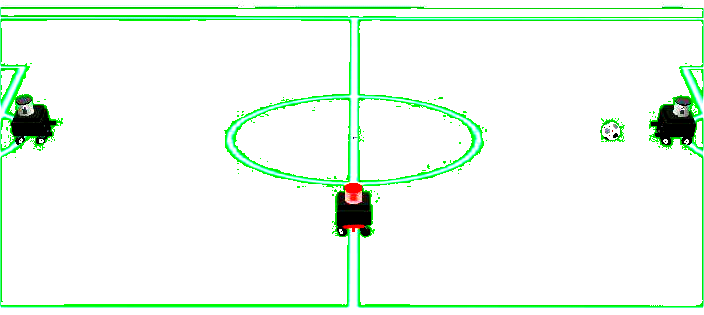
A
B
C
Figure 2.1 Illustration of a Webots simulation with the three robots in their starting positions. Robot A and robot B try to play the ball to each other while robot C tries to intercept the ball.

To determine the success rate of team play we measure the number of successful passes until the opponent touches the ball and the time between those successful passes at different velocities and communication strategies. A pass is successful if the ball reaches the other player without being touched by the opponent. Moreover, if the pass takes less than 1 second or more than 100 seconds, the pass is not counted. Those constraints are imposed to prevent unrealistic situations, e.g. when robots are next to each other or when robots are stuck in corners.
In all simulations the opponent speed is kept constant. The starting positions of the three robots are displayed in Figure 2.1. Each simulation runs at least 8 hours with at least 2000 successful passes. This gives sufficient results to compute reliable averages.
We take into account uncertainties in position calculations due to calculation time (depending on robot velocity) by introducing a delay, and camera errors by introducing a normally distributed random error to positions [3].

3. Results
The results of the simulations are presented in Figures 3.1 and 3.2. The results show that with all 4 communication strategies there is first an increase in the number of successful passes with increasing velocity, and then a decrease. The time between the passes decreases with increasing velocity, except for communication strategy 2. Furthermore, an increasing information transfer in the communication strategies leads to an increasing number of successful passes, although not necessarily to a decrease in average time between successful passes.

Discussion
Reviewing the hypotheses of Section 1, given the obtained results we notice that:

- Hypothesis 1 is only partly confirmed. The strategies 2, 3 and 4 show that an increasing information transfer increases the number of successful passes, although there seems to be no relation with the time between successful passes. From the simulations we notice strategy 1 produces a completely different behaviour: there was no realistic cooperation since both robots were chasing the ball continuously.
- Hypothesis 2 is confirmed. Indeed, for all strategies the number of successful passes first increases and then decreases with increasing velocity.
- Hypothesis 3 is not confirmed. For the strategies 1, 3, and 4, the time between successful passes decreases with increasing velocity, although not exactly inversely proportional, since there is an influence of uncertainties related to the robot velocity. Strategy 2 does not show this relationship: there is a sudden increase in time between successful passes due to a strong increase of successful passes where the robot with the ball has to drive around its opponent. In strategies 3 and 4 the team mate moves along with this robot allowing more space for team play.
Figure 3.1 Successful passes versus relative velocity under different communication strategies.

Figure 3.2 Time between passes versus relative velocity under different communication strategies.

5. Conclusions
Communication is required for team play in multi-agent systems. Increasing the information transfer leads to better results. For robot soccer, a higher velocity than the opponent increases success at first, although this also increases uncertainties, which will ultimately prevent successful team play; each RoboCup team should therefore find its own optimal velocity.
The developed framework is a good start for team play simulations for RoboCup teams. It quickly provides a good first impression before modifications are implemented in real. The framework however is still very basic. At this moment image processing is modelled by sending positions to the robots. Also, the controllers are still basic and assume perfectly working actuators and sensors. We noticed Webots itself still has some bugs and shortcomings mainly since it is based on numerical approximations.

6. Future research
In future research our framework for simulating robot soccer can be directly used and optimized, e.g. for simulating team play with different ball velocities and with different opponent velocities. The framework can also be extended with more robots in order to simulate two full teams. For optimization one can think of, e.g. implementing full image processing and a more realistic driving system
Other research areas could be the relation between different communication strategies and the influence of uncertainties on successful team play.

References
[1] The official RoboCup website, http://www.robocup.org/.
[2] R.R. Negenborn, Robot Localization and Kalman Filters, Msc. Thesis, University of Utrecht, 2004.
[3] J. Caarls, Fast and Accurate Robot Vision for Vision based Motion, Msc. Thesis, Faculty of Applied Physics, Delft University of Technology, 2000.
[4] A.M. van Driel, A Self-Calibrating Vision System for Soccer Playing Robots, Msc. Thesis, Faculty of Applied Physics, Delft University of Technology, 2004.
[5] J.-H. Kim, Soccer Robotics, Springer-Verlag Berlin Heidelberg, 2004, ISBN 3-540-21849-9.
[6] Webots website, http://www.cyberbotics.org/.
[7] The source code of our developed framework, http://home.planet.nl/~poies009/framework.zip.

