


Peristaltic Compressor

T.B. Bakker (wb1051946), B.C. Haverkamp (wb1053108) and R. Jorritsma (wb1063170)

Abstract
A research has been done to determine whether peristaltic compression is a useful method in large-scale heat pump systems. Therefore a simulation- and a test model have been created, resulting in good insights in the working principles. Although the peristaltic compressor in its current configuration is not suitable for heat pump systems the working principle itself offers potential for further research.

Introduction
In the search for alternative energy sources, heat pump systems have been the object of research during the last decades and many successful applications have been developed. However, these systems have not yet been implemented in large-scale systems. One of the technical challenges that arise when designing such a system is finding an appropriate compressor, which is capable of achieving the necessary flow rates wat voor flow rates precies? Wat stroomt er? Een vloeistof? at satisfactory efficiency.

In that light this research has been performed into the workings of a new kind of compressor called peristaltic compressor. It sets as goal to determine the efficiency of such a system and determine whether it can be used in large-scale heat pump systems.

Hypothesis
The peristaltic compressor has an efficiency that is competitive hoe quantificeer je “competitive”? definieer de grenzen waarbinnen iets competitive is. with existing alternatives and will maintain this level of efficiency when used in large-scale heat pump systems.

Working principle
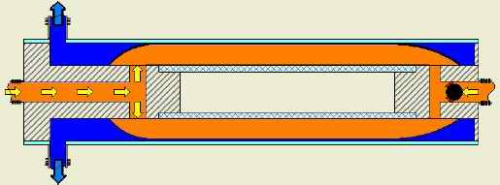
Outer Tube
Inner Tube
Bladder
One-way valve
Gas Outlet
Gas Inlet
Water Inlet/Outlet
Figure 1: Schematic overview of working principle.
Vragen figuur: fungeren beide blauwe pijpen zowel als inlet als als outlet, of is de bovenste altijd de inlet en de onderste altijd de outlet?

The peristaltic compressor, Fig. 1, (naar alle figuren moet in de tekst worden verwezen) uses water pressure to compress gas. Two streams allebei water, of 1 water en 1 gas? flow through the system separately. The device consists of two concentric tubes, with various inlets and outlets, and a flexible skin called the bladder. A three-way valve waar zit die in het plaatje? In het plaatje wordt alleen over een 1-way valve gesproken. Ik begrijp niet waar die voor dient. connects the water inlet/outlet to respectively a high-pressure water source or an atmospheric outlet.
The working cycle is split up into two strokes; the intake stroke and the compression stroke. During the intake stroke the three-way valve is set to outlet, allowing the water to flow out of the system and make way for the gas, that will flow in to the bladder due to overpressure at the gas inlet. During the compression stroke the three-way valve is set to inlet, causing high-pressure water to flow into the system and force out the gas that is trapped in the bladder. Wat is hier nu peristaltisch aan?

Method
In order to test whether the isentropic efficiency of the peristaltic compressor is competitive onduidelijk word.. with existing alternatives, a simulation model was built (als je zegt “is built”, dan ben je nog bezig met bouwen) in Matlab Simulink. In this model parameters such as in- and outlet pressures, stroke frequencies and temperatures can be varied. With the knowledge gained from this model, a test model was designed and build to test and compare results from simulation with reality. A 2-meter long, 60mm round Perspex tube was used as base for the peristaltic compressor. Thermocouples, pressure transducers and flow meters where attached to measure all the needed values. Since the test results of the experiment showed that the simulation model gives an accurate description of the systems behavior, it’s data van het model of van de opstelling? data can be used to predict performances of hypothetical hoe bedoel je “hypothetical”?? systems. (For the simulation model and detailed test model drawings, see “Study on the working principle of peristaltic compressor”(2005))

Vraag: wat hebben jullie van het bovenstaande nu precies zelf gedaan, en wat was er al aanwezig? Maak dat duidelijk in de tekst.

Results
The system welk system? De gemodelleerde peristaltische compressor? has been checked on three performance criteria consisting of mechanical efficiency, overall efficiency and system capacity.
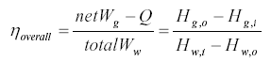
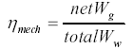
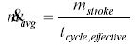
Wat betekenen de symbolen? Leg ze allemaal uit, Aan formules waarvan ik de betekenis niet kan achterhalen heb ik niets. Operating conditions zoals? and system parameters zoals? influence the performance criteria. The system dynamics are influenced greatly by the relationship between the gas-pressures over the head loss wat is “head loss”? of the water, known as reduced pressures. Heat transfer over the bladder influences the overall efficiency and is related to heat transfer coefficient k_{q}. In de uitleg onder “working principle” heb je het helemaal niet over warmteoverdracht gehad. Het gaat daar alleen maar over de pompwerking. Hoe zit het met die warmteoverdracht? Leg uit bij “working principle”.
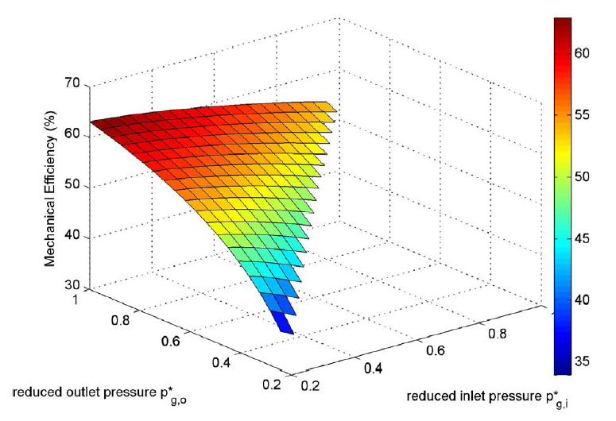
Figure 2: Mechanical Efficiency as a function of inlet/outlet pressure Is dit de waterdruk of the gasdruk? Welke efficientie is dit precies in de formules op de vorige bladzijde?Uitleg van symbolen nodig.

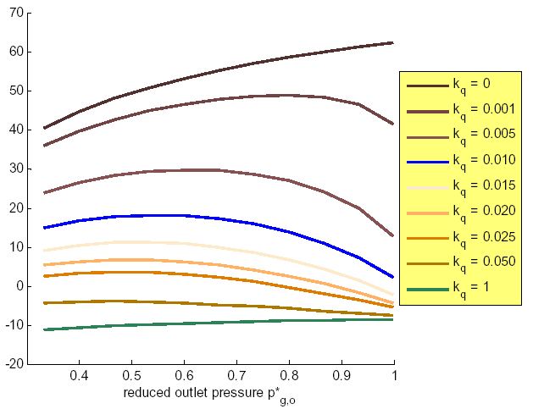
Figure 3: Overall efficiency as a function of reduced outlet pressure
Uitleg van symbolen nodig.. Wat is Kq?deze varuiabele staat niet in de formules op de vorige bladzijde.
Wat is verder het verschil tussen “mechanical efficiency” en “overall efficiency”? meer uitleg nodig.

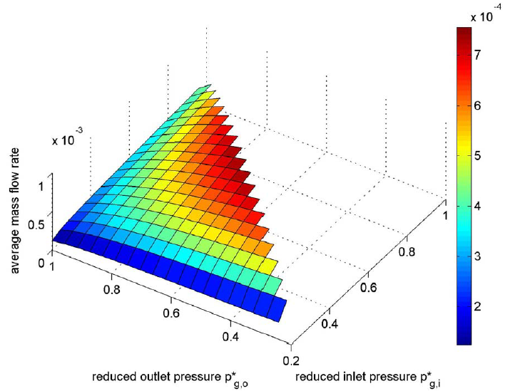
Figure 4: Average mass flow rate van het gas of het eater? as a function of inlet/outlet pressure van het gas of het water?

As shown in Figures 2, 3 and 4 the operating conditions must be chosen carefully to find an optimum in all performance criteria. Hoezo? Wat is het optimum, hoe kan ik dit optimum uit de grafieken allezen? Resultaten moeilijk te begrijpen. Finally the simulation has shown that increasing the stroke stroke waarvan? volume does not influence the efficiencies.

Discussion
During the experiment with the test-model a couple of remarkable results were observed. First of all there was a problem when evaluating the energy balance. The amount of energy flowing into the system during a single stroke was significantly less then the energy going out. After thorough examination this “energy-gap” is believed to be caused by a flaw in the measurements of the water temperature. Due to this the efficiency of the test-model, calculated using the measured values, is not reliable. However the experimental data could be used to test the theoretical model.
Secondly, over time, a slight decrease in internal energy of the gas-collection vessel could be seen. After performing a vessel test two reasons were determined; a small leakage in the vessel caused gas to flow out and secondly there was a drop in temperature due to heat transfer to the environment. For both reasons a correction was applied confirming the theoretical expectations. Wat voor correctie precies?

Conclusion
During the course of this research the first working prototype that uses the principle of peristaltic compression has been devised. Als dat echt zo is, maak dan duidelijk in je inleiding dat de peristaltische compressor zo nieuw is, date er nog geen voorbeelden van bestaan. Insight into the working principle was used to develop a theoretical model of the compressor. Remarkable phenomena have come to attention when this prototype and the developed theoretical model were studied. The peristaltic compressor, as looked at during this study, copes with heat transfer during the compression process. Due to this heat transfer, the compressor’s efficiency is not competitive with existing alternatives and, when used in current configuration, not recommendable for usage in heat pump systems in general. If the peristaltic compressor were to be placed in a different configuration, utilizing or eliminating the heat transfer, it could compete with the alternatives. Furthermore, increasing the dimensions does not influence the efficiency and, since the complexity of the system is minimal, it can easily be scaled up and used in large-scale heat pump systems. The peristaltic compressor in its current configuration has a couple of very distinct features and these could possibly be used for other applications.

Dus.. Is je hypothese verworpen of niet? Waar zie ik in je grafieken en in je resultaten de vergelijking met de bestaande compressoren? De basis voor je conclusie is daardoor niet duidelijk.
- Recommendations
After performing this first research into peristaltic compression it is the author’s opinion that there are two possible directions for further research.
Firstly, different configurations in which the heat transfer is utilized or eliminated can be explored. One could think of using a closed loop water stream.
Secondly, applications in which the characteristics are desired must be investigated. Examples of systems that could benefit from a system with separated streams and heat transfer between the two media are medical applications or gas coolers.

[1] Bakker, Haverkamp and Jorritsma (2005); Study on the working principle of peristaltic compression Wat is dit? Een artikel of een rapport? Geef tijdschrift, rapportnummer, aantal blandzijden, etc. op, zodat ik het met die gegevens kan vinden.
[2] Cengel and Boles (2003); Thermodynamics Idem als hierboven.

