Maxim Segeren
Nr  13-382 | Sectie opdrachtgever  Engineering Dynamics |  | Naam opdrachtgever  Prof. Daniel Rixen |  |  | Datum  Niet invullen
Titel | How good will the badminton shuttle bounce ?
Trefwoorden | Sport equipment, dynamic tests, Finite Element modeling
Inleiding  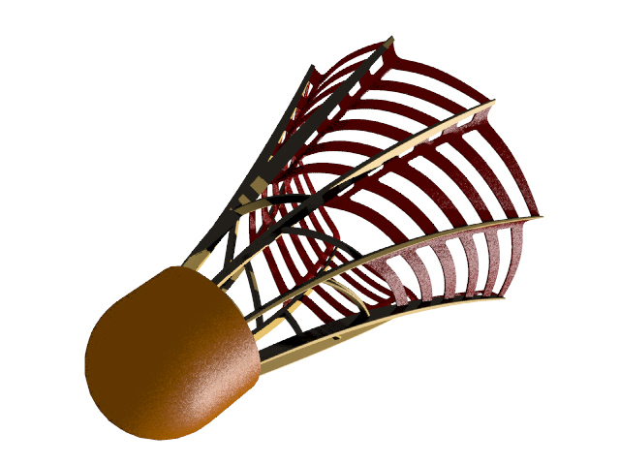 | Badminton shuttles are usually made out of cheap plastic or out of feathers. In the first case there are cheap but no fun to play, in the second they fell good for the connoisseurs but are expensive and last only for a short time during a match. A new design has been develop by Creazi colleczione (in Amsterdam). The new shuttle will replace the feather shuttles and therefore need to have similar aerodynamic and mechanical properties.  In particular it is essential that the bouncing property of the new shuttle on the net of the racquet is optimal. Therefore we want to investigate experimentally and with a finite element model the properties of different designs of the tip of the shuttle.
Vraagstelling | The basic questions we want to answer in this preliminary investigation are:  - Can we measure the impact time and the coefficient of restitution of different shuttle tips in our dynamic lab using simple tests and sensors such as accelerometers or laser?  - Can the measurements be used to compare the designs and say if their impact properties are similar to the professional feather shuttle tip.  - Can we build a simple axisymmetric Finite Element model that can predict the dynamic properties of the shuttle tip?
Uitwerking en eisen | The investigation should be conducted as follows:  - Propose a measurement procedure to evaluate the impact time and coefficient of restitution of different shuttle tips.  - Perform the impact measurements on different tips and on professional feather shuttles.  - Set up a Finite Element model (Ansys) and see if, by choosing appropriate material properties, the impact time and coefficient of restitution can be predicted within 15 % of accuracy.
Opmerkingen | Support will be provided by the Engineering Dynamics section and Creazi colleczione The candidates must have an interest in experimental testing and dynamical modeling. Information about the new shuttle design can be found on www.creazi.nl
Begeleiding | Naam | Sectie |  | Tel | E-mail
Begeleiding | Prof. dr. ir. D.J. Rixen | Eng. Mech. |  | 8 1523 | d.j.rixen@wbmt.tudelft.nl
Begeleiding | Ir. Nadine Conza | Eng. Mech. |  | 8 2701 | n.e.conza@wbmt.tudelft.nl
Begeleiding | Hanco Ravelli | Creazi colleczione |  | 020 6732626 | hanco@creazi.nl

