Onderzoek opdracht
Werktuigbouwkunde / Maritieme Techniek
Toegewezen aan: Arnoud Tukker, Peter van den Bergh, Moritz Palm, Dhiretjh Sewdoelare
Nr  13-414 | Sectie opdrachtgever  DCSC | Naam opdrachtgever  Prof.dr.ir. M. Verhaegen |  |  | Datum  Jan 2006
Titel | Cable-force measurement and control during the launch of a sailplane
Trefwoorden | Aircraft, sailplanes, force measurement, force control, winch launch
Inleiding | The most commonly used way to launch sailplanes (gliders) is the winch launch (see figure). Most winches are stationary and consist of an automotive engine and a gearbox that connects to a differential with cable-drums instead of wheels. These drums carry approximately 1200 m of steel cable. During a launch, the cable is pulled onto the drum whilst the glider goes up like a kite. Launch height primarily depends on the winch driver’s experience and feeling for the task.  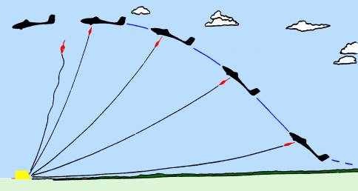
Vraagstelling | It is a known fact, that keeping the force in the winch cable constant during the launch, has several advantages: (near-) optimal launch height can be achieved, and the operator and pilot workload are reduced, hence increasing the overall safety.  Investigate different methods to actively measure the cable-force during a launch. Furthermore, investigate if it is possible to maintain a pre-set and constant cable force during a launch.
Uitwerking en eisen | Search for a low-cost and robust method to measure cable-force in the drive-line of a winch with reasonable accuracy. If possible, build a demonstrator of your concept. A simulation will also suffice if the cost of such a demonstrator are too high.  Additionally, build a simulation from equations of motion that will be made available to you, add simple engine and drive-line dynamics, and test the control method that you propose.
Opmerkingen | A real sailplane winch is available for validation purposes.
Begeleiding | Naam | Sectie | Tel | E-mail
Begeleiding | Diederick Joosten | DCSC | 86891 | d.a.joosten@dcsc.tudelft.nl
Begeleiding | Ton van den Boom | DCSC | 84052 | t.j.j.vavdenboom@dcsc.tudelft.nl

