Walking robot: better robustness with compliant legs?
13-409

Marco Blaazer (1194615), Erik Jansen (1181696), Jasper de Kruif (1178369), Martijn van Til (1181777)

Abstract: Robots walking with rigid legs are influenced by its foot impact on landing. To reduce this effect a robot is equipped with compliant legs. The influence of spring stiffness on robustness has been investigated. This has been done by varying mass at given spring stiffness. By using Adams© the boundary conditions have been determined. We expect that a robot with compliant legs will show increasing robustness with decreasing spring stiffness. Robustness has been determined by counting successful runs. Preliminary literature research determines that a gait of at least 10 steps is stable. Results show increasing robustness with increasing spring stiffness thus the hypothesis is falsified.

- Introduction
In the Delft Biorobotics Laboratory (DBL) research is carried out into walking robots. An important aspect of these robots is the so-called ‘passive dynamic stability’. This means that these robots can obtain a stable walking gait without use of an extensive control system.
The robots developed so far have been based on models with a simple walking gait. The computer models as well as the prototypes all walk with stiff legs to simplify the analysis, however, this also has drawbacks. With every step, the robot produces a large amount of impact force on the floor. This impact force is considered undesirable, because it could damage the prototype, but more importantly, it is assumed the impact has a negative influence on the robustness∗. In this paper we test this assumption by equipping a robot with compliant legs which will have a positive influence on robustness.

- Walking models
The model used by DBL so far has been the ‘simplest walker’ model, see figure 1a. This is an inverted pen-dulum, with the entire mass attached to the hip joint, the legs are rigid and massless. In Germany ‘Lauflabor’ is researching a ‘compliant spring-mass model’ , further referred to as “Lauflabor”, see figure 1b.
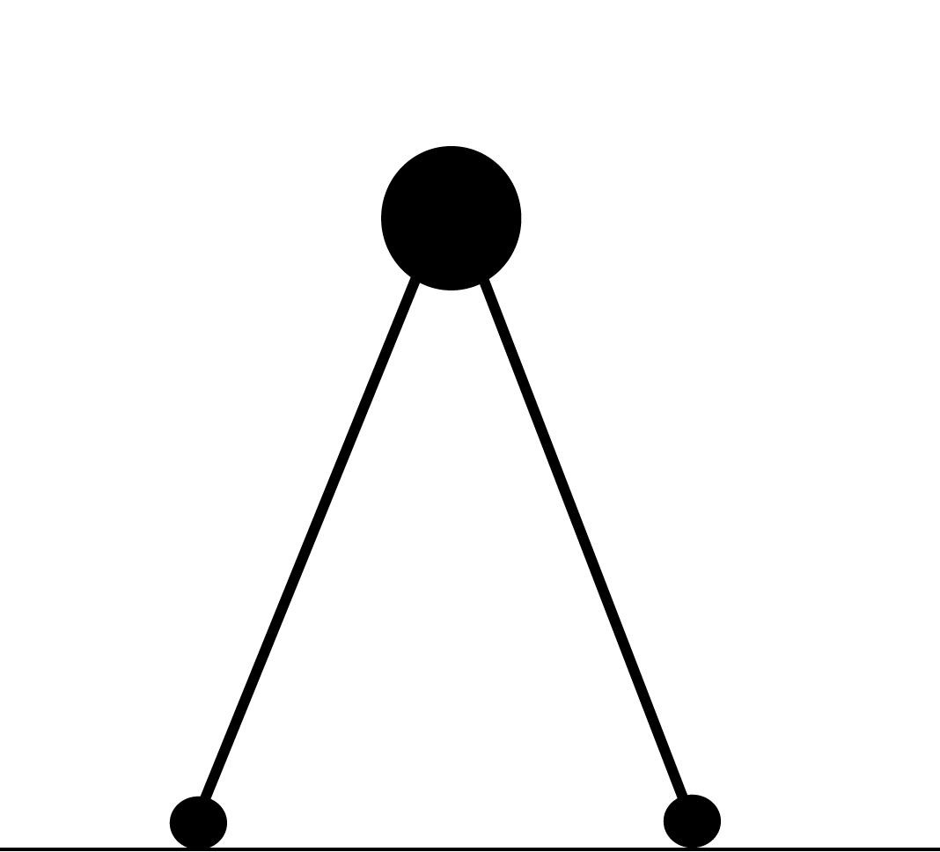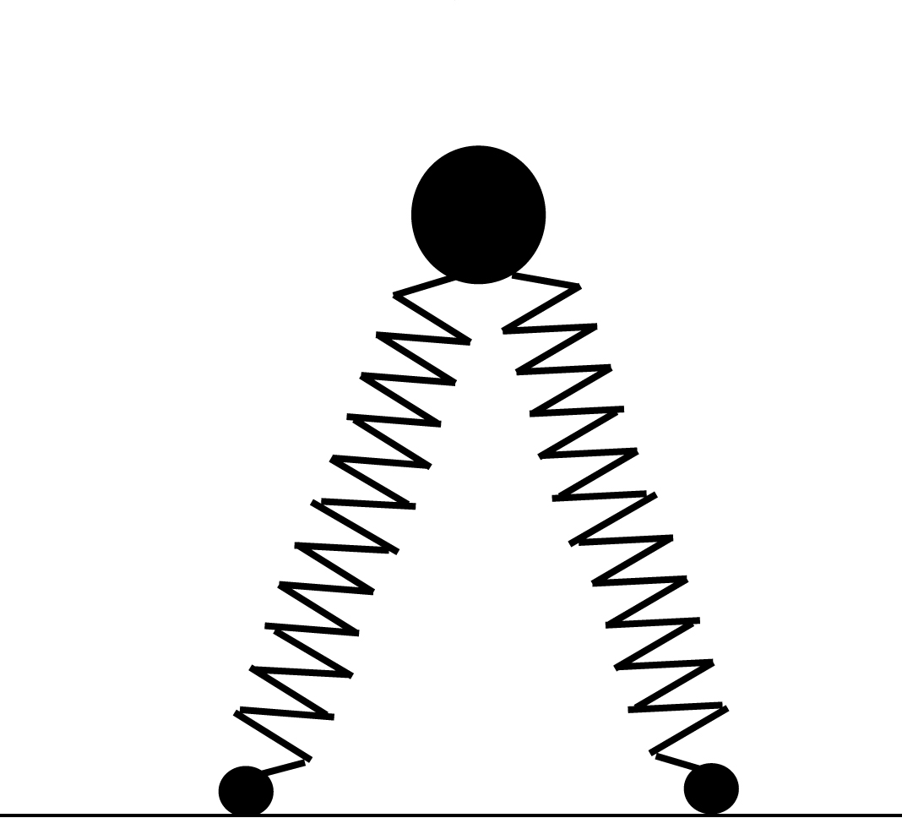
1.a
1.b
Figure 1a: Simplest Walker Figure 1b: Compliant spring-mass model
The Lauflabor research is suited as a basis of investigation for walking with a compliant gait. Lauflabor exhibits leg compliance on ground-impact and needs sufficient spring stiffness to recover. The general expectation is that with lower spring stiffness, the ground impact when walking will be smaller because of leg compliance. This leads us to posing the following hypothesis:
A walking robot with compliant legs will show in-creasing robustness with decreasing spring stiffness.

- Methodology
To investigate the hypothesis, prototype Mike weighing 4.6 kg (figure 3a) has been used. Mike is a 2D-robot which means he has four legs and cannot fall sideways. To adapt Mike to the Lauflabor model, Mike has been equipped with tension springs attached to the front side of the upper and lower legs (figure 2). This exhibits the exact same behaviour as the Lauflabor model this is represented schematically in figure 2.
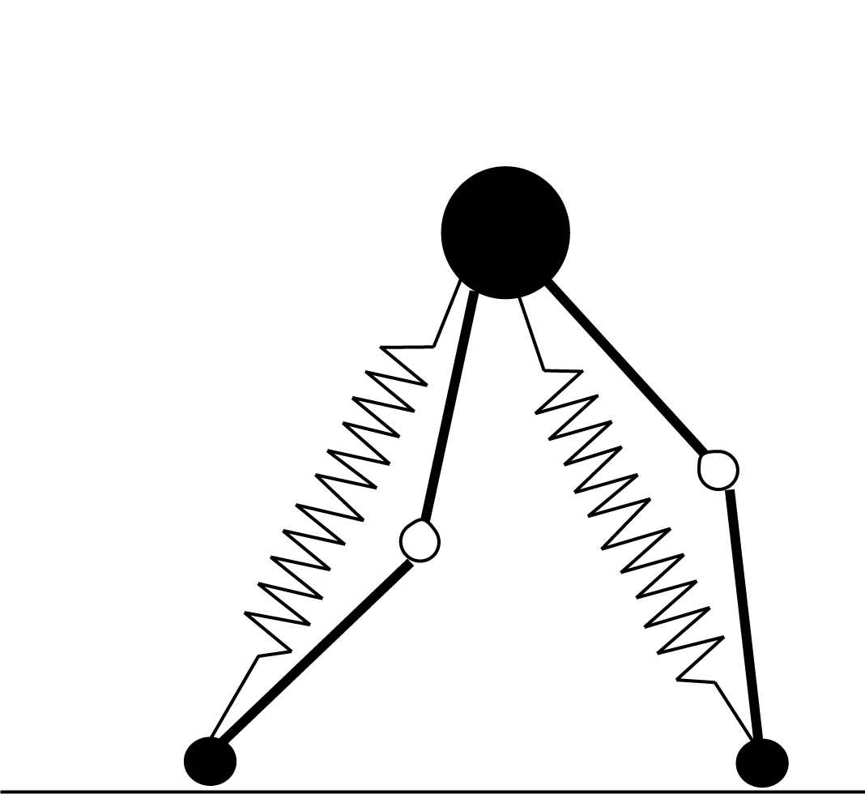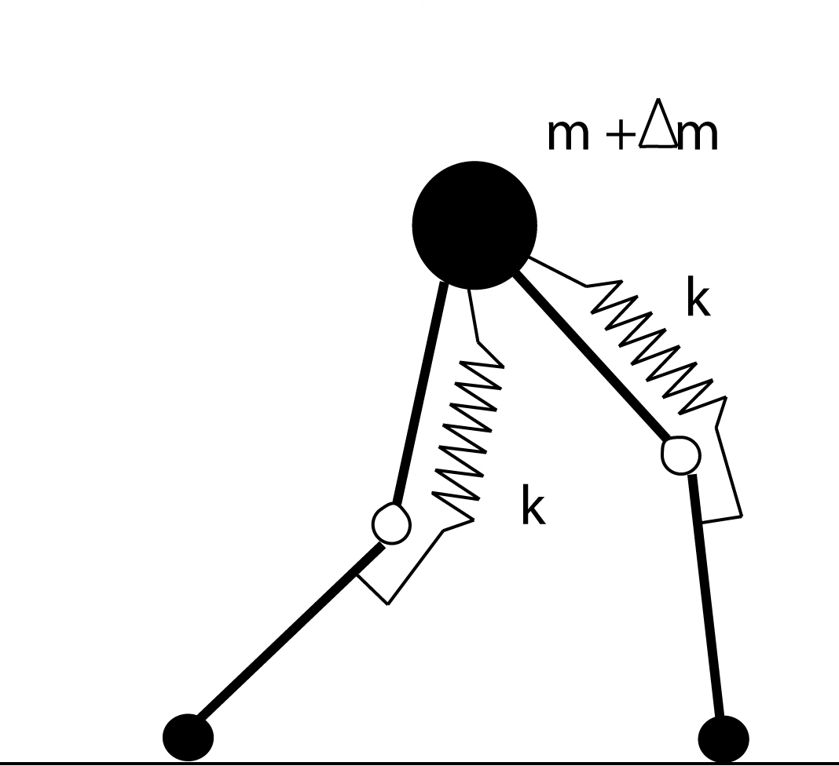
2.a2
2.b

Figure 2a: The way in which Mike complies with the compliant spring mass model. Figure 2b: The way in which Mike actually walks, compression springs replaced by tension springs on the front side.

This redesign was investigated in an Adams© simulation study of model dynamics (figure 3b). The knee-bending is limited (see arrow in figure 3a) to ensure that Mike buckles his knees, on impact, and springs back.
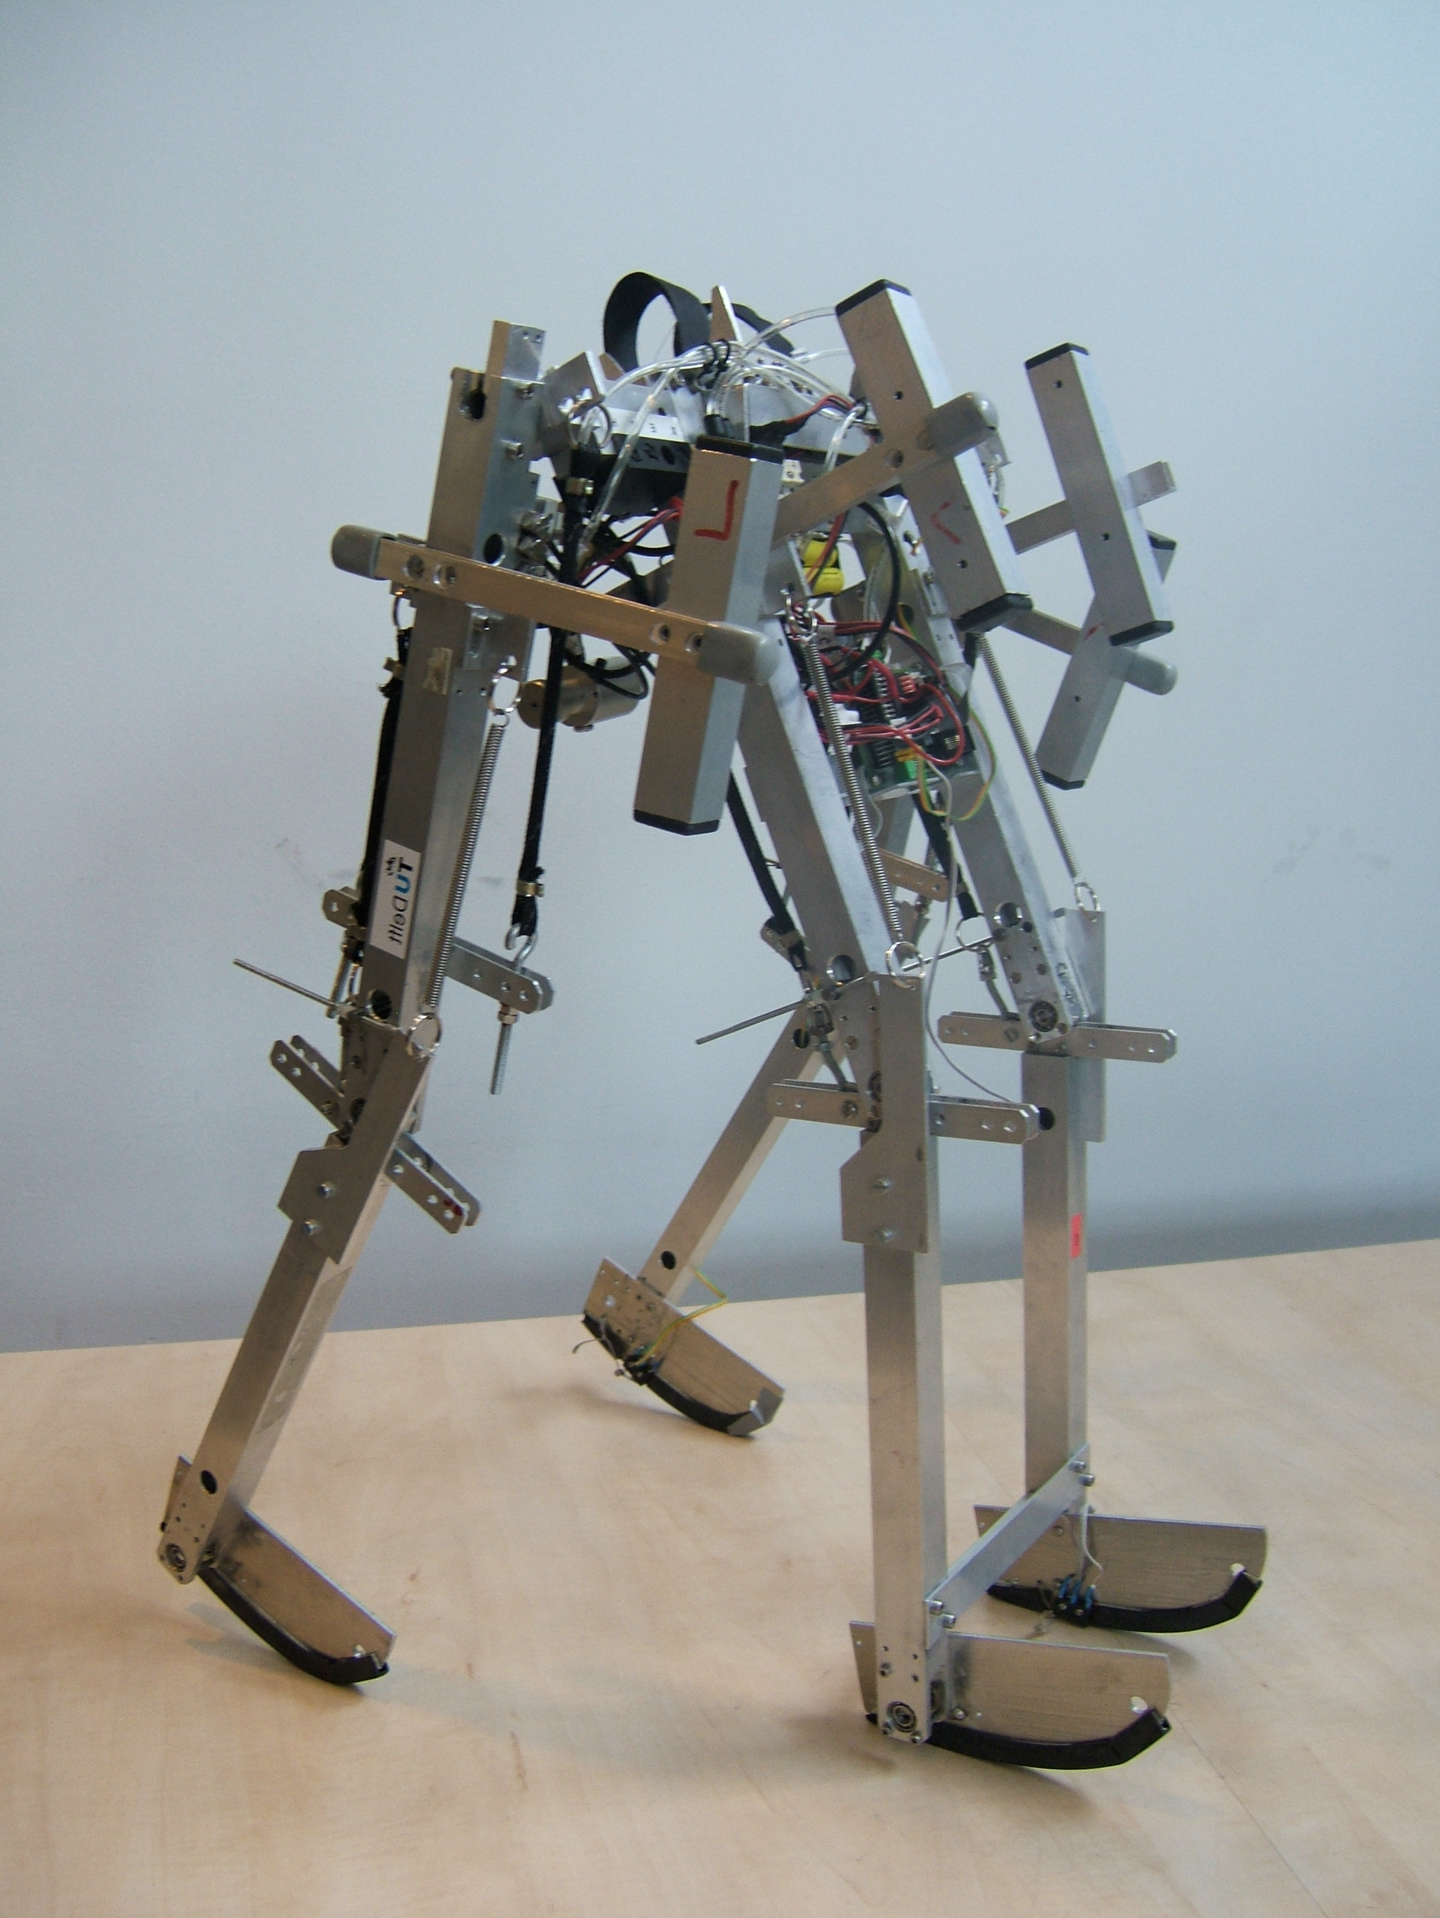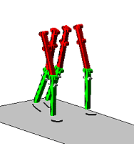
Figure 3a: Prototype Mike, figure 3b: Adams model of Mike
The simulation showed stable stepping for a maximum knee angle of 20° relative to the upper leg.

- Experiment
To investigate the hypothesis, test runs have been conducted with Mike, using spring stiffnesses within a range of 0.42 to 0.85 N/mm, determined as statically stable by the Adams© simulation, while keeping pretension force constant (20N). Experiments were not conducted in Adams©, because correct program-ming of the model controller required the use of more advanced programming techniques which were not available. For each spring stiffness, the robustness has been measured by increasing mass with 25 grams until the model shows unstable behaviour. This mass is added at the hip joint. Walking more than 10 steps means Mike has obtained a stable gait, all initial disturbances (e.g. starting push) have damped away. For each setting 5 runs are performed. The test runs are performed with the starting leg alternating between inner and outer leg.

- Results
For every stable run the success percentage increases with 20%. For example 3 runs stable within a set 5 results in 60% success.
Figure 4: percentage of success per spring stiffness and mass added
The transition lines between 0% and 100% success represent configurations for which Mike shows critical behaviour, here Mike is more sensitive to small disturbances (e.g. push-off, uneven floor, system temperature). From this data, a stability region can be drawn. Critical configurations are represented by the singly hatched region. This is presented in figure 5.

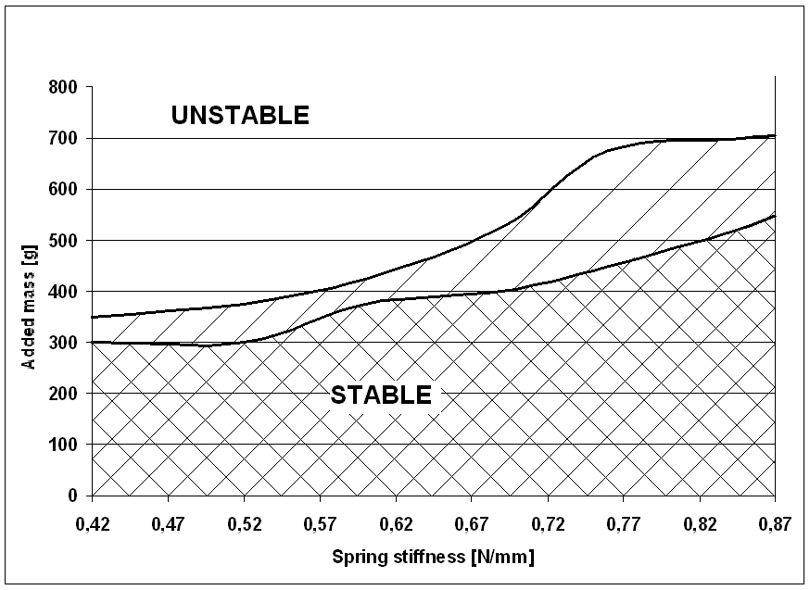
Figure 5: robustness increase with spring stiffness
- Discussion
The points between 0% and 100% success are scattered. This is caused, as expected, by initial disturbances (figure 4). With increasing spring stiffness, Mike is stable for a larger range of added mass (figure 5), this is the opposite of what was expected. Increasing spring stiffness results in a higher knee-torque, letting Mike recover more easily. Of course this does not apply indefinitely: in the limit case, stiffness is infinite and legs are no longer compliant.
During experiments, we observed that, in most situations when there is failure, Mike falls backward because the hip is slowed down and does not pass the apex of its trajectory.
A second observation is that pretension force of the springs also has impact, robustness increases with increasing pretension. This was found while experimenting and is not accounted for any further.

- Conclusion
Results prove that the exerted knee torque is an important factor in walking stability but behaves opposite to what was expected. The hypothesis there-fore is falsified.

- Recommendations for further research
Foot-contact force should be measured to obtain accurate data on the impact force when landing, it is expected that compliant legs will show less impact.
Influence of pretension on compliant walking should be researched.
To conduct research more accurately than we have done, a new prototype should be used, mainly because mechanisms and control systems are slightly damaged on Mike.

 Robustness: the ability of a passive dynamic robot to keep on walking while applying changes to the model parameters (including applying external disturbances).
Website www.dbl.tudelft.nl, between 15th Feb and 15th May 2006.
M. Garcia e.a., The Simplest Walking Model: Stability, Complexity and Scaling. ASME Journal of Biomechanical Engineering, V120(2). P.281-288.
Website www.lauflabor.de, between 15th Feb and 15th May 2006.
Geyer, H., Simple models of legged locomotion based on compliant limb behavior, PhD thesis, Friedrich Schiller Universität Jena, Germany, 2005
Van Liebergen, K., Beckers, R.,Cyclische loopbeweging voor de Simplest Walker, BSc paper, TU Delft, the Netherlands, 2002.

