13-416
Printer problems

Study on sheet feeding failure on inkjet printers

Benjamin Bloemendaal (stnr. 1175009), Dennis van de Bor (stnr. 1175041), Marco Doodeman (stnr. 1185713) and Henk Kroese (stnr. 1178350)
Summary
Study has been done on factors that influence the reliability of the paper feeding system in an inkjet printer. The feeding errors studied are ‘double grabbing’ and ‘grasping failure’. Based on the literature survey, the factors considered were roller and feeding-tray textures, roller force on the paper, feeding-tray position, paper dust and humidity. In general, results show that double grabbing of the sheets is mainly dependent on the texture of the feeding-tray. Grasping failures seem to be mainly dependent on the force applied by the roller to the paper, especially for a horizontal positioned tray. Grasping failures occur as well, when there is such an amount of paper dust on the roller that its original texture profile is uniformly covered. Furthermore, this research shows that increasing humidity levels above approximately 80% results in a grasping failure, contradicting literature on the subject stating humidity has effect on double grabbing only.

1. Introduction
Paper jams, paper skewing, grasping failure and double grabbing are common problems with inkjet printers. Currently, there are several theories on the decisive causes of these problems that are not consistant. Our goal is to validate these theories and to conclude with some advise on how to prevent these problems. Restrictions on the scope of the experiment are set by time; the focus of the test will be on the sheet feeding problems: ‘grasping failure’ (the feeding system failing to grasp the paper) and ‘double grabbing’ (feeding two or more sheets at once). Because all inkjet printers share the same principle of sheet feeding, conclusions on the problems can be drawn from experimenting on one single printer-type independent sheet feeding set-up.
It is believed that factors that influence the sheet feeding problems are: paper type, feeding-tray position (horizontal or inclined), texture of the roller and the tray pads (pad on the tray that presses the paper against the roller), force applied by the roller on the paper, humidity and paper dust. Theories on all but paper type will be tested; only the most standard paper¹⁾ is used because of the restriction of time.
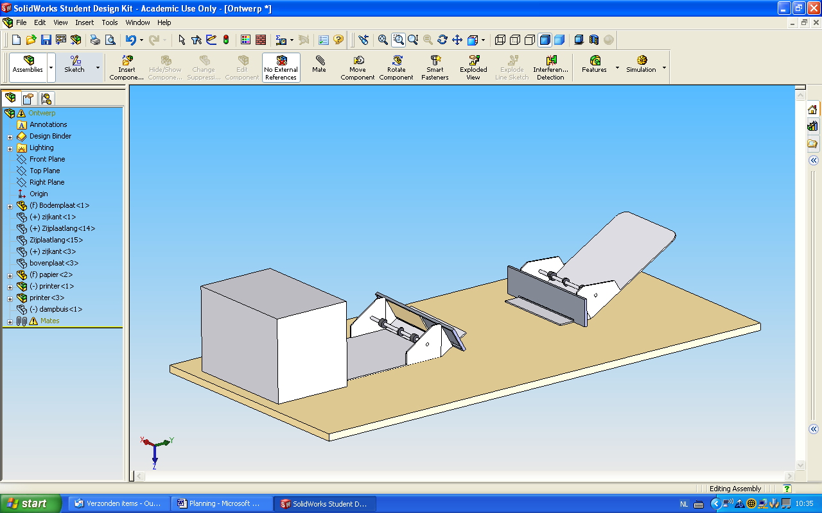
Figure 1: Set-up experiments 1 and 3
sheets
printer set-up
Initial question of the assignment
What are the decisive factors on sheet feeding errors of an inkjet printer, under the assumption of correct use of the system?

Hypotheses

H 1. Friction correlated factors²⁾
These eight hypotheses are summarized in table 1.
Explanation of table 1
For both grasping failure and double grabbing distinction can be made between: the error taking place (1) within a pack of sheets

(table 1: hypotheses 1A and 1C), or (2) at the last sheet(s) in the tray (table 1: hypotheses 1B and 1D). This brings the total different cases to study to four: 1A, 1B, 1C and 1D.
On each of these four cases two ‘sub hypotheses’ are formulated: the first (1) states what factors are of influence on the particular error (table 1: darkened cell) and the second (2) states which of these factors can be considered decisive³⁾ (table 1: marked ‘decisive’). This sums up to a total of eight hypotheses.
All hypotheses in table 1 include the condition of standard room conditions⁴⁾.

Example table 1
H 1C1: Under room conditions⁴⁾, double grabbing of any sheets except of the last sheet (1C) is only dependent of the force on the paper and the type of feeding-tray (darkened). H 1C2: the force applied by the roller to the paper (marked ‘decisive’) is considered as the decisive factor³⁾ on this particular error.

H 2. Humidity
Using sheet feeding system 1⁵⁾, double grabbing will not occur between 40% and 70% relative humidity in the pack of paper at room temperature⁴⁾.

H 3. Paper dust
Using sheet feeding system 1⁵⁾, paper dust does not influence grasping failure at room conditions⁴⁾.

2. Method
Testing the hypotheses is done by the means of three experiments.
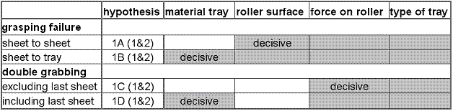
The first experi-ment (fig. 1) consists of combining and testing all the friction correlated factors²⁾. Under room conditions⁴⁾ these four factors were altered in a way to simulate all the common combinations found on modern printer systems:
Table 1: Hypotheses friction-correlated factors

1. position of the tray: horizontal and inclined
2. material of the tray pads: felt, cork and ABS (commonly
used thermoplastic)
3. force on the paper: four multiples of the common force⁶⁾
4. surface of the roller: textured, worn texture, smooth

This results in 72 tests displayed in figure 3.
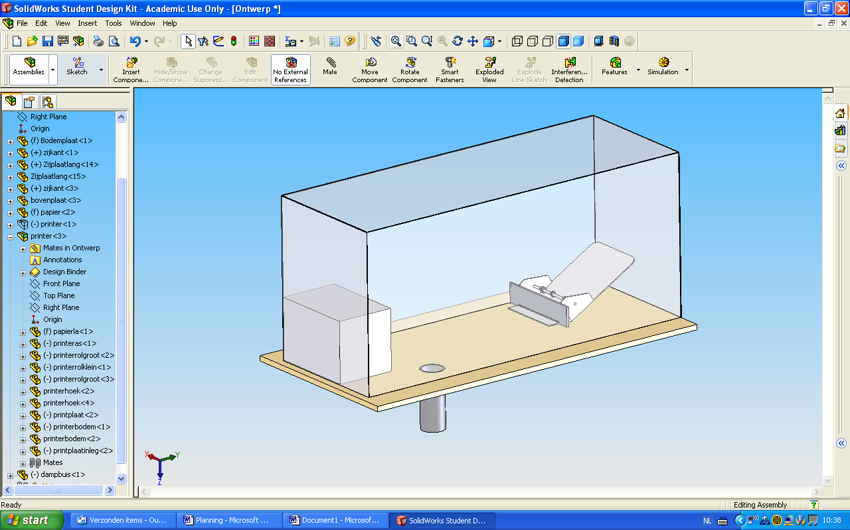
Experiment 2 (fig. 2), the test on the influence of humidity, was executed using only one of these 72 combinations: sheet feeding system 1⁵⁾. With the aid of a moisture absorber (by Henkel), and by placing the friction feed system inside an airtight box, a relative low paper humidity could be attained. By subsequently using a waterboiler a controlled increase to a high level of humidity could be established. Humidity was measured with the aid of a hygrometer (in open air) and a ‘sword hygrometer’ (between the sheets).
Figure 2: Set-up experiment 2
airtight box
conditioned paper
13-416

In experiment 3 (fig. 1) the influence of paper dust was tested on sheet feeding system 1⁵⁾ as well, this time applying and altering a layer of paper dust on the roller.

The protocol of testing for all three experiments is the same; a pack of 50 sheets is run completely through the feeder, denoting each error that occurs. Then the same test is repeated until a variance (2σ) of less than one feeding error is reached with a reliability of 95%. Finally a series tests with only one sheet in the tray is run the same way as the pack of 50 sheets.

3. Results
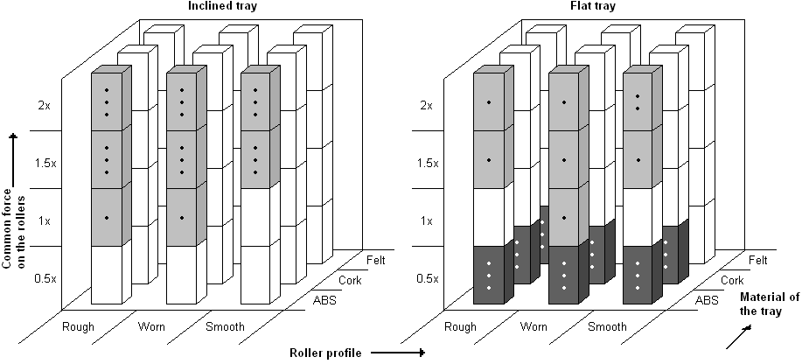
Figure 3: Results experiment 1
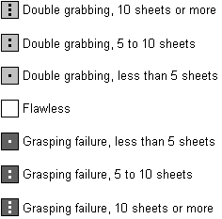

The results show that, when using ABS as tray pad material, double grabbing occurs increasingly when the force on the paper is equal to or larger than the force commonly used. When using a horizontal tray and half the common force⁶⁾, the roller fails to grab the paper, regardless of the other factors. In every other tested set-up the system performs flawless.

The test on humidity shows that double grabbing does not occur between 20% and 85% relative paper humidity. Grasping failure frequently occurs above a relative paper humidity of about 80% to 85%, but does not occur in the range of 20% to approx. 80%. Testing was only possible between a paper humidity of 20% to 85%.
The third test shows that grasping failures only occur when the texture of the roller is fully and uniformly covered with paper dust.

4. Discussion and conclusions
Hypotheses 1A1 and 1A2 have to be rejected, because grasping failure within a pack of sheets only occurs in systems using half the common roller force⁶⁾ and a horizontal tray. The material of the tray pads and the surface of the roller do not seem to influence the error.
Hypotheses 1B1 and 1B2 have to be rejected as well, because the same result as the one on grasping failures in a pack of paper was found for the test on a grasping failure of the last sheet.

Hypotheses 1C1 and 1C2 remain inconclusive, because experiment 1 resulted in no double grabbing within a pack of sheets at all; the results can neither confirm nor reject these hypotheses.
Hypotheses 1D1 and 1D2 can both be considered plausible. Results on double grabbing of the last sheets in the tray show an independence of only the texture of the roller. The largest spread in results was found with changing the material of the tray pads.

Hypothesis 2 seems to be plausible, because results of experiment 2 show neither grasping failure nor double grabbing occurred between 20% and 80% relative paper humidity. However, the values measured during experiment 2 may differ about 3% from the actual humidity, caused by the inaccuracy of the hygrometers.

Hypothesis 3 is rejected, because, when the texture of the roller is fully covered with paper dust, the system will always fail to grasp the paper; paper dust on the roller does influence a grasping failure. However, the amount of paper dust causing such an error is highly unlikely to find on any roller of a commonly used printer system.

5. Recommendations
- Perform the same tests on other paper types,
because conclusions on this experiment only apply
to standard printer/copy paper¹⁾
- Try to achieve values >85% and <20% in humidity
test, because conclusions on this experiment do not
apply to these ranges although these conditions are
common in some places.

6. References
-Stephan J. Bigelow,
Bigelow’s PRINTER Troubleshooting Pocket
Reference, McGraw-Hill, 2000
- Howard M. Fenton, Frank J Romano,
On demand printing 2nd edition, Prentice hall, 1998
-Sappi Europe: http://www.sappi.com

