Nr  15-482 | Sectie opdrachtgever  Eng. Dynamics |  | Naam opdrachtgever  Prof. Daniel Rixen |  |  | Datum  Jan 2007
Titel | Bullitproof ???  Measuring delamination in composites using hot techniques
Trefwoorden | Experimental mechanics, high tech composites, finite elements, thermal analysis
Inleiding  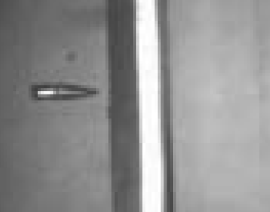  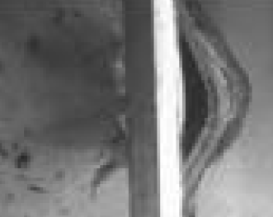 | In our department we are investigating the effect of projectile impact on high tech composites. For this purpose composite plates are impacted with bullets (at the PML lab of TNO) and we try to predict the damage due to impact in the plate.  It is difficult to evaluate the damage when cracks appear between composite layers inside the plate (this is called delamination). Hence, we want to develop an experimental technique to “see” the delamination after impact in detail.  The basic idea is that one could localize the delamination zones by heating the damaged plate from one side and measuring the transmitted heat with an infrared camera on the other. The location where delamination has occurred will have a lower thermal transmission coefficient and will thus appear colder on the picture. Is this a hot idea?
Vraagstelling  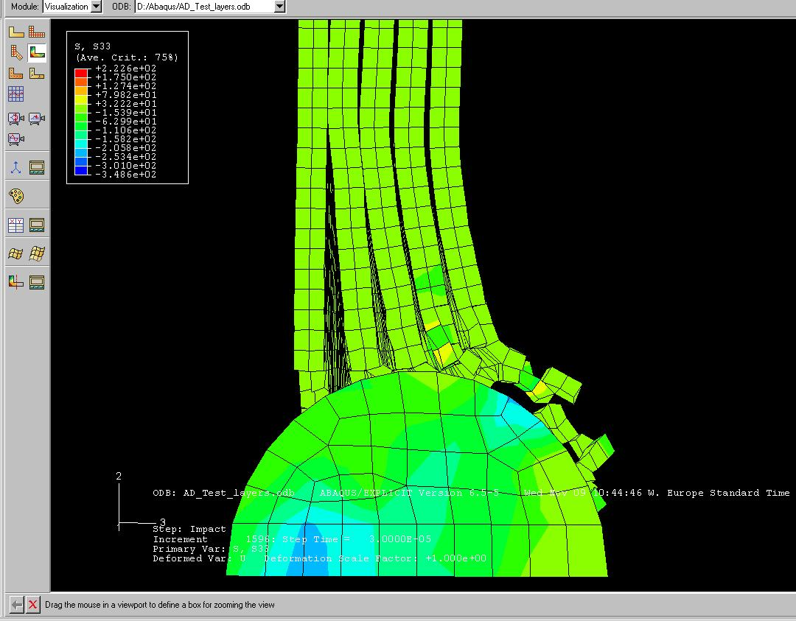 | The basic questions we want to answer in this preliminary investigation are:  - Is it possible to locate delamination in composite plates by measuring in time with a infrared camera the heat transmitted across it?  - Does the difference in the thermal transmission speed say something about how severe the cracking is in the composite?  - Is it possible to estimate the depth of the delaminated layers based on the blurring of the infrared image contours?
Uitwerking en eisen  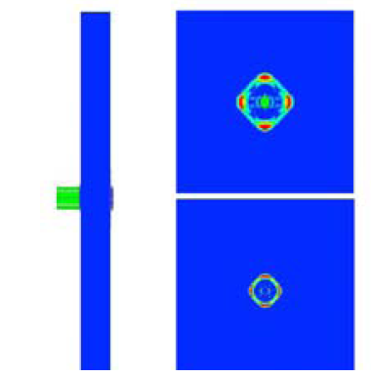 | The investigation should be conducted as follows:  - Perform a literature research (in scientific journals and patent data bases about similar experimental procedures)  - Analyze the heat transmission through a composite plate (composed of Dyneema fibers) with a simple 2D Ansys model to evaluate the best experimental procedure for identifying delamination.  - Produce a composite plate in the lab with several built-in delamination zones (at different depths, of different severity).  - Using an infrared camera on one side as detector and a heat source (infrared light or laser spot for instance) on the other, set up the experiment and measure the produced composite plates.
Opmerkingen | This project requires hand-on lab experiments, building of a good setup, but also analysis with a Finite Element program (Ansys) and good mechanical thinking to come up with a workable procedure. This challenging project will be supervised by Ms. Béate Heru Utomo, a PhD student from our department working with TNO.
Begeleiding | Naam | Sectie |  | Tel | E-mail
Begeleiding |  | .
Begeleiding | Prof. dr. ir. D.J. Rixen | PME/Eng.Dyn. |  | 8 1523 | d.j.rixen@wbmt.tudelft.nl
Begeleiding | Ir. Béate Heru Utomo | PME/Mech.Mat. |  | 8 6512 | B.D.HeruUtomo@tudelft.nl
