Smart structures
15-415
Tim Hooijdonk (1175289) and Riny Vermue (1219073)
Abstract
Due to the high costs of design materials, it is generally desirable to minimize the amount of materials in structures. This results in light weight constructions. Inherent to these light weight structures the structure becomes more flexible and consequently more sensitive for disturbances. To have the same performance as conventional constructions, the light weight variants can be controlled actively (smart structures). In this paper the conventional approach is compared with the active control approach. Based on a model the vibrations in a clamped beam are analysed. The model is verified by testing several clamped beams in an experimental setup. It is shown that with active control the clamped beam can have a smaller thickness while maintaining the same performance as in the case of the passively controlled clamped beam with original thickness.

- Introduction
Costs of design materials are high nowadays. In engineering it is therefore favourable to minimize the material costs and design lighter constructions. These light weight structures are more flexible and consequently more sensitive for disturbances.
In wind turbines for instance, due to gusts and turbulence, vibrations arise in the rotor blades and result in great loads on the tower. In a cost perspective it is desirable to reduce materials needed for the rotor blades and the shaft. To reduce the loads the blades and the tower can be redesigned (by making the construction heavier) or active control can be used.
A structure is controlled passively when its stiffness is increased by adding more material to the design (e.g. increasing the thickness of a rotor blade). A structure is controlled actively when it is dampened using a controller and an actuator (a smart structure).
Figure 1: piezo actuator
In this study active control on a clamped aluminium beam is examined using an actuating piezo element. A piezo actuator deforms when a voltage is applied (figure 1).^{[1]}
A clamped beam is a structure which is fit to be tested in an experimental setup. It is shown that a light weight actively controlled beam has the same settling time (a measure of performance) as a heavy weight passively controlled beam. From simulation study (see Results), the hypothesis can be stated as follows:

The actively controlled clamped aluminium beam of 800 x 40 x 3 millimetres thick (figure 2a) has the same settling time (6.4 seconds) as the passively controlled clamped aluminium beam of 800 x 40 x 11 millimetres thick (figure 2b).

Active control: The dynamic properties (stiffness and dampening) of the beam are increased.
Passive control: The dynamic properties of the beam are increased by making the beam thicker.
Settling time: The time it takes an initial force disturbance is reduced to within 0.5 millimetres of the equilibrium position at the location of the position sensor (see Method).

- Method
The two forms of control, passive and active, are simulated (Matlab) before the experimentation. The model consists of a clamped aluminium beam, a Lorenz actuator (a force actuator) and a position sensor (figure 2).
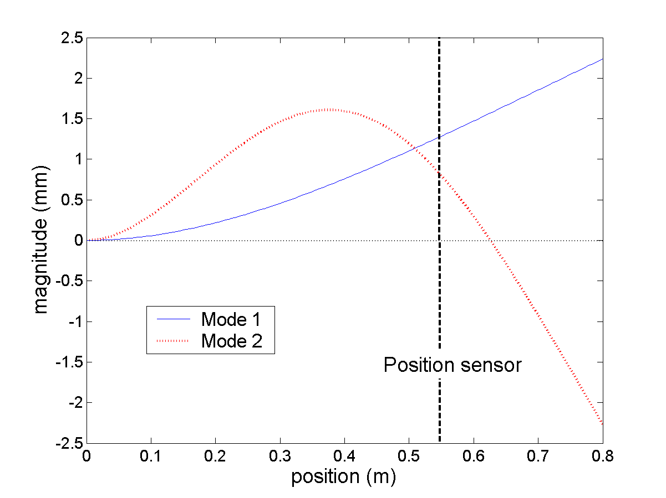
With both forms of control, an initial force of 24 Newton is applied on the tip of the beam by the Lorenz actuator. After the initial force is removed, the clamped beam starts to vibrate. The position sensor measures the vibrations of the beam. For active control a controller and a piezo actuator (type: T105-H4E-602 30 x 35 millimetres.^{[2]}) are added to the clamped beam (figure 2a).
Figure 2: experimental setup with:
active control (a), passive control (b)
Figure 3: location of position sensor
Based on the input signal from the position sensor, the controller outputs a signal to the piezo actuator.
To control the first two Eigen modes (dynamic behaviour is a linear combination of different Eigen modes), it is preferable to place the position sensor at such a location where both modes have the same sign and the nodes of each mode are distant (figure 3). Therefore the position sensor is placed 250 millimetres from the loose end of the beam.^{[3]} The piezo actuator is located near the clamped end, because of the high strains associated with the first two Eigen modes.

Settling time is firstly determined in a simulation model. Then a transfer function of the beam (denominator) and the piezo actuator (numerator) based on formula 1 ^{[1]} is set up. The initial force is modelled by an impulse function.
(1)

The simulation is fulfilled by system identification ^{[4]} on the experimental setup (see figure 4). The system is identified by applying a white noise signal with a bandwidth of 80 Hz (this is broad enough for finding the first three Eigen frequencies as predicted by the simulation) that was applied on the 3 millimetres thick beam used in the experimental setup. It showed that only the first two Eigen modes of the beams used in this study should be considered when designing a controller. The controller is designed using loop shaping. ^{[5]}
To validate the simulation the settling time of passively controlled beams of varying thickness (3, 4, 8, 10 and 15 millimetres) is investigated in an experimental setup as well as the settling time of an actively controlled beam of 3 millimetres thick.
- Results
The outcome of the experiments is presented in figures 5 and 6. The passively controlled beam of 10 millimetres thick has the same settling time (6.5 seconds) as the actively controlled beam of 3 millimetres thick.
- Discussion and conclusions
Simulation showed that an actively controlled beam of just 3 millimetres thick has the same settling time (6.4 seconds) as a passively controlled beam of 10 millimetres thick has. Reviewing this result the hypothesis has been confirmed. When 30% of the mass of the original beam (10 millimetres thick) is used, the original settling time (6.5 seconds) can be maintained.
However, this does not prove that a mass reduction of 70% is applicable for all geometries of clamped beams or for other geometries. On the other hand, reviewing the results, it is very likely that generally a large amount of mass reduction is possible when using active control.
For the example of the wind turbine stated earlier the outcome of this study gives useful insights. The examined beams have a geometry that resembles, among other things, the dynamic behaviour of a rotor blade of a wind turbine.

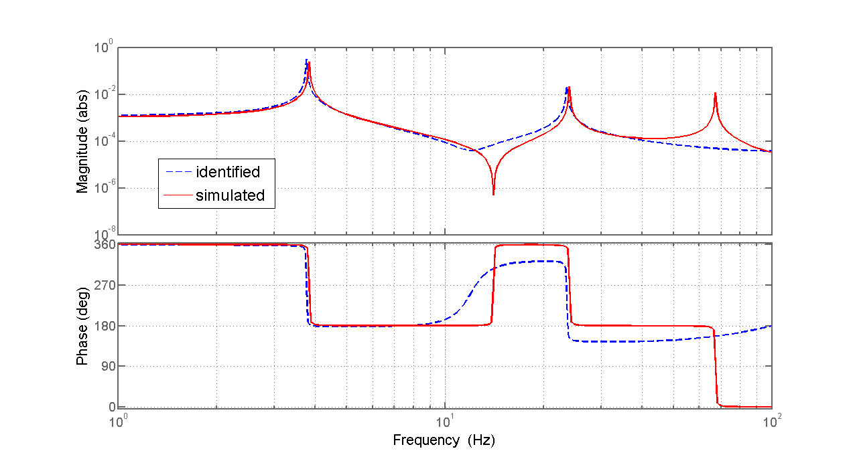
There are still some differences between this study on a clamped beam and other structures. The disturbance could be a varying influence instead of just being an initial force. Secondly, more complex geometries have to cope with more Eigen modes that to be considered designing a controller. This results in more complex controllers. Nevertheless, like all structures, they can be modelled as a state space model. This makes it possible to control vibrations using piezo actuators and to reduce mass.
Figure 4: bode diagram of identified and simulated model of the beam of 3 millimeters thick. It is seen that the simulation has a good fit on the first two Eigen modes.
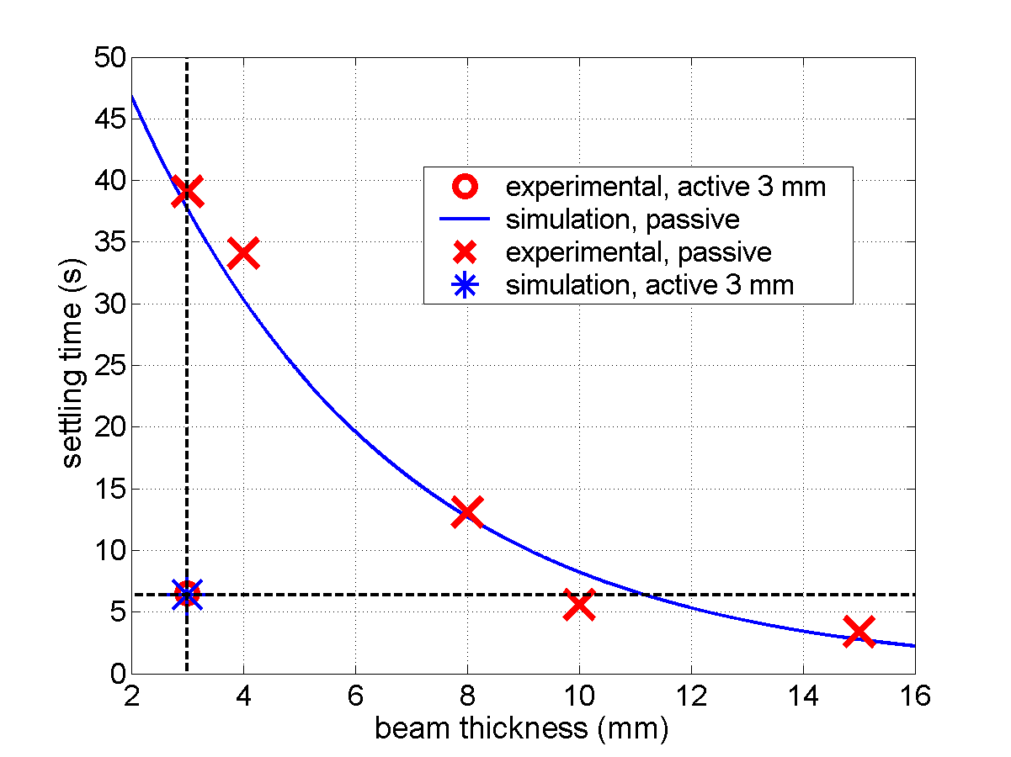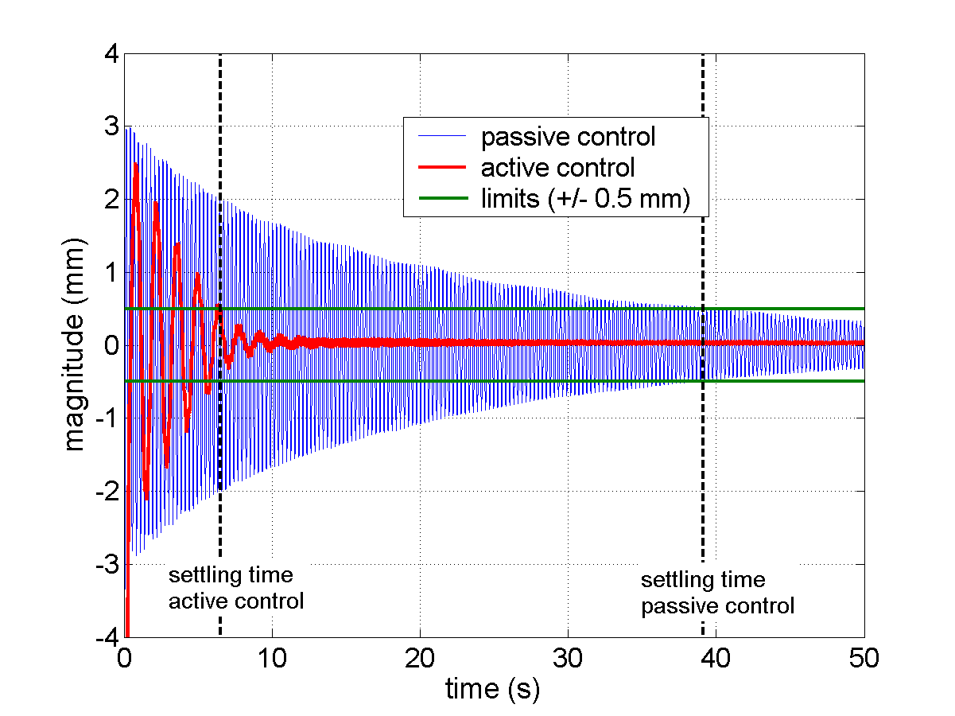
Figure 5: experimental results versus simulation results.
Figure 6: experimental results (thickness 3 mm).
The scope of this study was on comparing passive and active control to gain insight in the possibilities of mass reduction. Further research can be done on the effect of using more piezo actuators on the control performance, the possible mass reduction of other (more complex) geometries and possibilities of mass reduction using active control in case of continuously varying disturbance (e.g. time varying force).
- References
[1]S.O. Reza Moheimani & Andrew J. Fleming, Piezoelectric Transducers for Vibration Control and Damping, Springer-Verlag London Limited, 2006
[2] http://www.piezo.com
[3] André Preumont, Vibration Control of Active Structures, An Introduction, Boston Kluwer Academic Publishers, 2002
[4] Michel Verhaegen, Identification of the Deterministic Part of MIMO State Space Models given in Innovations Form from Input-Output Data, Pergamon Press Ltd., 1993
[5] Feedback Control of Dynamic Systems, Gene F. Franklin, J. David Powell & Abbas Emami-Naeini, 2002, Prentice-Hall Inc, ISBN: 0-13-098041-2

