Effects of Adaptive Bone Remodelling on Total Shoulder Arthroplasty
Caspar Bolsman (9092231) and Inge de Jong (9402690)

Abstract
Loosening of the glenoid part of the shoulder joint prosthesis is among the most prevalent modes of failure in Total Shoulder Arthroplasty (TSA). Adaptive Bone Remodelling (ABR) which is the ability of bone to adapt its internal structure (density) to the loading conditions, can affect the long-term integrity of TSA. In this study, it is investigated to which extent ABR is relevant for the loosening of the glenoid prosthesis. This is done numerically using a finite element model, which incorporates a model for ABR. The result shows that the bone density distribution is significantly different after the prosthesis insertion. The largest changes in density distribution are located in the proximity of the prosthesis.

Introduction
Total shoulder arthroplasty (TSA) is a procedure that involves the reconstruction of the shoulder joint by inserting humeral and glenoid prosthesis components in the humerus and the scapula, respectively. See Figure 1.
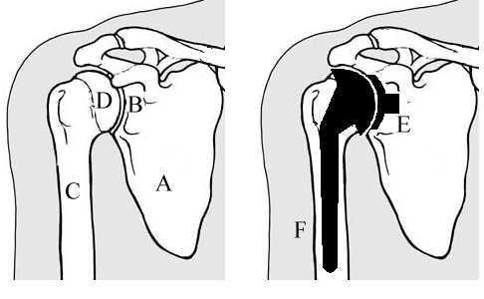
Figure 1: Anatomy of the shoulder joint:
A: Scapula D: Humeral head
B: Glenoid E: Glenoid Prosthesis
C: Humerus F: Humeral Prosthesis

It appears that loosening of the prosthesis in the scapula, which impairs the correct function of the shoulder joint, occurs approximately one year after TSA.

In a Total Hip Arthroplasty, it is shown that the ‘stress shielding’ (which implies the bone resorption) mainly causes the loosening of the prosthesis. The stress shielding around the prosthesis can be described by the Adaptive Bone Remodelling (ABR) theorem.
The ABR is the ability of bone to adapt its internal structure to the supports and loads applied. Based on this theorem the density of bone will increase where the load is increased and vice versa. The ABR is mathematically described by [Weinans et al.] see appendix 1.
The bone resorption caused by ABR around the glenoid prosthesis can be one of the factors affecting the loosening of the prosthesis.
The current project is aimed at identification of the importance of ABR in the glenoid part of the scapula after implantation of the prosthesis. Of interest is the amount of bone remodelling triggered by the implantation of the prosthesis and the range of the effect of the change in density distribution.
It is hypothesised that the density of bone changes after implantation of the prosthesis. The disturbance caused by the prosthesis is a small range disturbance, there is no effect at greater distance from the prosthesis.
Approach
The FE software Charles and the 3D FE model of the glenoid part of the scapula with and without the prosthesis are available. The geometry and material properties of the glenoid are determined from CT scan images.
In order to investigate the effect of ABR, a routine has been written to describe the process of adaptive bone remodelling. This routine is incorporated into the FE software. The routine is an iterative process, which is described below and in Figure 2.
- FE Analysis of glenoid with prosthesis Output: specific strain energy
- Determination of remodeling signal
- Calculation timestep
- Calculation new density distribution
- Importation new density distribution into FE model
- Start a new iteration or stop the process.
The iterative process stops when a new equilibrium of density distribution is reached.
Figure 2: Structure of the iterative loop
The glenoid part of the scapula is analysed both before and after the implantation of the prosthesis. The model without prosthesis is used to determine a reference value for each element separately. These reference values are than used for the calculation with the prosthesis.
Assumptions and simplifications
- The constant values for the ABR rule are experimentally determined for dogs, see [Weinans et al.]. The assumption is that the ABR in the glenoid is comparable to the ABR in the dog femur, so that the usage of the same constants for the ABR is justified.
- Bone is modelled as an isotropic elastic material. It is modelled as a continuous material and the effects of microstructures are neglected.
- A scapula inside the human body is in equilibrium with all forces and constraints acting on it. The model describes only the glenoid part of the scapula. Constraints and forces acting on the model are simplified, with the consequence that model calculations may not give realistic density distribution. Giving each element in the calculation its own reference value compensates this.
- In the FE model, the displacement constraints are applied on the cut boundary of the glenoid. This type of boundary conditions is an approximation. To have more accurate results, the prescribed nodal displacements calculated from the FE model of the full scapula must be applied on the boundary of the glenoid.
- ABR is restricted to the glenoid part of the scapula. To calculate the response of the bone after implantation of the prosthesis, only this part is needed.
- The applied load is the shoulder joint reaction force for 90-degree abduction of the arm.
- A perfect interface bonding is used to simulate the entire interface between prosthesis and bone.
Results
After insertion of the prosthesis, the bone density is changed and a new density distribution is determined. The data concerning the density distribution in the glenoid shows that the density change in the implantation zone is up to 100% and no remodelling occurs in the rest of the glenoid. Figure 3 shows the density distribution in the implantation zone.
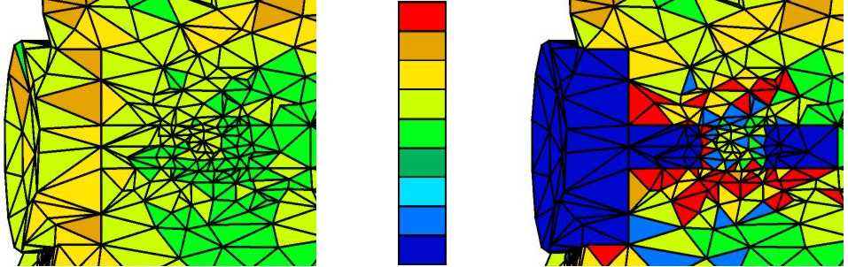
Figure 3:Density of slice of FE model before and after ABR
There is an overall mass increase of 0.55% of the structure after remodelling.
Conclusions and recommendations
The implantation of the glenoid prosthesis generates a new mechanical load distribution inside the glenoid part of the scapula. This new loading condition causes a new density distribution in the glenoid based on the ABR rule. This conclusion is in agreement with the hypothesis.
More research needs to be done on the following points, in order to improve the understanding of the effect ABR on the TSA:
- All loads and boundary conditions have to be known in order to use one reference value for the whole structure.
- All loads corresponding with the daily activities must be applied on the model.
- All the used constants need to be found for a scapula of a human being, instead of the dog values.
References
Rietbergen, B van (1996) Mechanical behavior and adaptation of trabecular bone in relation to bone morphology.
Weinans, H.H. (1991) Mechanically induced bone adaptations around orthopaedic implants.
Appendix 1
The formulas, which mathematically describe
the process of ABR, are shown below:
$\begin{aligned}\frac{dρ}{\text{dt}}=τ\begin{matrix}\end{matrix} \\ \end{aligned}$$\begin{aligned}\begin{matrix}\text{if}\begin{matrix}\frac{U_{a}}{ρ}≤(1−s)\begin{matrix}k\end{matrix} & \begin{matrix}\end{matrix}\text{if}\begin{matrix}\end{matrix}(1−s)\begin{matrix}\end{matrix}k<\frac{U_{a}}{ρ}<(1+s)\begin{matrix}\end{matrix}k & \begin{matrix}\end{matrix}\text{if}\begin{matrix}\end{matrix}\frac{U_{a}}{ρ}≥(1+s)\begin{matrix}\end{matrix}k\end{matrix}\end{matrix} \\ \end{aligned}$
In which:
$τ$ = Time constant [gr²mm⁻²J¹month⁻¹]
$a\left(ρ\right)$ = Free surface area (density dependent)
[mm⁻¹]
$k$ = Reference value [Joule/gr]
$s$ = Size dead zone [%]
$\frac{U_{a}}{ρ}$ = Specific strain energy [Joule/gr]
Figure 1 Free surface area dependence of density
The density of bone ranges from 0 to 1.8 g/cm³. In this range a high density means the bone is solid. A lower density represents a more open spongy structure.

