Biomechanical Efficiency Rowing Bike

Bart van der Holst (9355068) and Rogier van der Leede (9505615)

Abstract

Users of the rowing bike experienced that climbing a slope takes more effort on a rowing bike than on a conventional racing bike. This could be the result of a difference in biomechanical efficiency between the bikes. In an experiment it was tested on a treadmill whether the rowing bike had a lower biomechanical efficiency than the conventional racing bike. This was tested on a treadmill at different speeds (20 km/h and 30 km/h) and on simulated slopes of 0%, 3% and 7%. From the results it is concluded that the biomechanical efficiency of the rowing bike is not lower than the biomechanical efficiency of the conventional racing bike for the conditions tested.

Introduction

The rowing bike provides a sportive way of transporting oneself. A lot of muscle groups are involved in the body movement to power the bike. This in contrary to the conventional bicycle, where mainly the leg muscles provide the power for propulsion. Also the rowing stroke used on the rowing bike accounts for a less continuous power input than the cycling movement of the conventional bike. This means that the velocity of the rowing bike is less constant.
Another difference between the rowing bike and the conventional bike is the way the bikes transmit the power of the rider (P_{mechanical}) to the road (P_{external}).
The conventional bike uses the well-known chain wheel with chain for this purpose. The rowing bike uses the Snek with steel cable (see Fig 1 & 2).
Now the question arises: ‘Do these physiological and mechanical differences result in differences in
efficiency between these bikes?’. Experienced rowing bikers all share the opinion that riding a level road on a rowing bike does not take more effort than on a conventional bike. But riding up a slope does take considerably more effort on a rowing bike than on a conventional bike. We decided to study whether this is the result of physiological and mechanical losses within the Man & Bike system. In this experiment we are interested in the Biomechanical Efficiency (BME).

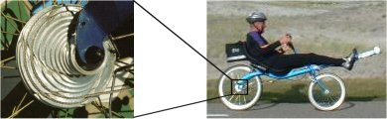

Figure 1: The Snek

The BME is defined as the product of the physiological and the mechanical efficiencies. Thus for the Man & Bike system the following relation holds:
P_{metabolic}
P_{mechanical}
P_{external}
η_{physiological}
η_{mechanical}
Man
Bike

P_{external} is the power that is transmitted on the road.
It will be contributing to the kinetic energy of the Man & Bike system while accelerating. When traveling on a level road at constant speed, P_{external} is used to
overcome air friction and friction of the tires.

The aim of this study is tot test the hypothesis that the BME of the rowing bike will not differ significantly from the BME of a conventional bike on a level road, but will be significantly lower on a slope.

Figure 2: The rowing bike
Materials and Methods

The 5 subjects were experienced users of the rowing bike. Experience with the rowing bike is preferable because a lack of technique may influence the efficiency of the complicated movement considerably. All subjects performed the same 6 tasks on 2 bikes in a different order. The tasks consisted of three climbing slopes, which resembled steepness’ of 0%, 3% and 7% and at speeds of 20km/h and 30 km/h.
The experimental setup consisted of a treadmill on which the rowing bike and a standard racing bike could be mounted:
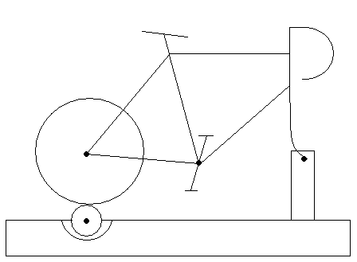
Figure 3: The racing bike on the treadmill

The treadmill provided a constant P_{external} per task that was performed on the 2 bikes. P_{external} had values between 50 W and 170 W, depending on the task.
The heart rate of the subject was measured after performing the task for 3 minutes and this is a reliable measure for the P_{metabolical}¹.
With the heart rates (P_{metabolical}) of the 2 bikes and P_{external}, the difference in BME of the 2 bikes can be deducted from the BME-formula.
With this difference in BME between the 2 bikes we can test our hypothesis.

Results

From the data there seems to be a difference between the heart rate results (P_{metabolical}) for the 2 bikes.
Figure 4: Average heart rates

The data was analyzed statistically: ANOVA (Analysis of Variance), repeated measures and for a level of significance of 5%. The result of the analysis is that there is no significant (P=5,6%) difference between the heart rate results. If there is no significant difference in heart rate, there will be also no significant difference in BME.

Discussion

The data agree with the first part of the hypothesis, namely that there is no significant difference between the BME of the 2 bikes on a 0% slope.
The second part of the hypothesis must be rejected because the BME of the rowing bike was not significantly lower on a slope.
Therefore the hypothesis cannot be accepted completely. With the data of tests on more subjects it is expected that the difference s between the BME of the 2 bikes will become significant on a slope, as noted in the hypothesis.

The rowing bike has a non-continual propulsion. Therefore the driver on his rowing bike and some moving parts on the rowing bike can be modeled as a mass slinging on a track:

Figure 5: Slinging mass

When the mass hits the wall, its velocity is reversed. This reversion can be fully, not or partially elastic. Any non-elastic reversion implies energy loss.
After the thrust swing, there is a brief moment of rest. This counts as a non-elastic reversion and all kinetic energy will be lost.
After the dead swing, the momentums of some parts are reversed by pushing against the footsteps. These momentums are those of head, body, arms of the driver and steer of the bike:

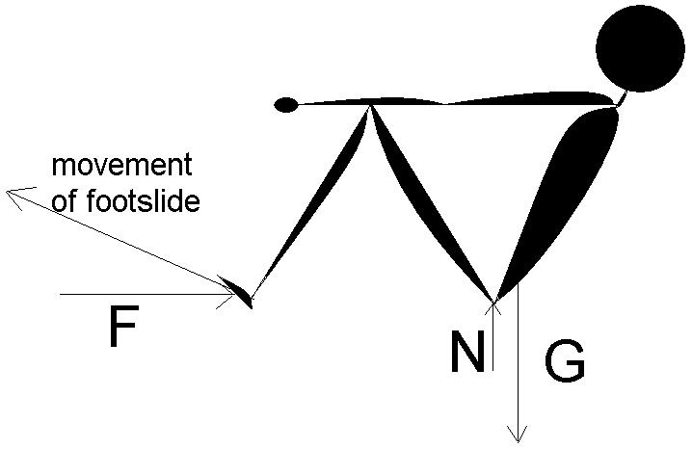
Figure 6: Power transfer

Because power and movement of footsteps differ by 20 degrees, 94% of this energy will be transferred.

Independent of the BME of the 2 bikes which was examined in our study there are other differences between the bikes that influence the performance.
First, the rowing bike has a 12% smaller frontal area. Second, the rowing bike is 5 kg heavier than the racing bike.
While traveling on a level road, the rowing bike will be faster because the frontal area is smaller.
But while climbing at low speeds, the advantage of the smaller frontal area can be neglected and the extra mass of the rowing bike will make the rowing bike slower.

Conclusion

From the results it is concluded that the BME of the rowing bike is not lower than the BME of the racing bike. Because of the large standard deviation, we suspect that tests on more subjects will yield a significant difference between the bikes.

Reference:
1) Per-Olof Astrand, Kaare Rodahl: Textbook of work Physiology, fig.4-25, page 190

