Modeling the behavior of the Dynamic Mechanical Analyzer
Ewoud van West (9942214)

Abstract
In order to improve the accuracy of mechanical properties of material samples measured on a Dynamical Mechanical Analyzer (DMA), the dynamics of the analyzer has been investigated. Based on experimental testing of the components of the analyzer, a dynamical model has been constructed. It was our aim to use the mathematical model to correct the measurements of the DMA for stiffness and inertia effects not coming from the sample. The model has proved to be very useful in estimating the errors on the mechanical properties given by the DMA. This accuracy is strongly dependent on the relative stiffness of the sample stiffness compared to the dynamic stiffness of the machine components. However, due to inaccuracy inherent to the impact testing performed for the structural identification, the current mathematical model cannot be used to correct results from the DMA.

Introduction  The Dynamical Mechanical Analyzer (DMA) is used to measure dynamical properties of materials such as static stiffness, damping and inertia. Knowing these properties with high accuracy is essential when predicting reliability and performance of new materials in advanced designs. For instance, in electronics industry, dynamical stiffness of curing thermosets strongly determines the mechanical performance of chips.  Due to the presence of clamping devices between the DMA force and displacement sensors, measured properties can differ from the real sample properties (see figure 1.).  EMBED Word.Picture.8  Measurement  Column: ->  1. The DMA with a model interpretation  In order to investigate the influence of the dynamics of the DMA structure on the measurement, we will verify if:  - The frame is very stiff compared to the measurement column  - Using a mathematical model of this column, the dynamic stiffness of the sample can be derived from the measurements given by the DMA  The DMA has a frequency range of 1-1000 Hz. From 0 to 85 Hz, forces and displacements are measured by capacity sensors.Above 85 Hz, piezo-electrical sensors are used. In this research we will investigate the hardware used in the 0-85Hz range.  Hypothesis  Addition of our mathematical model to the DMA increases its accuracy regarding the dynamical stiffness by 5%  So the DMA gives a dynamical stiffness based on its measurements. Now we apply our model on these same measurements and we will get a better dynamical stiffness, where the accuracy regarding to the literature value for the stiffness of this sample increases by 5%. |  | Methods and Materials  Frame  To verify the first assumption the eigenfrequencies of the frame have been measured. Using hammer impacts and excitation from the DMA shaker, resonance frequencies and amplitudes have been measured by accelerometers at different locations on the frame (see figure 1.).  Measurement Column  First a model has to be assembled (figure 2.)  Displacement is measured at node 4; Force is measured at node 1.  Assumptions:  Top (T)  4  3  2  Sample (S)  Bottom (B)  1  - Bottom(B) and Top(T) will be modeled as simple mass-spring systems (B: 1 mass, 1 spring; T: 2 masses, 1 spring)  - Sample(S) will be modeled as a finite bar element.  - No mass-coupling  - Displacement at bottom (node 1) is zero  - Force at top (node 4) is zero  2. Model of column  Results of modeling the parts will show if these approximation is good enough or more elements have to be added. (more masses and springs)  Then a global model for the whole column can be build from these three components.  The displacement at the bottom (node 1) will be measured in de frame testing.  The relation between force (F) and displacement (u) is given by the impedance Z:  $\frac{ρ\text{AL}}{6}$-> Finite  element S  EMBED Equation.3  Now the global impedance matrix  will be bassembled.  EMBED Equation.3  The values for the bottom and the upper part have to be identified by performing dynamic tests on the lower and upper part independently.
By exciting the different parts with an impact hammer, measuring with accelerometers at the model nodes and using Fourier Transforms, transfer functions can be measured in the frequency domain.  The mass and stiffness parameters of the subcomponents are then found by fitting the dynamic response of the model on the measurements (see Figure 3).  When all the subparts of the measuring columns are identified we can run in Matlab numerical simulations for different excitation frequencies on node 4 and different size and Young’s modulus E for the sample. Displacement at node 4 and the force at node 1 represent the DMA measurements. Therefore, comparing the sample stiffness obtained from these simulated measurement with the actual Young’s modulus indicates the error on the material properties due to the DMA structural dynamics, i.e. the influence of the clamping devices.  Results  Frame  A Hammer test on the frame showed resonance peaks at:  - 7,5 Hz  - 230 Hz  - 435 Hz  - 800 Hz  The low frequency (7,5 Hz) is due to a suspension pad at which the DMA is placed. This is a very low stiffness suspension and because of the big inertia of the frame compared to the column this has no influence.  The other frequencies are investigated by using the internal shaker to shake at this frequency. The measured frame displacement was 1.5% of the forced displacement, so the frame was indeed vibrating, but that the amplitude of this movement can be neglected at the measured displacements.  Measurement column  Bottom part:  The results clearly showed the first resonance peak at 890 Hz. The mass and spring stiffness were:  - k = 4.8e6 N/m  - M = 0.15 kg (this includes sensor mass)  Plotting the model with the measured data for the relation F₁/F₂ gives:  Bottom  F₂  F₁  3. Model fitting on bottom part |  | Top part:  Similar results were gained from experiments on the upper part giving:  - k = 6.4e6 N/m  - Mtop1 = 0,27 kg (including sensor mass)  - Mtop2 = 0,64 kg  The accuracy of these variables k and M is very limited. They are based on averages and involve a lot of numerical errors. These errors are due to e.g. windowing, Fast Fourier transformations (FFT’s) etc. Therefore the values can vary within 10%  Better results could come from pure harmonic excitation where these variables can be derived without performing these numerical operations.  Simulation  With all this data the model was assembled in Matlab. Running simulations for different parameters (frequency, E, geometry) a 3D graph is plotted showing the effects of the frequency and the Young’s modulus on the new E (E_DMA). For clarity the ratio between the E_DMA and the true E is plotted on the vertical axis and there is a horizontal plane at ratio 1, representing the perfect ratio.  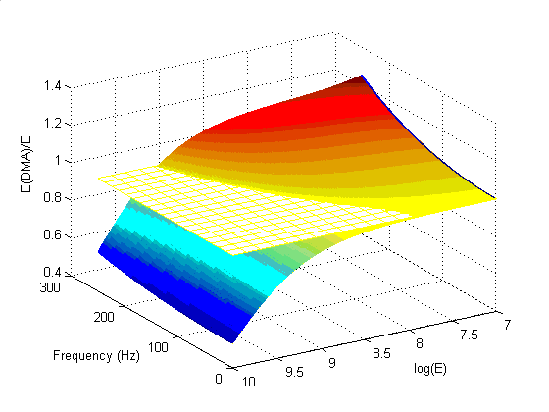  4. Ratio of modeled E with true E  Conclusion  Based on the relative displacement the frame can be regarded as very stiff compared to the measurement column and the frame can be left out of the dynamical model.  The model has proved to be very useful in estimating the errors on the mechanical properties given by the DMA. This is shown in graph 4 where large errors occur for high frequencies and very stiff samples.  This accuracy is strongly dependent on the relative stiffness of the sample stiffness compared to the dynamic stiffness of the machine components.  However to use this model to correct results from the DMA, the model is not accurate enough.  Deviations of 10% in k and M values lead to deviations of 20 % in the model. Then an improvement of 5% can never be achieved. Therefore we have to reject our hypothesis, although the research was most useful, showing the importance of the clamping effects.  The main reason for this inaccuracy is the method used for the structural identification of the DMA, the impact testing. Better results can be achieved using a pure harmonic excitation for this identification.

