A 2D finite element model of bone adaptation in the proximal femur of

osteoarthritic patients

An assignment by the Research Laboratory of the Department of Orthopaedics of the Erasmus University (EUR)
N.A.S. Cramer (9164111), G.M. van Essen (9230354), under supervision of J.S. Day, J.C. van der Linden
22 May 2002

Abstract
Osteoarthritis (OA) is a disorder which involves cartilage breakdown, irregular bone formation and eventual joint failure. The health of the cartilage depends on the mechanical properties of its bony bed. In this study a two-dimensional finite element computer model of the proximal femur was constructed, where the bony changes of OA were modeled as a local change of stiffness of the bony bed. It was investigated if this model could predict the altered density distribution of a femur with severe OA as can be observed on x-rays of patients. The model was constructed from a scan of human femur and loading- and boundary conditions were chosen based on anatomy studies. Before implementing the conditions of OA, the reliability of this model was tested by means of a sensitivity analyses. In order to compare outputs of the model with real cases of OA we defined the bone remodeling signal as the change in strain energy density in the femur with OA conditions relative to the intact femur. The analyses showed that our model is rather sensitive to the chosen parameters. However, evaluating the results of the two-dimensional finite element model has shown that there is a correlation between the signal predicted by the model and the altered density distribution, observed on X-rays of patients with OA.

Introduction
Osteoarthritis (OA) is a common joint disease in the elderly, causing pain and decreased mobility. The disease usually occurs long before it can be detected with current diagnostic methods, so permanent and irreversible damage of the joint has often occurred by that time. Thus, it is highly desirable to develop sensitive and reliable methods for early diagnosis and prognostication of disease progress. By this study more insight can be gained in the disease and the factors that cause it.
The result of OA is degenerated cartilage combined with modifications in the underlying bone bed. It has been proposed that in clinical situations cartilage degeneration occurred due to alterations of the bony bed [8]. Bone density and strength (bone density ~ stiffness) adapt to imposed stresses. By bone modeling and remodeling a functionally and mechanically purposeful architecture of the bone is produced. Alteration of the architecture will lead to altered stress patterns and the other way around [7]. Recent evidence demonstrates specific architectural changes in the trabecular bone¹ in OA that are consistent with an acceleration of bone turnover, which results in younger, less highly mineralized bone [2]. This decreases the stiffness of the bone as a material and will cause greater tissue deformation. The subchondral bone¹ will adapt by making more bone matrix.
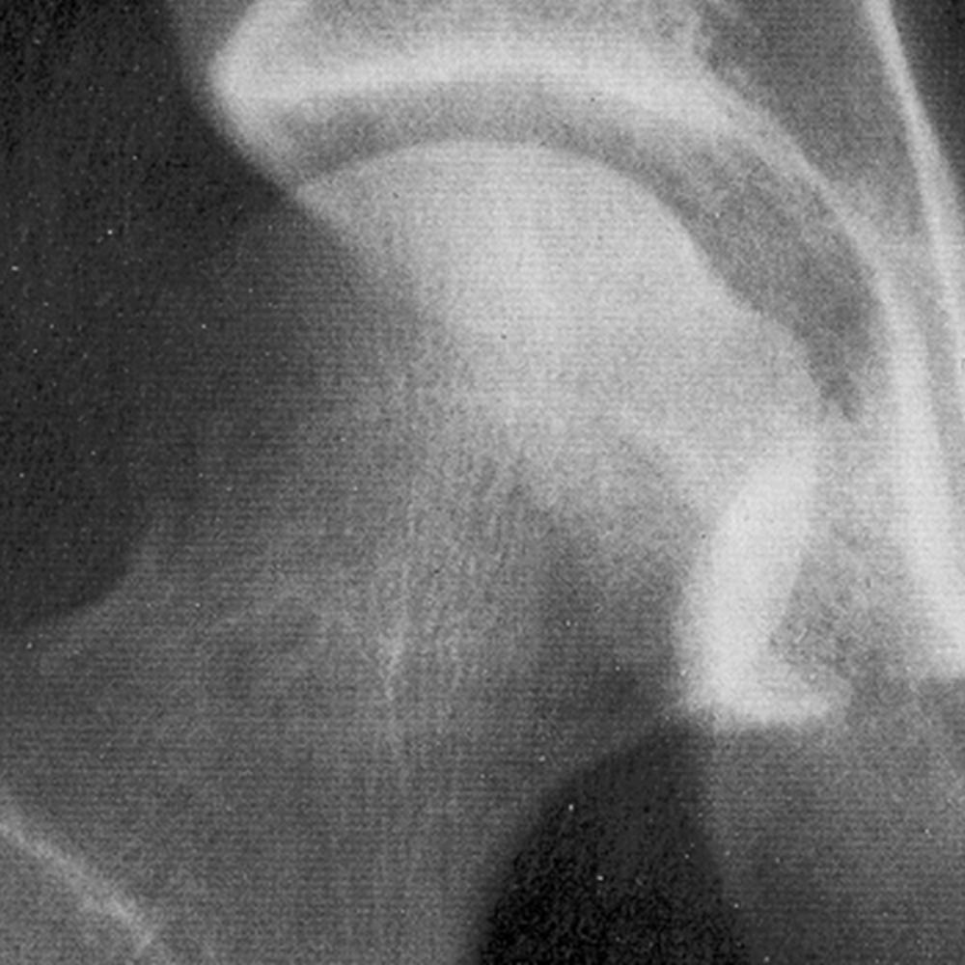
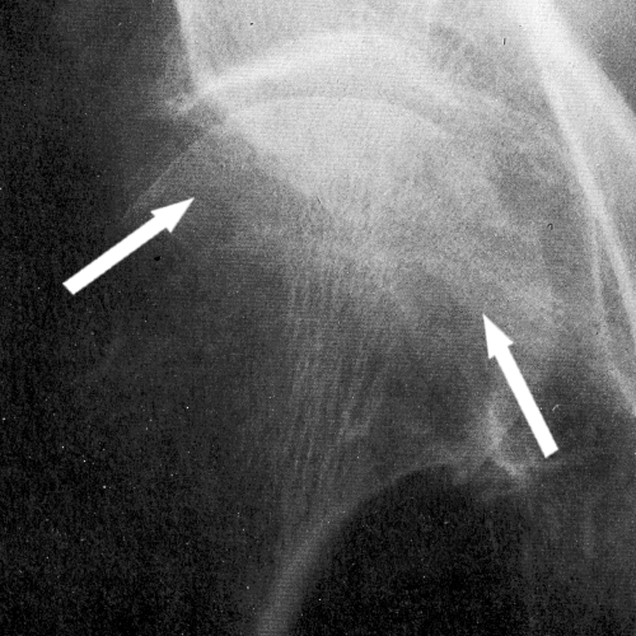
In the orthopedic laboratory of the EUR it has been hypothesized that as the bone remodels in response to its new mechanical environment, the subchondral plate¹ thickens and the volume fraction in the underlying trabecular bone increases. Eventually, the remodeling process may even ‘overshoot’ the original environment, resulting in stiffened subchondral bone [3]. As a consequence the more peripheral portions of the femoral head will be stress-shielded and bone will adapt by resorption [4]. The end configuration is a quite altered density distribution of the bone in the femoral head as can be observed on x-rays of patients (Fig. 1).
Fig. 1. x-rays of a human femur head (a) a healthy femur (b) femur with OA; the arrows show the areas of bone resorption.
b
a
This research project involves the generation of a two-dimensional (2D) Finite Element (FE) model of the proximal femur where the initial aspects of OA will be implemented as a local reduction of the density. Mechanical consequences and bone adaptation will be evaluated after which the conditions of late stage OA will be implemented as a local increase of the density. We will test the hypothesis that the reduction of the stiffness (40%) [3] of bone tissue in the femoral head will induce bone remodeling which will eventually lead to the density distribution observed on x-rays of patients with severe OA. This hypothesis will be qualitatively tested.
¹Fig. A from the Appendix shows the composition of the tissues of the hip joint [1,7].

Methods
A linear 2D FE model of the proximal femur was constructed of 133×190 (x,z) cubes (voxels) of 0.391mm (Fig. 2). This was done because the FE software program Voxel 3D which uses rectangular voxels, is especially suited to study the behavior of bone material. Bone density data were taken from a gray-scale scan of a slice of a real human femur, using a linear relationship between gray-value and density [6]. Then a linear relationship was used between density and stiffness. Calibration was performed by assuming 20 GPa [3] stiffness for the part of the femur with the highest density (the cortex¹). We modeled the cup of the joint, the acetabulum, based on pictures of the human anatomy [1] and gave it a stiffness of 20 GPa. The cartilage was modeled as a layer on top of the subchondral bone with a stiffness of 6 Gpa.
We applied the main force (representative for the static loading conditions the human body experiences) as a point load on the acetabulum, which in its turn distributed the force evenly to the subchondral bone. Since the trabeculae¹ are organized in such a way that they transfer load, the direction of the applied main force corresponded with the trebecular architecture; 71°(Fig. 2). We based the magnitude of this force (800N) on the weight of the average human body [5]. The force exerted on the femur that keeps it in its place, was represented by distributed point loads of respectively 60N, 120N, 180N and 240N parallel to our main force [9]. To prevent the model from rotating about the y-axis, the base was fixed (Fig. 2). Also bending about the x-axis was suppressed.
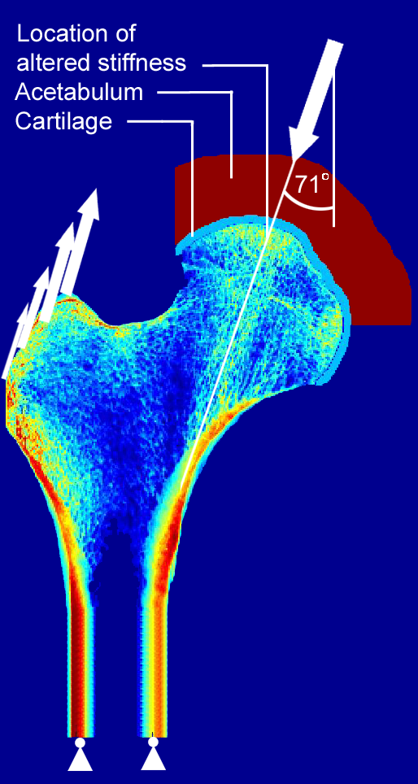
To establish the reliability of the above described basic model parameters we did a sensitivity analysis. We varied arbitrarily the direction of the main force, the location of its application and the thickness of both the acetabulum and the cartilage.
Fig. 2. basic 2D FE model of a femur, with boundary and loading conditions.
Main force
x
z
y
After running our model we looked primarily at the Strain Energy Density (SED= ½[σ_{x}ε_{x}+σ_{y}ε_{y}+σ_{z}ε_{z}+τ_{xy}γ_{xy}+τ_{yz}γ_{yz} +τ_{zx}γ_{zx}]) of each voxel (only in the head of the femur) by making contour plots. We then determined the percentages each of the models differed from the original basic model and made box- whisker plots.
After we completed our basic model we implemented aspects of OA by a local reduction respectively increase of the stiffness. The location of the spot with the altered stiffness is indicated in Fig. 2. We may assume this as the most logical location because studies on OA support the fact that the disease develops at places where the tissue is maximal loaded [7]. The size of the spot we choose arbitrarily.
After running our model we looked at the output Maximum Principle (MP) strain and stress and at the SED of each voxel by making vector and contour plots. We defined in each voxel the change in SED of the implemented conditions of OA relative to a reference value, which was the SED in our basic model. This variable was defined as the remodeling signal (RS, the signal the tissue responds to by resorbing, negative RS, or forming, positive RS, bone matrix), thus:
RS = [SED_{OA} – SED_{reference}] / SED_{reference}
We made contour plots of the RS to compare them with x-rays of patients with OA.

Results
The results of our sensitivity analysis can be found in Table 1 and Table 2 of the appendix.
The RS-plot of the situation with a reduction of stiffness causes the bone to produce more bone material in the more peripheral portions of the head, but especially in the softened spot (Fig. 3 a). In this spot the production of bone-material ‘overshoots’ the originally environment, as mentioned in the Introduction, which causes the situation of a spot with a higher stiffness. Running the model with an increased stiffness of the spot results in the RS observed in Fig. 3 b. This picture shows that there will disappear bone material in the more peripheral portions of the femur head. On the X-ray of the OA bone (Fig. 1 b), this resorption of bone in the more peripheral portions of the head can also be seen.

Discussion
As a first study on this subject some valuable information can be deducted from the model. Though, it should also be noticed that from our sensitivity analysis the conclusion can be drawn that our model is rather sensitive to variations of the chosen parameters, especially to variations of the location of the main force. However, looking at the actual RS (this was only done for this specific parameter) it shows that the influence is much smaller (table 2).

The determination of the location of the spot with the altered stiffness needs further refinement. Also, in our model the spot covered the subchondral bone plate and trabecular bone while in fact the initial softening (and eventually hardening) of the bone tissue is only found to be in the subchondral bone plate. The plot of the RS as a result of the stiffening of the spot shows that there is also bone resorption in the spot itself. Actually, this doesn’t seem to be so in OA cases. This is probably due to the fact that bone remodeling is initiated by deformation on a cellular level, where the bone material is actually less stiff. However, it wasn’t within the reach of this project to study this phenomenon more thoroughly.
A real femur is a 3D bone. Therefore, modelling it as a 2D object has already limitations in itself.
We assumed static forces, while in fact the human body is also loaded dynamically. The exact location and magnitude of the applied forces is difficult to determine, especially when using the acetabulum to apply a distributed force. However, because the model is linear the magnitude of the applied forces will not have a great influence on the interpretation of the output of the model.
Because of the multiple modeling assumptions and relatively large sensitivity of the model to the chosen parameters, no hard conclusions can be drawn about the validation of our hypothesis. However, evaluating the results of the FE model has made the hypothesis much stronger that an explanation for the altered density distribution, observed on X-rays of patients with severe OA, might be found in the reduction of stiffness of bone tissue in the femoral head which will induce bone remodeling. For future research this is a promising result.

Recommendations
Future models will have to reduce the number of modeling assumptions and will have to map accurately the influence of used assumptions. Our recommendations to future models are:
- construct a 3D model, but take in mind the extra computation time;
- conduct detailed studies on:
  - the exact location, direction and magnitude of the forces;
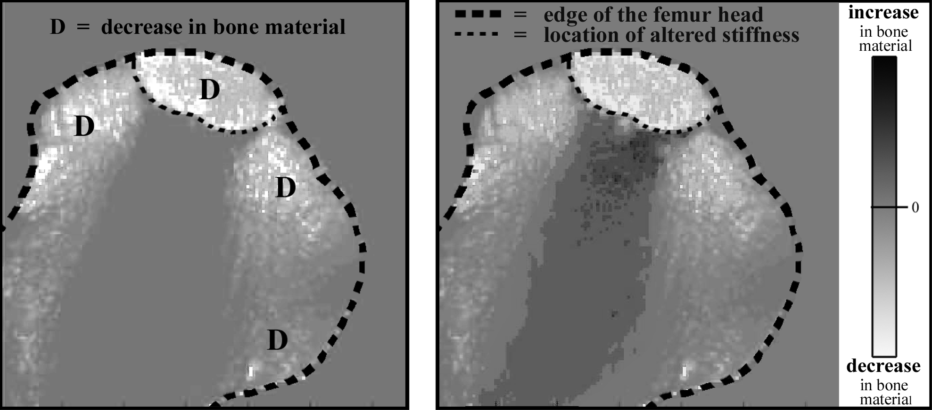
  - the exact location and size of the spots with altered stiffness;
b
Fig. 3. RS plots of the femoral head (a) with a local reduction of the stiffness (b) with a local increase of the stiffness
a
  - the variations of stiffness of the spots;
  - the exact (maybe non-linear) relationship between density and stiffness;
- model cartilage and acetabulum more conform reality.
- average the output of the models with the varying input parameters, to compensate for the relatively large sensitivity of the model.
Appendix

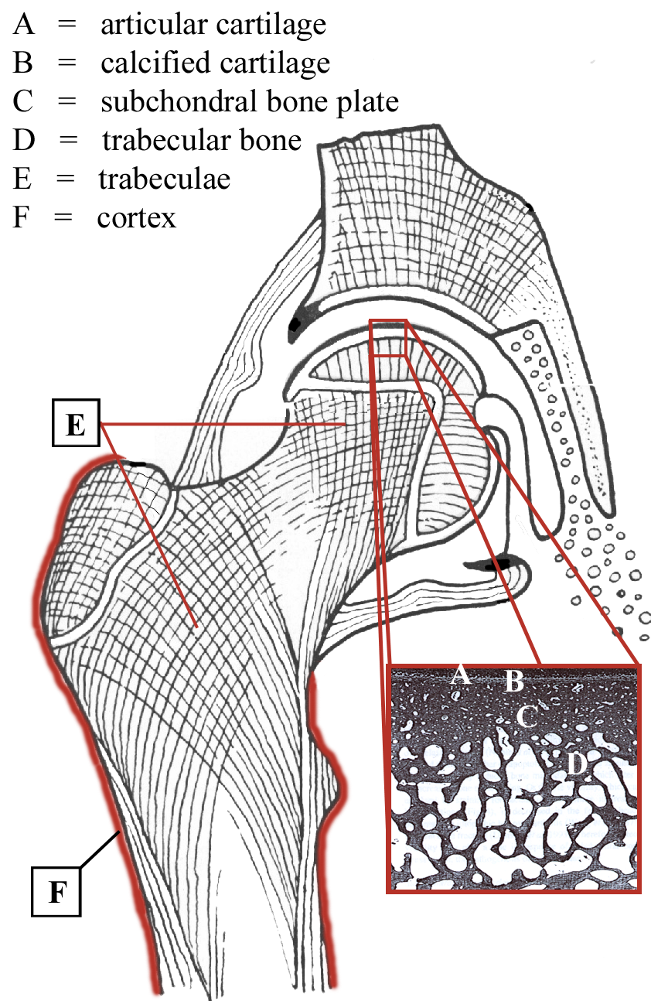
Fig.A. Schematic figure of the composition of the tissues of the human hip joint [1] and a histology of the osteochondral area demonstrating articular cartilage, calcified cartilage and subchondral bone, which can be further classified into the subchondral bone plate and the trebacular bone [7].

Table 1. Results sensitivity analysis looking at the SED | Median | Standard Deviation | 95% of deviations of SED value’s are within¹:
% dev. with force angle 69° (-2°) | 9,2 % | 24 % | +/- 50 %
% dev. with force angle 73° (+2°) | -10,3 % | 25 % | +/- 42 %
% dev. with location of force to the left (6 voxels) | 11,1 % | 2107 % | +/- 418 %
% dev. with location of force to the right (6 voxels) | -10,5 % | 84 % | +/- 154 %
% dev. with thinner cartilage (-33 %) | 10,5 % | 30 % | +/- 50 %
% dev. with thicker cartilage (+33 %) | 13,0 % | 25 % | +/- 65 %
% dev. with thinner Acetabulum (-8 %) | 0,1 % | 8 % | +/- 18 %
% dev. with thicker Acetabulum (+8 %) | -0,2 % | 9 % | +/- 15 %
¹ When processing the sensitivity analysis data we found that there were a few (<10) values that were profoundly larger than the bulk of the them. To eliminate these extreme values out of our sensitivity analysis we decided to look to the range, which covered 95% of all values

Table 2. Results sensitivity analysis looking at the RS. | Median | Standard Deviation | 95% of deviations of RS value’s are within¹:
% dev. with location of force to the left (6 voxels) ² | -10,6 % | 30 % | +/- 41 %
² In this study only the Rs sensitivity analysis was performed of the parameter which had the largest SED sensitivity. All the other parameters will show to be less sensitive to the RS. We did not include all the other parameters because this requires running extensively more models.

References
[1] Boileau Grant JC. An atlas of anatomy, fifth edition, 1962. Hip joint on Coronal Section, partly schematic; 282
[2] Burr DB PhD. The importance of subchondral bone in osteoarthrosis. Current Opinion in Rheumatology 1998, 10:256-262
[3] Day JS, Ding M, van der Linden JC, Hvid I, Sumner DR, Weinans H. A decreased subchondral trabecular bone tissue elastic modulus is associated with pre-arthritic cartilage damage. Journal of Orthop Research 19 (2001) 914-918
[4] Fazzalari NL, Parkinson IH. Femoral Trabecular Bone of Osteoarthritic and Normal Subjects in an age and Sex Matched Group. Osteoarthritis and Cartilage (1998) 6, 377-382
[5] Heller MO, Bergmann G, Deuretzbacher G, Dürselen L, Pohl M, Claes L, Haas NP, Duda GN. Musculo-skeletal loading conditions at the hip during walking and stair climbing. Journal of Biomechanics 34 (2001) 883-893
[6] Hvid I, Bentzen SM, Linde F, Mosekilde L, Pongsoipetch B. X-ray quantitative computed tomography: the relations to physical properties of proximal tibial trabecular bone specimens. J Biomech 1989;22(8-9):837-44
[7] Kawcak CE, McIlwraith CW, Norrdin RW, Park RD, James SP. The role of subchondral bone in joint disease: a review. Equine veterinary journal (2001) 33 (2) 120-126
[8] Radin EL, Rose RM. Role of subchondral bone in the initiation and Progression of Cartilage Damage. Clin Orthop 1986;34
[9] Weinans H, Sumner DR, Igloria R, Natarajan RN. Sensitivity of periprosthetic stress-shielding to load and the bone density-modules relationship in subject-specific finite element models. Journal of Biomechanics 33 (2000) 809-817

