Approximation models employing design sensitivity data

C.M.Lotion (9529526)

Abstract
Response surface techniques are methods to study the effect of all kinds of parameters, for example heat or load, on a structure by performing computer simulations. Due to the high computational and economical costs of conducting these simulations, simple mathematical approximation functions are created with data from these simulations in order to replace them. The approximation functions are named meta-models. Most contemporary approximation techniques, which are also known as surface fitting techniques, only employ the coordinates of the structures material (surface) points, which are present in simulation data to construct a meta-model. These coordinates are commonly named function values. However, in many cases the derivative information, which represents the slope in surface points, is available inexpensively, for example in finite element analysis. The derivative information is also known as sensitivity data and can be included to improve the accuracy of the meta-model and cut down the costs. In addition, the costs can be reduced by selecting the most appropriate Design of Experiments (DOE). A DOE is a method to efficiently construct the setup of an experiment by choosing a (limited) collection of test coordinates. These test coordinates are also named design points an represent the values of the test parameters that are to be applied to perform the according test. This article discusses preliminary research on the applicability of sensitivity data in combination with Full Factorial, Box-Behnken, Central Composite and Latin Hypercube Sampling Designs (FFDs, BBDs, CCDs and LHS). These are the four most promising DOEs based on experience when employing only function values. The Sum of Squared Errors (SSE) is used as an accuracy measure for the approximation of the meta-model. The basic conclusion that can be drawn is that derivative data can indeed be included efficiently to approximate meta-models. By employing derivatives and applying the iterative weighted least squares (IWLS) procedure to improve weight factors for function and derivative data a considerable global improvement is gained over approximations based on function values only. Latin Hypercube Sampling produced superior results and, therefore, it is considered the best DOE compared to Full Factorial, Box-Behnken and Central Composite Designs. Future studies could investigate the influence of characteristic parameters of engineering problems, for example, large numbers of design variables.

Keywords derivatives, design of experiments, design sensitivities, iteratively weighted least squares, Latin Hypercube Sampling, meta-models, response surface models.

Introduction
Despite the rapid increases in computer capacity, the enormous computational cost of running complex engineering simulations for design optimisation is still a costly and laborious undertaking in practice. Therefore, to reduce these costs, simple surrogate models or meta-models are constructed with the coordinates of the structures material (surface) points of the actual simulation model. These coordinates are also named function data, and are finally used to replace the expensive simulation model. In many cases, when performing finite element analyses for example, inexpensive derivative data is available and may be used to improve the accuracy of the meta-model and consequently, reduce the costs of constructing the response surface. The derivative data is also called gradient information or design sensitivity data and represents the slope in the structures material points.
A Designs of Experiments (DOE) is a method to build a setup of an experiment by choosing a (limited) number of test coordinates. At each of these design points a test is performed. Choosing an efficient DOE to conduct the tests can thereby also reduce the costs.
This article discusses preliminary research on the feasibility of using sensitivity data in combination with Full Factorial, Box-Behnken, Central Composite and Latin Hypercube Sampling Designs (FFDs, BBDs, CCDs and LHS). These are the four most promising DOEs based on experience when employing only function values.

Theory
Designs of Experiments are methods to construct a design of an experiment by choosing a (limited) collection of test points. These design points are values of the test parameters which are to be applied for a given experiment. The following figures give a summary of key features of the four selected DOEs and shows where design points might be situated:
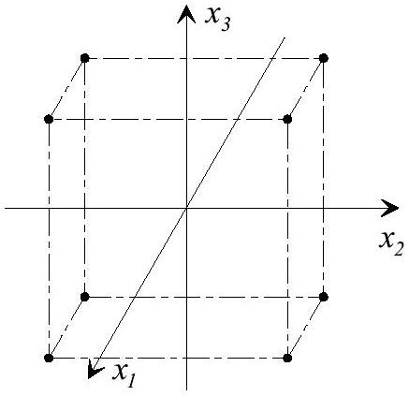

Figure 1. Full Factorial Design
design points, k variables, which are named factors and L_{i} values, which are called levels, of each factor. The interaction between factors can be studied.
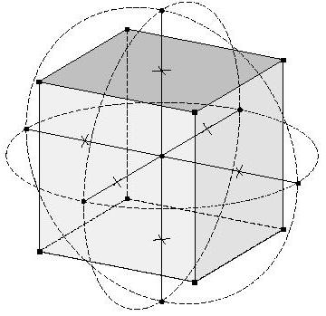

Figure 2. Central Composite Design
Needs only design points for k variables with: 2^{k} points on vertices, 2k points on the axes of the hypercube and c centre point replicates. The design is categorised by α, the distance between centre and points on axes.
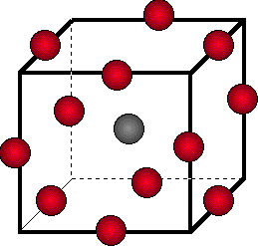
Figure 3. Box-Behnken Design
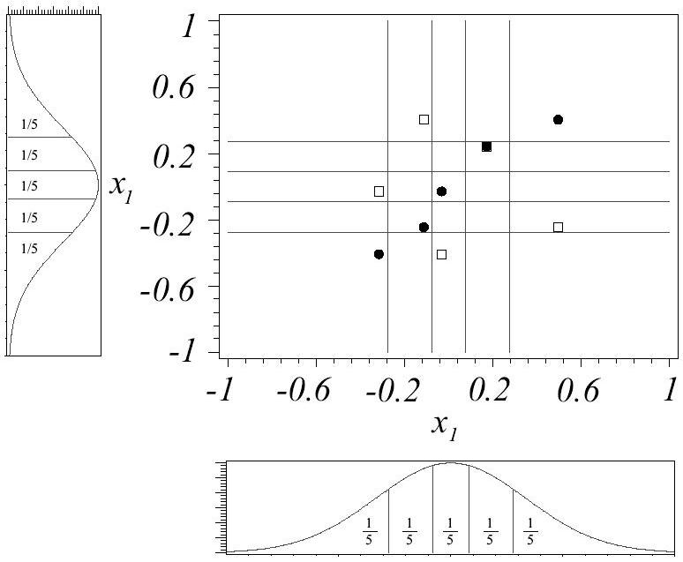
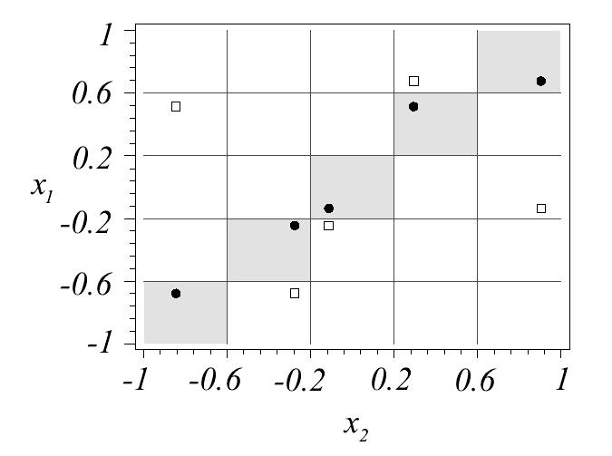
design points on vertices and axes of the hypercube for k variables and c centre point replicates, therefore .

Figure 4. Latin Hypercube Sampling Design
(uniform and normal)
user-defined design points which are chosen by user-defined distributions of the design variables. Each design variable may have its own distribution function, for example, a uniform or normal distribution. The most appropriate distribution can be chosen for a particular engineering problem.

Problem statement
The main problem which was addressed is how to build optimal meta-models implementing design sensitivities. Here, “optimal “ performance is quantified by means of the statistical model property Sum of Squared Errors (SSE). This property could be used an accuracy measure for the global performance of the approximation function or fit as it quantifies the errors of both function and derivative data.

Key questions

The key questions present while conducting the research where:
Does including sensitivity data significantly increase the accuracy of approximation models?
Which Design of Experiments (DOE) produces the smallest Sum of Squared Errors (SSE) in this approximation?

Hypothesis
The hypothesis consists of three parts and can be formulated accordingly.
The SSE of function and derivative values of smooth polynomial approximation models using a CCD, BBD or LHS will respectively:
- at least be 70% and 35% smaller than the SSE when using a FFD.
- be maximally 15% higher and 40% smaller when including available design sensitivity data with the same number of design points.
- be maximally 20% higher and 45% smaller when also making use of the weighted least squares (IWLS) procedure to improve weight factors for function and derivative data.

Setup of experiments and test problems
A number of test problems were used to investigate the effect of including sensitivity data and application of the four selected Designs of Experiments (DOEs) on the accuracy of the meta-model fits. This was achieved by performing a comparison of the reduction of the following Summs of Squared Errors (SSEs) to that of a conventional Full Factorial Design, which does not employ any sensitivity data:
- SSE of the function value (dSSEf)
- SSE of the derivative of the first design parameter (dSSEg1)
- SSE of the derivative of the second design parameter (dSSEg2).
Only two-variable second order polynomial meta-models, approximated by first order polynomials with a small number of design points, were included in the performed tests. The test scheme for conducting these experiments consisted of the following steps:
- generation of DOEs with Regan Pro (Regression Analysis Program)
- compution of function and derivatives values in the analytical mathematics program Maple 6.
- simultation with the curve fitting program Mamop 1.4 (Multiple Approximation Method for Optimization), including application of the following test conditions to each of the four DOEs (See Table 1):
  - function values only
  - function and sensitivity data
  - function, sensitivity data and the iterative weighted least squares (IWLS) procedure to improve weight factors for function and derivative data .

Results
The hypothesis is confirmed by the test results. Traditional DOE theory can be applied in almost the same way to approximation functions for meta-models using sensitivity data as to those for function values only. Presented in Table 1 and Figure 5 to 9, for example, are the test results for test function as meta-model.
Approximations with a FFD and CCD achieve the smallest SSE-decrease, with CCD performing slightly better than FFD, which does not even have any effect. This is exactly as it should be according to theory, as these DOEs need the largest number of design points to perform an accurate fit. Adding derivative information and implementing the IWLS procedure does not improve the SSEs either, as the Least Squares (LSQ) fit has been found. One can also expect these DOEs to be superior to BBD and LHS, when large numbers of design points are considered.
On the other hand, using BBD and LHS does bring about a significant error reduction, thus, complying with both hypothesis and theory. Yet, there are some small differences. By including derivative information the SSEs of design sensitivities decrease, causing an overall improvement of the approximation. These SSEs improve when applying IWLS as well. Conversely, the SSEs of function values increase, so the accuracy of local approximations is less. This is caused by including the sensitivity data, which automatically puts more weight on global than on local accuracy of the fit. Although, the BBD seems to cause a better performance than LHS for both function values and gradients, it is actually inferior to it, as the reduction of the SSE of function values (and sometimes even derivative values) rapidly decreases by applying the IWLS procedure. Considering all the above, LHS proves to be the best of the presented four DOEs for using function and derivative information with the tested meta-model approximation functions.

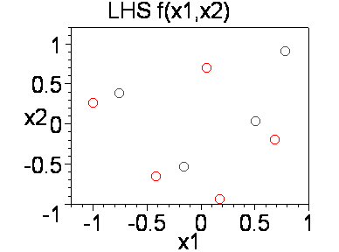
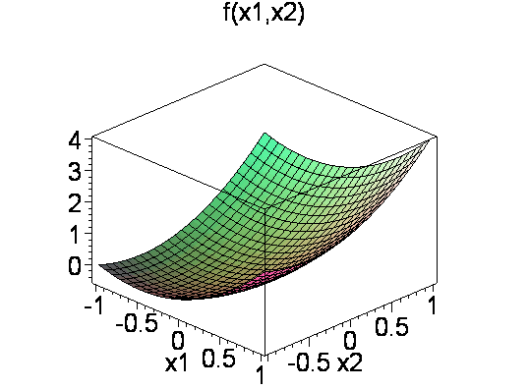
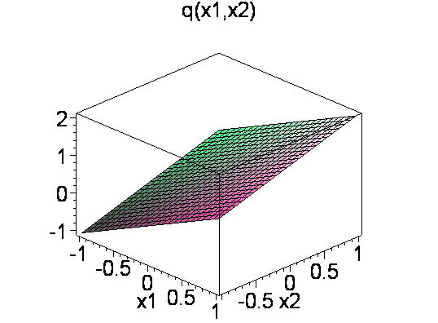
Figure 5. Plot of , the Latin Hypercube Design for performing the surface fit and , the approximation function with application of sensitivities and IWLS .

Table 2. Reduction of Sum of Squared Errors for test function with different DOEs and test conditions.
Reduction Sum of Squared Errors dSSE [%]
 | dSSE_{f} | dSSE_{g1} | dSSE_{g2}
FFD 9 dpts*
function | 0,000 | 0,000 | 0,000
sensitivities | 0,000 | 0,000 | 0,000
IWLS | 0,000 | 0,000 | 0,000
CCD (spherical: ) 9 dpts
function | 11,100 | 33,333 | 33,333
sensitivities | 11,100 | 33,333 | 33,333
pareto | 11,100 | 33,333 | 33,333
BBD 5 dpts
function | 100,000 | 66,667 | 50,000
sensitivities | 71,900 | 66,667 | 78,875
IWLS | 57,250 | 66,667 | 80,000
LHS (x1, x2 uniform) 9 dpts
function | 87,025 | 40,958 | 52,958
sensitivities | 78,505 | 47,208 | 53,833
IWLS | 72,750 | 47,667 | 53,875
*dpts: design points

Conclusions
The basic conclusion that can be drawn is that inexpensive derivative data can be employed efficiently in combination with conventional Designs of Experiments (DOEs) in almost the same way to approximation functions for meta-models using sensitivity data as to those for function values only. By including derivative information the Sums of Squared Errors (SSEs) of design sensitivities decrease, causing an overall improvement of approximations. On the other hand, the SSE of function values (and sometimes even derivative values) will increase, so the accuracy of local approximations will be less. Hence, there has to be a compromise between obtaining the smallest SSE of function and derivatives values. The accepted increase in SSE for either depends on their relevance in the problem at hand. The example presented here shows that by including derivatives data and using the IWLS (a procedure to improve weight factors for function and derivative data), a significant global improvement is gained compared to approximations based on function values only. LHS produced superior results and, therefore, it is the best DOE compared to FFD, BBD and CCD.
Figure 6. Reduction Sum of Squared Errors for tests with function data
Figure 7. Reduction Sum of Squared Errors of First Order Derivative to variable x₁ for tests with function and sensitivity data
Figure 8. Reduction Sum of Squared Errors of First Order Derivative to variable x₂ for tests with function and sensitivity data

Recommendations
In future studies the effects of more characteristic parameters of engineering problems could be investigated, for example, large numbers of design variables, non-polynomial functions, noise and singularities. The first parameter would especially be interesting, as most response surface problems concern multi-variable designs.

References
Jin, R. , W. Chen and T.W. Simpson (2001): Comparitive studies for metamodelling techniques under multiple modelling criteria. Struct Multidisc Optim 23, pp. 1-13.
Keulen, F. and K. Vervenne, Gradient-Enhanced Response Surface Building, pp.1-8.
Lauridsen, S. (2001, preprint): Approximation Concepts in Engineering Design Optimization – Ph. D. Dissertation, pp. 1-60.
Lauridsen, S., R.Vitali, F. van Keulen, R.T. Haftka and J.I. Madsen (2001): Response Surface Approximation using Gradient Information, In G. Cheng, Y. Gu, S.Liu, and Y. Wang (Eds.), Proceedings of The Fourth World Congress Of Structural and Multidisciplinary Optimization, (WCSMO-4), Dalian, China, pp. Paper 171. Liaoning Electronic Press.
Rijpkema, J.J.M., L.F.P. Etman and A.J.G. Schoofs (preliminary): Metamodel Based Design Opimization Including Design Sensitivities, pp. 1-13.
Toropov, V.V., F. van Keulen, V.L. Markine and L.F. Alvarez (2001): Multipoint Approximations Based On Response Surface Fitting: A Summary of Recent Developments, 1-8.

