Plans of Experiments in Gradient Based Response Surface Building: A Comparative Study
ManWo Ng 1016989
Abstract
In engineering practice one is often interested in the relation between input and output of a system. Many response surface (RS) techniques have been developed in order to increase the accuracy of approximation models. A recent development in computer simulation based RS building is to include derivative information. However, all of these methods are focused on procedures after a crucial first step in RS building: choosing a plan of experiments. There are many different plans of experiments, thus it is expected that the accuracy of the RS approximation is greatly affected by the choice of the plan of experiments. This study reveals that the accuracy of approximation models indeed depends strongly on the plan of experiments used.

Introduction
In engineering practice one is often interested in the relation between input and output of a system. That is, a mathematical approximation relating the input variable(s) to the output variable(s), which is also known as the response surface (RS).
Traditionally, the functional relationship is obtained by fitting function data obtained by physical experiments for fixed sets of input variables. These fixed sets are determined by so called plans of experiments.
Unlike the situation above, there is a huge engineering area where the function data in the plan points are obtained by computer simulations. This is for example the case in structural optimization applications, where the function values are evaluated by finite element calculations. Much effort is made to make the RS approximations as accurate as possible. A recent development in computer simulation based RS building is to include derivative information. This inexpensively obtained gradient information could theoretically improve the quality of RS (Van Keulen et al. 2001). Triggered by the inclusion of gradient information in RS building, a method to weight the function values and derivatives against each other has been proposed (Van Keulen and Vervenne 2002).
However, all of these methods are focused on procedures after a crucial first step in RS building: choosing a plan of experiments. There are a lot of different plans of experiments, each of them having specific properties. Thus it is expected that the accuracy of the RS approximation is greatly affected by the choice of the plan of experiments.
In this paper four plans of experiments are compared systematically. Special attention will be paid to their predictive performances when the two RS techniques as proposed in the papers by Van Keulen et al. (2001) and Van Keulen and Vervenne (2002) are applied.

Methodology
The following four plans of experiments will be compared in this paper for the case of two variables. Figures of these designs will be provided. For more information the reader is referred to specialized books (Myers 1995; Khuri 1996).
- Random Design
A random design in an n-dimensional space is obtained by selecting k design points, i = 1,..,k randomly. k can be freely chosen. The random design used in this study includes 8 design points and is given in figure 1.
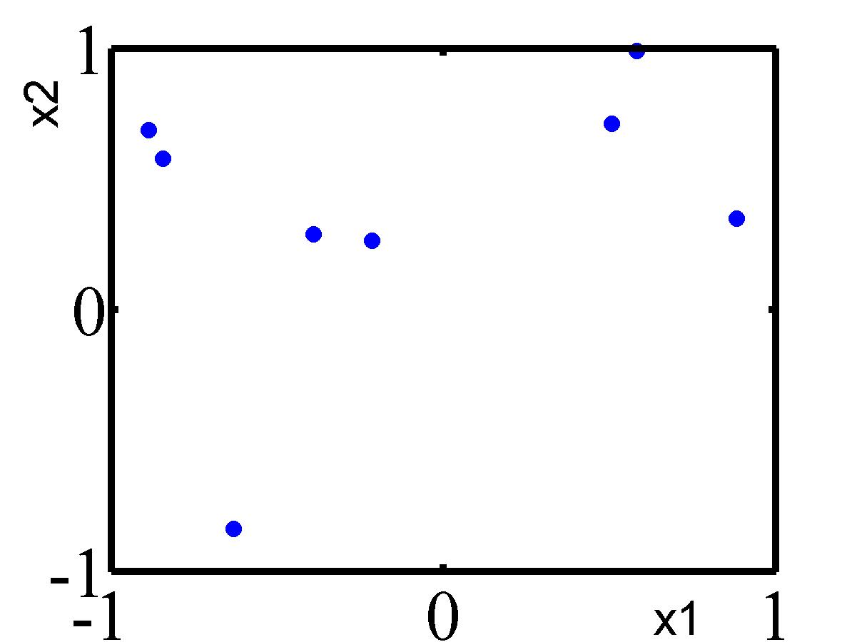
Figure 1: The random design used in this study.

- Full Factorial Design
Anfactorial design involves n factors or variables. Each variable is divided into L levels and is bounded by a lower and upper limit, usually scaled corresponding to ±1. The total number of design points equals.
For example a 3² factorial design contains 2 variables, 3 levels of each variable and 9 design points in total.
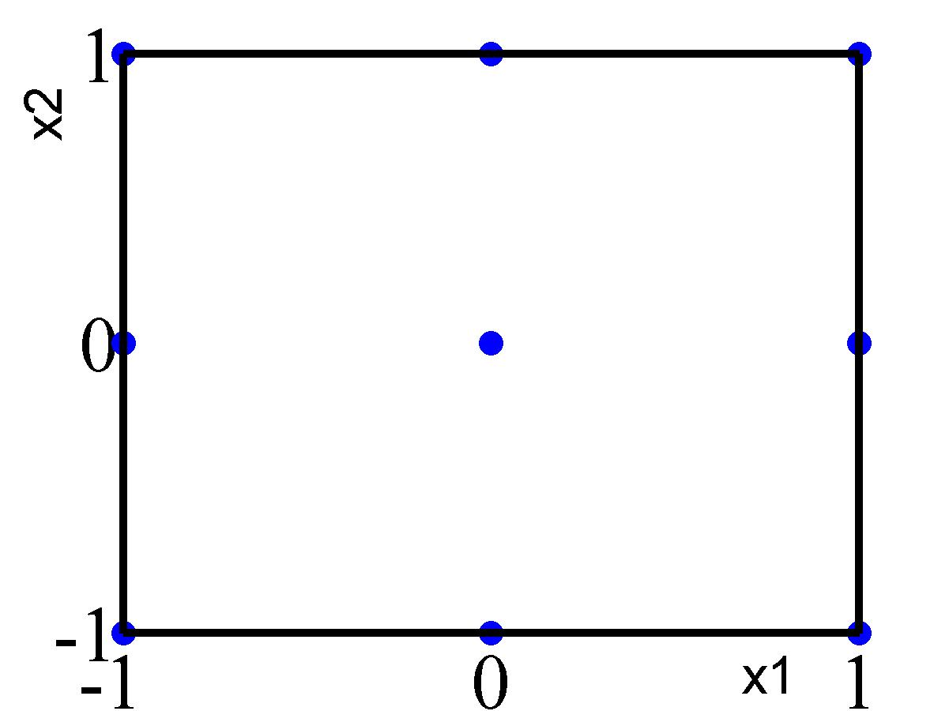
Figure 2: 3² full factorial design.

- Central Composite Design (CCD)
The central composite design consists of the following portions:
- Factorial portion. A 2^{n} factorial design, where the factor levels are scaled to the usual ±1 values.
- c center points ()
- Axial portion. 2 axial points on each axis of the variables at a distance of α from the center point.
The total number of design points is thus:
Based on the value of α the design possesses certain properties. Table 1 gives an overview of the standard possibilities.

CCD | Α
Face Centered
Spherical
Orthogonal
Rotatable
Table 1: Different values of α give different CCDs. F is the number of factorial experiments.
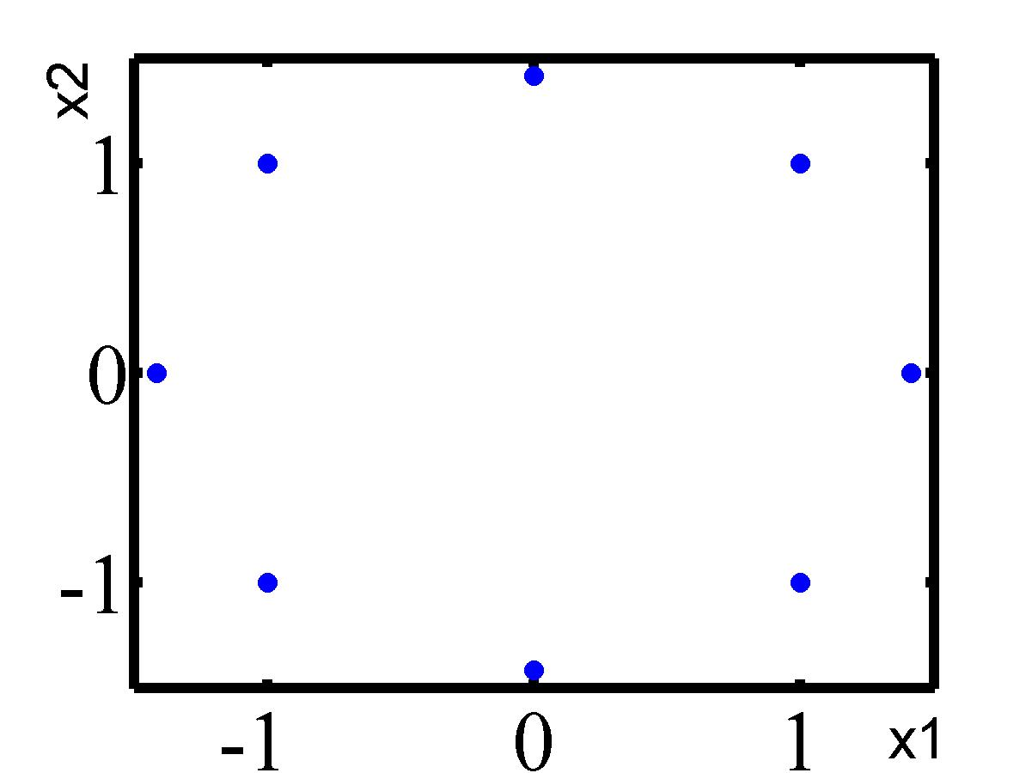
Figure 3: CCD Spherical/ Rotatable. The other CCDs will also be investigated.

4. Latin Hypercube Sampling (LHS)
To obtain an LHS in an n-dimensional space, each variable is divided into k non-overlapping intervals. k is the number of desired points. For each variable and in each interval, 1 point is selected based on some probability distribution in that interval. The k points obtained for x₁ are paired randomly with the k points of x₂. These pairs will subsequently be randomly paired to the k points of x_{3,} and so on.
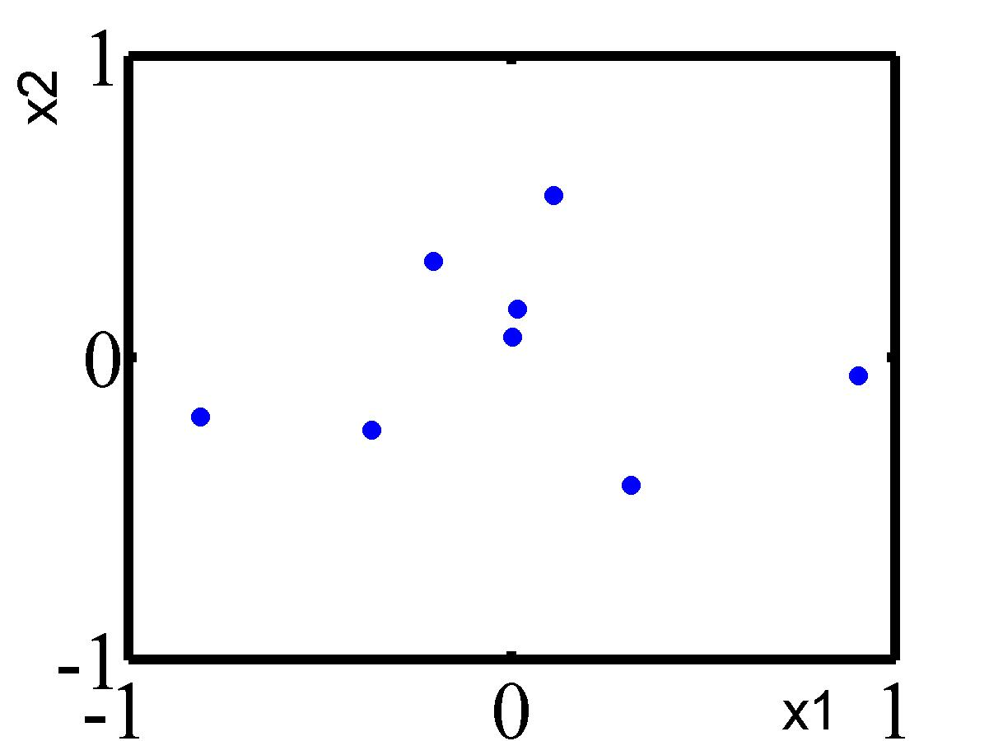
Figure 4: LHS with normal distributed variables
To test the predictive performances the next procedures will be followed:
- Three Test Problems are selected from the book of Hock and Schittkowski (1981) that offers a huge number of test examples for nonlinear optimization algorithms.
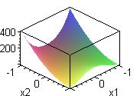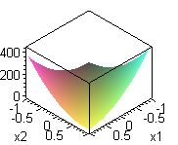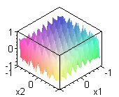
Figure 5: Test Problems. From left to right: Test 1, 2 and 3.

The mathematical descriptions for Test 1, 2 and 3 are respectively:

For each Test Problem the function values and derivatives in the design points will then be evaluated.
2. Based on these observations a least squares (LS) problem is obtained (Lauridsen et al. 2001).

To approximate the Test Problems the following approximating models will be used:

- 1st order gradient enhanced polynomial model;
- 2nd order gradient enhanced polynomial model.

The no-gradient cases will also be studied as a reference.
Another parameter that will be investigated is the weighting scheme of the function values against derivative data as proposed by Van Keulen and Vervenne (2002). This weighting scheme will henceforth be referred to as ParNorm.
3 Once the coefficients of the polynomial models are obtained by solving the LS problem, the accuracy of the different models will be compared based on the Analytic Root Mean Square, which is defined as:
Where:
A = integration area as determined by the ±1 values.
y = test function
y_{approx} = obtained approximation model

Results
Comparison between the CCDs shows the following trend: The CCD Spherical/Rotatable is systematically less accurate than its orthogonal and face centered counterparts, except in Test 3. This is the case in 1st order (gradient enhanced) models as well as in 2nd order (gradient enhanced) models. In Test 3 the opposite is true: CCD Spherical/Rotatable outperforms the other CCDs. Figure 6 illustrates the situation.
Fig 6 CCD Spherical/ Rotatable is systematically less accurate than the other CCDs, except in Test 3.

Overall distinction between the CCD Orthogonal and the CCD Face Centered is less clear. Only when first order (gradient enhanced) models are concerned, is this distinction more obvious. The CCD Orthogonal is then the more accurate one. Fig 7 shows this trend.
Figure 7: CCD Orthogonal is the more accurate one.

The LHS performs well in first order models, especially when gradient information is included. See figure 8.
Figure 8: Good overall performance of the LHS

Only in Test 3 ParNorm improves accuracy substantially. See figure 9.
Figure 9: ParNorm proves to be useful.

Discussion and Conclusions
This study reveals that the accuracy of approximation models indeed depends strongly on the plan of experiments used. Not only there is a substantial difference in accuracy within a given problem, there is also a tendency that certain plans of experiments are in general more accurate than the others.
The fact that the ParNorm weighting scheme consistently improves accuracy in Test 3 only, could be an indication that it is a great tool to fit quickly fluctuating RS.
However, this study is only meant to be a first investigation into the influences of plans of experiments on the accuracy of RS. Many more Test Problems should be used. Further research should also include Test Problems in more than 2 variables.

References
F. van Keulen and K.Vervenne (2002). Gradient-Enhanced Response Surface Building
Jin, R., W. Chen and T.W Simpson (2001). Comparative studies of metamodelling techniques under multiple modeling criteria.
Khuri, A.I and J.A. Cornell (1996). Response Surfaces, Design and Analyses, Second Edition, Revised and Expanded. Marcel Dekker, Inc., New York.
R.H. Myers and D.C Montgomery (1995) Response surface methodology: process and product optimization using designed experiments. New York: Wiley & Sons.
S. Lauridsen, R. Vitali, F. van Keulen, R.T. Haftka, and J.I. Madsen (2001). Response Surface Approximations using Gradient Information.
W. Hock and Schittkowski (1981) Test examples for nonlinear programming codes. Berlin, Heidelberg, New York: Springer

