Kandidaatsopdracht Onderzoek Werktuigbouwkunde
Nr  05-070 | Sectie opdrachtgever  Technische Mechanica | Naam opdrachtgever  Prof. dr. ir. D.J. Rixen |  |  | Datum  Juli 2001
Titel | Evaluating dynamic testing procedures for rubber compounds
Trefwoorden | Dynamic testing, material model, signal analysis.
Inleiding  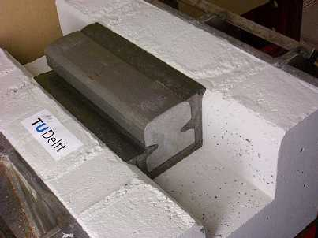 | In modern railway tracks, the rails are embedded in a rubber-cork compound so to reduce the radiated noise and to decrease the maintenance cost compared to classical tracks. When designing embedded rail systems, one must predict its static and dynamic behavior to ensure good operation when a train (or tram) is passing on it. It is thus essential to know the mechanical properties of the compound. In the lab of the Engineering Mechanics section, a material sample can be tested either by  using a material test bench (Metravib® machine), or using structural dynamic test equipment (shaker, force transducer and accelerometer). In order to build confidence in the material testing that will be carried out on the compound for embedded rail, it is of interest to know if the material test bench yields the same results as the tests performed with classical dynamic sensors.
Vraagstelling | Under harmonic loading, the dynamical behavior of the compound is identified by its stiffness (proportional to deformation) and its damping (proportional to deformation speed). These visco-elastic characteristics can be described by defining a complex modulus.  The project work should answer two important questions:  - Do we find the same results when measuring the complex modulus of a compound sample using the dedicated material bench (Metravib) and using a dynamic test setup which includes a shaker, a force transducer and an accelerometer?  - Are the identified material properties identical when using a small or a big sample?
Uitwerking en eisen | - Using the Metravib test bench, measure the complex modulus of a compound sample provided by Edilon B.V. in a frequency range of 0 to 800 Hz. Observe what are the major testing conditions that influence the measurements (temperature, humidity, age of sample, amplitude of loading, prestress …).  - Build the experimental setup that allows measuring the force and accelerations resulting from a shaker excitation on a material sample.  - Using that setup and a data acquisition system (Siglab), measure the complex modulus of the same sample in a frequency range of 2 to 800 Hz. Make sure that the testing conditions are the same as for the Metravib bench measurements.  - Compare the results obtained in the two test campaigns.  - Redo the measurement of complex modulus using a smaller sample and verify that the results obtained are the same as for the first sample.  - If time permits, quantify the effect of the amplitude of excitation on the measured modulus.
Opmerkingen | Some basic knowledge about vibration theory and signal analysis is required.  The Engineering Mechanics group will provide support for using the hardware, setting up the experiments and evaluating the results. Edilon B.V. (Harlem), manufacturer of the compound and of the embedded rail system, will provide the samples.
Begeleiding | Naam | Sectie | Tel | E-mail
Begeleiding | Mr. P. Mohanty | T.M. | 8 6509 | p.mohanty@wbmt.tudelft.nl
Begeleiding | Ir. C. van ‘t Hof | T.M. | 8 3726 | c.vanthof@wbmt.tudelft.nl
Begeleiding | Prof. dr. ir. D.J. Rixen | T.M. | 8 1523 | d.j.rixen@wbmt.tudelft.nl
Toegewezen aan:

