Kandidaatsopdracht Onderzoek Werktuigbouwkunde
Nr  05-073 | Sectie opdrachtgever: TM |  | Naam opdrachtgever  Prof. dr. ir. D.J. Rixen |  |  | Datum  Juli 2001
Titel | Verification of a numerical model of an embedded rail structure (ERS)
Trefwoorden | Dynamic testing, dynamic analysis, parameter identification, ANSYS®
Inleiding  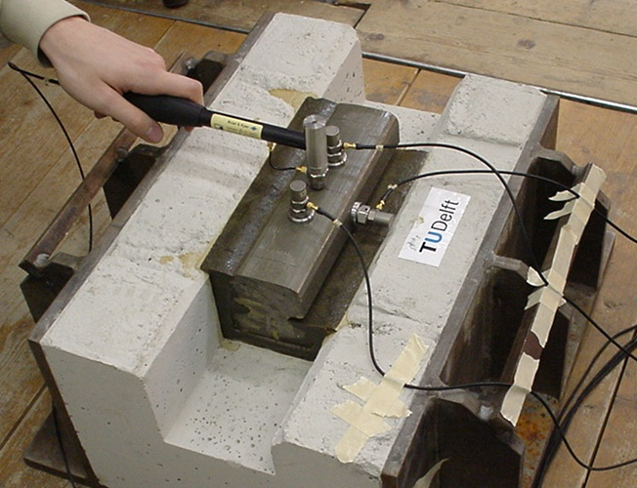  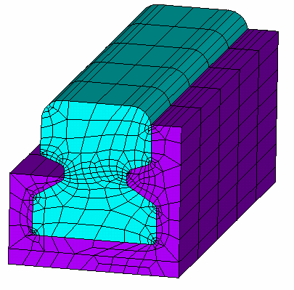 | How accurate is the FE numerical model (ANSYS®) of a modern track structure?  In modern railway tracks, the rails are embedded in a polyurethane-cork mixture (compound) in order to reduce noise emission and maintenance effort. While designing such a track, knowledge on its static and dynamic behavior is required to ensure safe operation when a train (or a tram) is passing. The most efficient and cheapest way to obtain such insight is to use numerical simulations. The FE model of ERS is available at Road and Railway Engineering Section (Civil Engineering). In order to verify the model, a Hammer Excitation Test is to be performed on an ERS exhibit in a laboratory and numerically simulated using the FE model (see Figures). The mechanical properties of the mixture such as stiffness and damping will be determined by testing a sample of the material (the same material as used in the ERS exhibit) at the lab of the Engineering Mechanics group. Based on a comparison of the results (in form of the Frequency Response Functions, resonant frequencies etc.) of the laboratory and numerical experiments some conclusions on accuracy of the numerical model are to be drawn. If necessary, a simple tuning of the model could be performed on the basis of model sensitivity information.
Vraagstelling | The project work should answer the following questions:  - Is it possible to determine a frequency response function of an embedded rail structure using the finite element software ANSYS®?  - Is the complexity of the material model of compound sufficient to accurately simulate the dynamic behavior of an embedded rail track?
Uitwerking en eisen | The following research path might be followed:  - Using the Metravib® test bench, measure the complex modulus of a material sample (provided by Edilon B.V.) in a frequency range from 0 to 800 Hz  - Analyze the complex modulus and extract the material properties corresponding to the chosen finite elements in ANSYS®  - Perform a Hammer Excitation Test (HET) on an ERS exhibit and obtain the Frequency Response Functions (using an existing MATLAB procedure)  - Adopt the existing ANSYS® model for simulation of HET in the time domain. Apply the material properties of the compound obtained from the Metravib® test to the model. Determine an appropriate integration time step and obtain the Frequency Response Functions (using an existing MATLAB procedure)  - Compare the results (the Frequency Response Functions) of the laboratory and the numerical experiments  - Indicate the sensitivity of the results to variation of the compound material properties (by performing few extra computer simulations)  - If time permits, try to improve the numerical results using the sensitivity information
Opmerkingen | Some basic knowledge about the vibration theory and signal analysis is required.  The Engineering Mechanics group (OCP) and the Road and Railway Engineering Section (CiTG) will provide all necessary hard- and software as well as theoretical and technical support. Edilon B.V. (Haarlem), manufacturer of the compound and of the embedded rail system, will provide the samples.
Begeleiding | Naam | Sectie |  | Tel | E-mail
Begeleiding | Prof. Dr. Ir. D.J. Rixen | TM – OCP |  | 8 1523 | d.j.rixen@wbmt.tudelft.nl
Begeleiding | Dr. V.L. Markine | VBK – CiTG |  | 8 3206 | v.l.markine@citg.tudelft.nl
Begeleiding | Ir. C. van ‘t Hof | TM – OCP |  | 8 3726 | c.vanthof@wbmt.tudelft.nl
Begeleiding | Ir. A.P. de Man | VBK – CiTG |  | 8 4011 | a.p.deman@citg.tudelft.nl
Toegewezen aan:

