Kandidaatsopdracht Onderzoek
Werktuigbouwkunde
Toegewezen aan: Marc van der Velden en Jorg Gerritsen
Nr  05-081 | Sectie opdrachtgever  TM |  | Naam opdrachtgever  Prof. dr. ir. D.J. Rixen |  |  | Datum  Januari 2002
Titel | Design of a drop test machine for packaging analysis
Trefwoorden | Mechanical design, dynamic testing, shock isolation, packaging
Inleiding  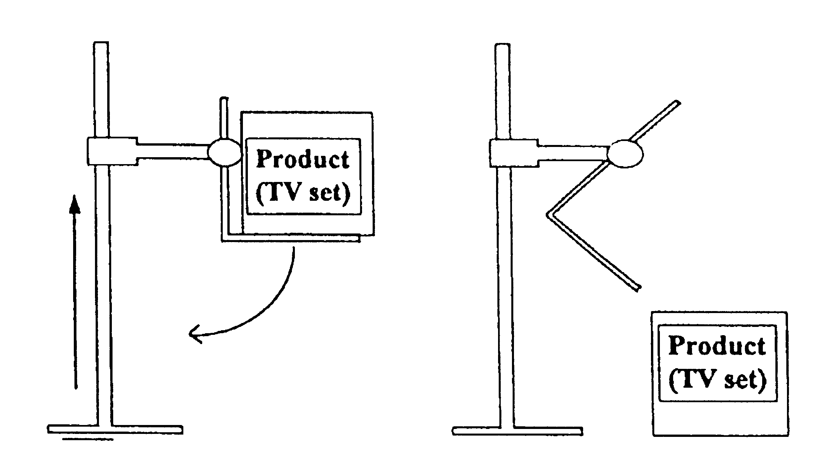 | The packaging of a product must be properly designed in order to protect it from shocks during transportation. This requires on one hand to use appropriate design procedures based on the stiffness and damping properties of the packaging material.  On the other hand, the final design of the packaging must be proofed in drop tests where the level of deceleration of the packaged product is measured.  Drop tests are thus needed to characterize the packaging material (stiffness and damping during shocks) and to certify every specific packaging design.  Drop tests are currently undertaken in the dynamics lab of the Engineering Mechanics group. For the drop tests to be precise and repeatable, it is necessary to use a drop test machine that releases the product such that it falls straight from a predefined height.
Vraagstelling | The project work consists in:  - Proposing a design of a simple drop test machine.  - Building a prototype of the machine in the dynamics lab.  - Testing the new machine to check the operational quality of the design and to verify if the machine ensures good repeatability of the measurements during drop tests.
Uitwerking en eisen | - Consult basic literature on drop tests for packaging design and define the requirements for a simple but efficient drop test machine.  - Propose a design for such a machine that can be build with simple components (beams, hinges, springs …). Check, by using simplified static and dynamic analysis, that the design is sound.  - Build a prototype of the machine in the dynamics lab of the Engineering Mechanics group.  - Perform some basic drop tests with the machine, using the measurement equipment of the lab and check if the measurements obtained do not vary between experiments when the drop test machine is used (repeatability).
Opmerkingen | The students choosing this topic should have a good practical sense.  The Laboratory for Mechanical Reliability (I.O.) will provide support for understanding the requirements of the machine and for the design.  The Dynamics group of the Engineering Mechanics section will support the students for the mechanical analysis and for the use of the dynamics lab.
Begeleiding | Naam | Sectie |  | Tel | E-mail
Begeleiding | Prof. Dr. Ir. D.J. Rixen | tm – OCP |  | 8 1523 | d.j.rixen@wbmt.tudelft.nl
Begeleiding | Sham Gurav | lw5-io – OCP |  | 8 1700 | S.P.Gurav@io.tudelft.nl

