Bachelor of Science Onderzoek
Werktuigbouwkunde
Nr  09-247 | Sectie opdrachtgever  Mens-Machine Systemen |  | Naam opdrachtgever  Prof.Dr.Ir. P.A. Wieringa |  |  | Datum  Jan 2004
Titel | Can intestine inspection robots be magnetically attracted to the intestinal wall?
Trefwoorden | Intestine inspection robot, electromagnetic fields, friction
Inleiding | At the Man-Machine Systems Group, research is being carried out on the development of a robotic device that can move along the large intestine (=dikke darm). The robot is an alternative for conventional flexible endoscopes. In order to move along the intestine, there must be sufficient grip between the feet of the robot and the inner surface of the intestinal wall, without causing damage to the tissue.  In this framework, a new idea involves friction manipulation between the intestinal wall and the robot by means of electromagnetic fields and magnetic microstructures. The idea has already been applied with success in pharmacology and, though earlyish, it seems very promising for quick and precise alteration of the friction in the large intestine. Magnetic structures and electromagnets can offer magnetic properties to the intestinal wall and the robot respectively. Then, an electromagnetic field can generate attractive forces between them. The question is whether such attractive forces can be used to manipulate friction and to generate sufficient grip for locomotion.  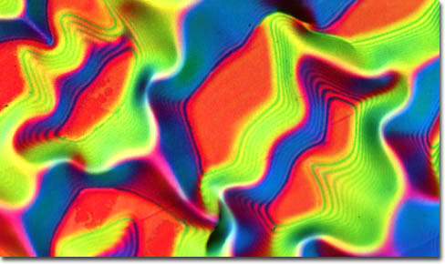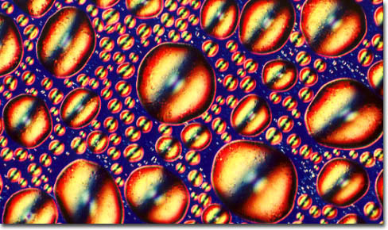  Magnetic structures at the microscale
Vraagstelling | Is it possible to manipulate friction in the large intestine magnetically?
Uitwerking en eisen | An experimental facility will be developed to measure normal and friction forces between the magnetically activated intestinal wall and a magnetic surface. An experiment will be carried out to evaluate the influence of electromagnetic fields on the frictional behaviour of the large intestine.
Opmerkingen | The experiments will be carried out in the Biolab of the Man-Machine Systems Group. Biological tissues can be obtained from the Erasmus Laboratory Animal Science (EDC) of the Erasmus University in Rotterdam.
Begeleiding | Naam | Sectie |  | Tel | E-mail
Begeleiding | D. Dodou, MSc | MMS |  | 87348 | d.dodou@wbmt.tudelft.nl
Begeleiding | Dr.Ir. P. Breedveld | MMS |  | 85232 | p.breedveld@wbmt.tudelft.nl
Toegewezen aan: Jan Carel Paro en Thijs Mandersloot

