Nr  09-249 | Sectie opdrachtgever  TM |  | Naam opdrachtgever  Prof. Daniel Rixen |  |  | Datum  Jan 2004
Titel | Physical model of the human pelvic girdle
Trefwoorden | Biodynamics, physical modeling, dynamic testing
Inleiding  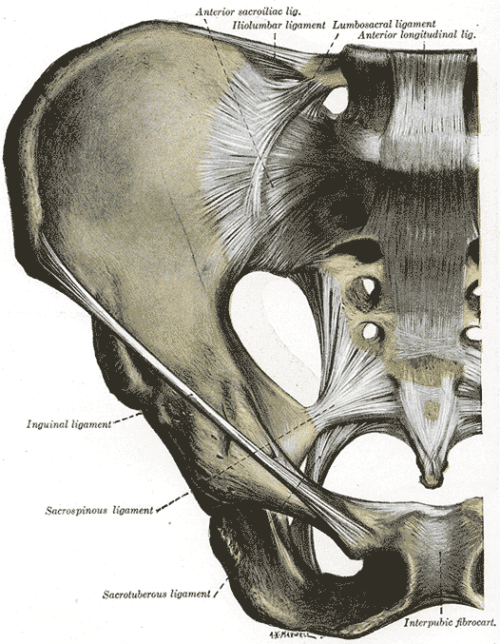 | Low Back Pain has a huge socioeconomic impact around the world, and it is one of the major causes of discomfort. In some cases medical screening cannot identify any pathology.  The working assumption underlying an in-house ongoing research is that abnormal biomechanical properties of the sacroiliac joints are the originators of pain. In the frame of the mentioned research, a diagnostic tool for the detection of these abnormalities is under development. To support the measurements, a mathematical biodynamic model of the pelvis girdle has been created.  In order to test the measurement apparatus and the model itself, a physical model reproducing the anatomy and the dynamic behaviour of the pelvis girdle is to be constructed.
Vraagstelling  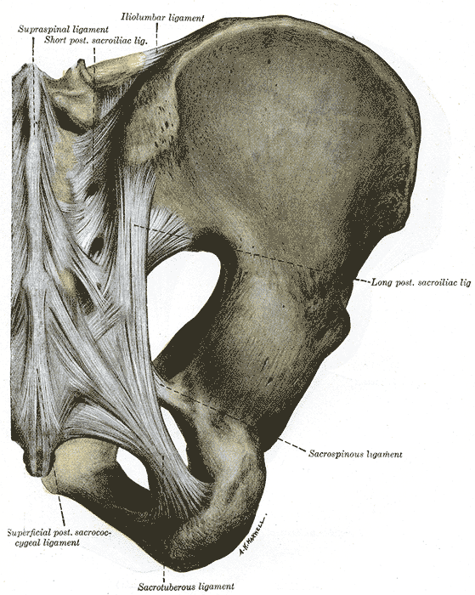 | A physical model of the pelvic girdle should be built, consisting of three masses (the three bones) and a set of linear springs representing the ligaments, according to the existing mathematical model.  The geometry and the topology of the model should resemble as much as possible the anatomy of the pelvis, in terms of density, mass, shape and spring configuration.
Uitwerking en eisen | The investigation should consider the following steps:  - Define a suitable (simplified) solid shape for the three bones  - Identify a suitable material in terms of physical properties and workability  - Find suitable springs  - Construct the model  - Compare the low frequency dynamic behaviour of the physical model with the simulations
Opmerkingen | Support will be provided by the Engineering Mechanics and Marine Technology groups. The candidates must have an interest in dynamics, as well as an independent and versatile inclination for laboratory work.
Begeleiding | Naam | Sectie |  | Tel | E-mail
Begeleiding | Prof. dr. ir. D.J. Rixen | Eng. Mech. |  | 8 1523 | d.j.rixen@wbmt.tudelft.nl
Begeleiding | Ir. Nadine Conza | Eng. Mech. |  | 8 6508 | n.e.conza@wbmt.tudelft.nl
Kandidaatsopdracht Onderzoek
Werktuigbouwkunde
Toegewezen aan: Henk Jan Wapstra en Christiaan Valentin

